Obama Plan Would Help Many Go to Community College Free

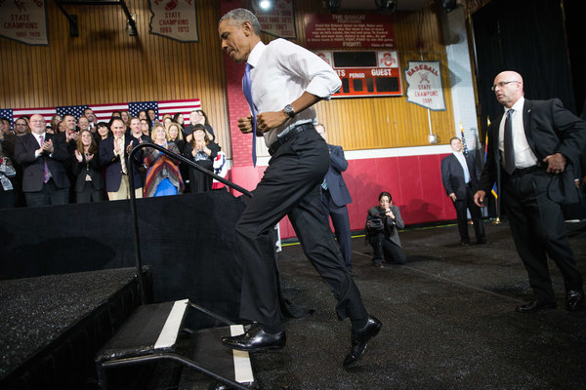
President Obama running onto the stage before delivering remarks at Central High School in Phoenix on Thursday.
Doug Mills / The New York Times

By JULIE HIRSCHFELD DAVIS and TAMAR LEWIN

January 8, 2015
WASHINGTON — President Obama said Thursday that he would propose a government program to make community college tuition-free for millions of students, an ambitious plan that would expand educational opportunities across the United States.
The initiative, which the president plans to officially announce Friday at a Tennessee community college, aims to transform publicly financed higher education in an effort to address growing income inequality.
The plan would be funded by the federal government and participating states, but White House officials declined to discuss how much it would cost or how it would be financed. It is bound to be expensive and likely a tough sell to a Republican Congress not eager to spend money, especially on a proposal from the White House.
“With no details or information on the cost, this seems more like a talking point than a plan,” said Cory Fritz, a spokesman for House Speaker John A. Boehner, Republican of Ohio.
Video | The Art of the Degree Vladimir de Jesus, a community college student, dreams of becoming an art teacher. But after first enrolling at LaGuardia Community College in 2008, he’s still working toward his degree.
Mr. Obama’s advisers acknowledged Thursday that the program’s goals would not be achieved quickly. The president, however, was more upbeat. “It’s something that we can accomplish, and it’s something that will train our work force so that we can compete with anybody in the world,” Mr. Obama said in a video posted Thursday night by the White House.
The proposal would cover half-time and full-time students who maintain a 2.5 grade point average — about a C-plus — and who “make steady progress toward completing a program,” White House officials said. It would apply to colleges that offered credit toward a four-year degree or occupational-training programs that award degrees in high-demand fields. The federal government would cover three-quarters of the average cost of community college for those students, and states that choose to participate would cover the remainder. If all states participate, the administration estimates, the program could cover as many as nine million students, saving them each an average of $3,800 a year.
Mr. Obama will include the program, which would need congressional approval, in his budget for the coming year, his advisers said, and detail it in his State of the Union address Jan. 20.
The plan is modeled after Tennessee’s free community college program, called the Tennessee Promise, which will be available to students graduating high school this year. It has drawn 58,000 applicants, almost 90 percent of the state’s high school seniors, and more than twice as many as expected.
The program has gone a long way toward making community college attainable for all students. In addition, the proportion of applicants who are African-American and Hispanic is higher than their proportion currently enrolled in Tennessee colleges. The program is backed by the state’s Republican governor, Bill Haslam, and largely financed from lottery funds.
Still, Tennessee Promise has been criticized by some who say it is structured to benefit middle-income students more than the neediest.
It is designed as a “last dollar” scholarship, paying only for tuition costs not covered by other programs. A low-income student who is eligible for a maximum Pell Grant of $5,730 would not receive assistance under the Tennessee program, because that amount would already cover tuition. A more affluent student, however, could get full tuition paid by the program.
Mr. Obama’s plan, by contrast, would cover tuition costs up front, White House officials said.
Representative Diane Black, Republican of Tennessee, said despite the success of her state’s program, she was skeptical of the Obama initiative, calling it “a top-down federal program that will ask already cash-strapped states to help pick up the tab.”
Chicago, too, has a new free community college initiative starting this year. The program initiated by Mayor Rahm Emanuel, a Democrat, will give Chicago Public School students who graduate with at least a 3.0 grade-point average waivers to cover tuition, books and fees at the city’s seven community colleges.
White House officials acknowledged in a conference call with reporters that the program was unlikely to win quick approval in Congress. Still, they said, in proposing it, Mr. Obama was seeking to press states and community colleges to beef up their investments in high-quality education in ways that would have a lasting effect even before federal legislation was enacted.
“We don’t expect the country to be transformed overnight, but we do expect this conversation to begin tomorrow,” said Cecilia Muñoz, the president’s domestic policy chief.
About 7.7 million Americans attend community college for credit, of whom 3.1 million attend full time, according to the American Association of Community Colleges, relying on 2012 data. Over all, the federal government provides about $9.1 billion to community colleges, or about 16 percent of the total revenue the colleges receive. Tuition from students provides $16.7 billion a year, or nearly 30 percent of revenue.
Senator Lamar Alexander of Tennessee, a former education secretary, will attend the announcement at Pellissippi State Community College in Knoxville, Tenn., on Friday.
In an op-ed published on Thursday, he expressed concern about the federal role in such a program. Tennessee has been hindered by federal bureaucracy, he wrote in The Knoxville News Sentinel. “Let other states emulate Tennessee’s really good idea,” he wrote.
Julie Hirschfeld Davis reported from Washington, and Tamar Lewin from New York. Peter Baker contributed reporting from Washington.

