Fred Wood selected as new Contra Costa College District Chancellor
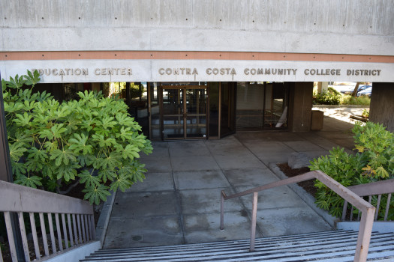
Sam Richards
Stock image for Contra Costa Community College District
By Sam Richards | srichards@bayareanewsgroup.com

PUBLISHED: November 4, 2016 at 1:09 pm | UPDATED: November 4, 2016 at 4:19 pm
MARTINEZ — Contra Costa Community College District leaders say new Chancellor Fred Wood has a uniquely relevant skill set for what its three colleges need most to do — help their students move on to four-year colleges.
Having graduated from College Park High School in Pleasant Hill and from the district’s Diablo Valley College before moving on to UC Davis, Wood personally knows the journey that approximately half of all district students make.
“He has walked the paths many of our students are working to do,” said district board member Greg Enholm.
During his time as vice chancellor of student affairs at UC Davis (while concurrently serving as a faculty member in chemistry), he oversaw a community college center on that campus that helped students make the transition.
“He focuses on student success and relationship building,.” said board President Vicki Gordon.
Wood will leave his post as chancellor at the University of Minnesota, Crookston to return to the district from which he earned an associate of arts degree. The district board voted 4-0 Friday morning at a short special meeting to select Wood, one of three finalists for the chancellor’s job. The finalists had been part of public forums at each of the three main campuses, as well as at the district’s downtown Martinez offices.
The others were Eugene Huff, the district’s executive vice chancellor of administrative services since 2013, and Kindred Murillo, superintendent/president of Lake Tahoe Community College in South Lake Tahoe.
Contract negotiations with Wood will now begin, said Gordon, adding that his salary and his start date will be established during that process. It is hoped his contract approval will be on the Dec. 14 board agenda.
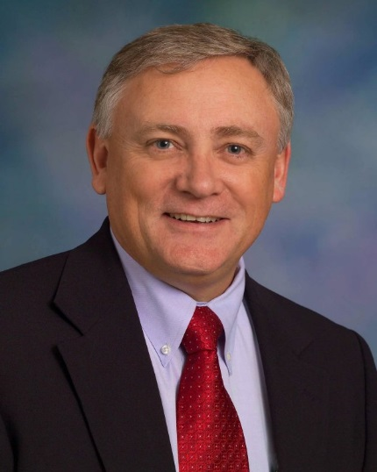

Dr. Fred Wood Courtesy CCCCD
Wood will succeed Helen Benjamin, who in May said she will retire before the end of December. Benjamin, 65, has been with the district since 1990, starting as Los Medanos College’s dean of Language Arts and Humanistic Studies and Related Occupations. She held several other positions within the district before becoming chancellor in 2005.
Wood was not on hand Friday, but in a statement issued later in the day, he said, “My DVC experience changed my life, and I am living proof of the power and impact community colleges can make.”
Even given Wood’s first-hand experience with the Contra Costa system and helping guide community college students to four-year institutions, all four college board trustees said Friday morning that choosing from among him, Huff and Murillo was a challenge.
“All of them were excellent candidates,” said trustee John Marquez, joining his colleagues in praising both the professional job recruiters involved and the college district students and staff who weighed in on the three finalists.
Gordon spoke directly to approximately 35 district officials and staff at Friday’s special meeting, thanking them for their help in the process, especially during what she called a “time of transition” after the Oct. 9 death of longtime board member John T. Nejedly.

