CONTRA COSTA COMMUNITY COLLEGE DISTRICT EQUAL EMPLOYMENT OPPORTUNITY PLAN
2016-2019

1 TABLE OF CONTENTS

- Introduction 2
- Definitions 3
- Policy Statements 5
- Delegation of Responsibility, Authority and Compliance 6
- Advisory Committee 8
- Complaints 10
- Notification to District Employees 12
- Training for Screening/Selection Committees 13
- Annual Written Notice to Community Organizations 14
- Analysis of District Workforce and Applicant Pool 15
- Recruitment and Hiring Procedures to Ensure Equal Employment Opportunity 20
- Additional Measures to Support Diversity and Ensure Equal Employment Opportunity 26
- Other Measures Necessary to Further Equal Employment Opportunity 28
- Maintaining Institutional Commitment to Diversity 31
- Accountability and Corrective Action 33
- Persons with Disabilities 34

Equal Employment Opportunity Plan

INTRODUCTION
The Contra Costa Community College District Equal Employment Opportunity Plan (Plan) reflects the District’s commitment to equal employment opportunity. It is the District’s belief that taking active and vigorous steps to ensure equal employment opportunity and creating a working and academic environment that is welcoming to all, will foster diversity and promote excellence.
Through an educational experience in an inclusive environment, our students will be better prepared to work and live in an increasingly global society. The Plan’s immediate focus is equal employment opportunity in its recruitment and hiring policies and practices pursuant to the applicable Title 5 regulations (Section 53000 et seq.) and the steps the District shall take in the event of underrepresentation of monitored groups. The Plan contains an analysis of the demographic makeup of the District’s workforce population and an analysis of whether underrepresentation of monitored groups exists. The Plan also includes the requirements for a complaint procedure for noncompliance with the Title 5 provisions relating to equal employment opportunity programs; complaint procedures in instances of unlawful discrimination; establishment of an Equal Employment Opportunity (EEO) Advisory Committee; methods to support equal employment opportunity and an environment which is welcoming to all; and procedures for dissemination of the Plan. To properly serve a growing diverse population, the District is committed to hiring and retaining well-qualified faculty and staff who are sensitive to, and knowledgeable of, the needs of the continually changing student body it serves.

DEFINITIONS

Reference: Title 5, § 53001 (a)(l)
  - Adverse Impact: means a statistical measure (such as those outlined in the EEO Commission’s Uniform Guidelines on Employee Selection Procedures) that is applied to the effects of a selection procedure and demonstrates a disproportionate negative impact on any group protected from discrimination pursuant to Government Code, Section 12940. A disparity identified in a given selection process will not be considered to constitute adverse impact if the numbers involved are too small to permit a meaningful comparison.

  - Diversity: means a condition of broad inclusion in an employment environment that offers equality and respect for all persons. It requires both the presence, and the respectful treatment, of individuals from a wide range of ethnic, racial, age, national origin, religious, gender, sexual orientation, disability and socio-economic backgrounds. The District recognizes that diversity in an academic environment promotes academic excellence; fosters cultural, racial and human understanding; provides positive role models for all students; and creates an inclusive and supportive educational and work environment for students, employees, and the community.

  - Equal Employment Opportunity: means that all qualified individuals have a full and fair opportunity to compete for hiring and promotion and to enjoy the benefits of employment with the District. Equal employment opportunity should exist at all levels in the seven job categories which include executive/administrative/managerial, faculty and other instructional staff, professional non-faculty, secretarial/clerical, technical and paraprofessional, skilled crafts, and service and maintenance. Equal employment opportunity also involves:
    - identifying and eliminating barriers to employment that are not job related; and
    - creating an environment which fosters cooperation, acceptance, democracy, and free expression of ideas and is welcoming to men and women, persons with disabilities, and individuals from all ethnic and other groups protected from discrimination pursuant to Government Code, Section 12940.

  - Equal Employment Opportunity Plan: a written document in which the District’s workforce is analyzed and specific plans and procedures are set forth for ensuring equal employment opportunity.

  - Equal Employment Opportunity Programs: all the various methods by which equal employment opportunity is ensured. Such methods include, but are not limited to, using nondiscriminatory employment practices, actively recruiting, monitoring and taking additional steps consistent
with the requirements of Title 5, Section 53006.

  - Ethnic Group Identification: means an individual’s identification in one or more of the ethnic groups reported to the State Chancellor pursuant to Title 5, Section 53004. These groups shall be more specifically defined by the State Chancellor consistent with state and federal law.

  - In-house or Promotional Only Hiring: means that only existing District employees are allowed to apply for a position.

  - Latino: replaces the term Hispanic in this Plan. This Plan recognizes that the state, county and District traditionally use Hispanic as a demographic term.

  - Monitored Group: means those groups identified in Title 5, Section 53004(b) for which monitoring and reporting is required pursuant to Title 5, Section 53004(a). Monitored groups are men, women, American Indians or Alaskan Natives, Asians or Pacific Islanders, African- Americans, Latinos, Whites, and persons with disabilities.

  - Person with a Disability: any person who (1) has a physical or mental impairment as defined in Government Code, Section 12926 which limits one or more of such person’s major life activities,
(2) has a record of such an impairment, or (3) is regarded as having such an impairment. A person with a disability is “limited” if the condition makes the achievement of the major life activity difficult.

  - Reasonable Accommodation: the efforts made on the part of the District in compliance with Government Code, Section 12926.

  - Screening or Selection Procedures: any measure, combination of measures, or procedures used as a basis for any employment decision. Selection procedures include the full range of assessment techniques, including but not limited to, traditional paper and pencil tests, performance tests, and physical, educational, and work experience requirements, interviews, and review of application forms.

  - Significantly Underrepresented Group: any monitored group for which the percentage of persons from that group employed by the District in any job category listed in Title 5, Section 53004(a) is below eighty percent (80%) of the projected representation for that group in the job category in question.

POLICY STATEMENTS

Reference: Board Policy 2052, Equal Employment Opportunity; Board Policy 2001, Nondiscrimination Policy; Board Policy 2059, Diversity
The District is committed to the principles of equal employment opportunity and will implement a comprehensive program to put those principles into practice. It is the District’s policy to ensure that all qualified applicants for employment and employees have full and equal access to employment opportunity and are not subjected to discrimination in any program or activity of the District on the basis of ethnic group identity, race, color, ancestry, religion, marital status, sex, national origin, gender, gender identity, gender expression, age, sexual orientation, physical or mental disability, medical condition, genetic information, veteran status, parental status, citizenship or because an individual is perceived to have one or more of these characteristics or based on association with a person or group with one or more of these actual or perceived characteristics. The District will
strive to achieve a workforce that is welcoming to everyone, including all genders, persons with disabilities and individuals from all ethnic and other groups to ensure the District provides an inclusive educational and employment environment. Such an environment fosters cooperation, acceptance, democracy and free expression of ideas. An Equal Employment Opportunity Plan will be maintained to ensure the implementation of equal employment opportunity principles that
conform to federal and state laws and can be found in its entirety on the District’s website under the Human Resources Department.

DELEGATION OF RESPONSIBILITY, AUTHORITY AND COMPLIANCE

Reference: Title 5, §§ 53003 (c)(1) and 53020
It is the goal of the District that all employees promote and support equal employment opportunity because equal employment opportunity requires a commitment and a contribution from every segment of the District. The general responsibilities for the prompt and effective implementation of this Plan are set forth below.
  - Governing Board
The Governing Board is ultimately responsible for proper implementation of the District’s Plan at all levels of District and college operations, and for ensuring equal employment opportunity as described in the Plan.
  - Chancellor
The Governing Board delegates to the Chancellor the responsibility for ongoing implementation of the Plan and for providing leadership in supporting the District’s equal employment opportunity policies and procedures. The Chancellor shall advise the Board concerning statewide policy emanating from the Board of Governors of the California Community Colleges and direct the publication of an annual report on Plan implementation. The Chancellor shall evaluate the performance of all administrative staff who report directly to him/her on their ability to follow and implement the Plan.
  - Equal Employment Opportunity Officer
The District has designated the chief human resources officer as its equal employment opportunity officer who is responsible for the day-to-day implementation of the Plan. If the designation of the equal employment opportunity officer changes before this Plan is next revised, the District will notify employees and applicants for employment of the new designee. The equal employment opportunity officer is responsible for administering, implementing and monitoring the Plan, including oversight of training and recruitment activities, and for assuring compliance with the requirements of Title 5, Section 53000 et seq. The equal employment opportunity officer is also responsible for receiving complaints described in Section 7 of this Plan and for ensuring that applicant pools and selection procedures are properly monitored.
  - Equal Employment Opportunity Advisory Committee
The colleges and District Office will establish an Equal Employment Opportunity Advisory Committee to act as an advisory body to the equal employment opportunity officer and the District as a whole to promote understanding and support of equal employment opportunity policies and procedures. The Equal Employment Opportunity Advisory Committees shall assist in the implementation of the Plan in conformance with state and federal regulations and guidelines, monitor equal employment opportunity progress, and provide suggestions for Plan revisions as appropriate.
What is the process for making suggestions for the Plan revision?
  - Agents of the District
Any organization or individual, whether or not an employee of the District, who acts on behalf of the Board with regard to the recruitment and screening of personnel, is an agent of the District and is subject to all the requirements of this Plan.
  - Good Faith Effort
The District shall make a continuous good faith effort to comply with all the requirements of its Plan.

ADVISORY COMMITTEE

Reference: Title 5, § 53005
The District has established an Equal Employment Opportunity Advisory Committee to assist the District in implementing its Plan. The committee may also assist in promoting an understanding and support of equal opportunity and nondiscrimination policies and procedures. The committee may sponsor events, training, or other activities that promote equal employment opportunity, nondiscrimination, retention and diversity. The equal employment opportunity officer, or designee, shall train the advisory committee on (1) the requirements of Title 5, Section 53000 et seq. and of state and federal non-discrimination laws; (2) identification and elimination of bias in hiring; (3) the educational benefits of workforce diversity; and (4) the role of the advisory committee in carrying out the District’s Plan. The committee shall include a diverse membership whenever possible. A substantial good faith effort to maintain a diverse membership is expected. If the District has been unable to meet this requirement, it will document that efforts were made to recruit advisory committee members who are members of monitored groups.
  - Purpose
It is the purpose of the District Equal Employment Opportunity Advisory Committee (DEEOAC) in conjunction with the college Equal Employment Opportunity Committees to advise, assist, and make recommendations to and through the chief human resources officer to the Chancellor’s Cabinet for the development and implementation of a Districtwide equal employment opportunity program. The District Equal Employment Opportunity Advisory Committee shall understand and promote a Districtwide commitment to diversity, inclusion and equal employment opportunities.

  - Committee Structure
The structure of this committee shall represent individuals interested and committed to diversity, and shall include a diverse membership whenever possible. The District Equal Employment Opportunity Advisory Committee will include the following:

- three members from the college’s Equal Employment Opportunity Committee (including the college’s EEO officer); and
- two community members appointed by the Governing Board.

In order to further ensure diverse membership, the DEEOAC is an open committee seeking broad participation. Additional members may be appointed by the following:

- one member designated by Faculty Senate Coordinating Council;
- one member designated by Classified Senate Coordinating Council;
- one member designated by Management Council;
- one member designated by Local 1;
- one member designated by United Faculty; and
- one member designated by Student Trustee Advisory Council.

The chief human resources officer and other District staff will participate as appropriate and shall report directly to the Chancellor, or designee.

Appointments to the District Equal Employment Opportunity Advisory Committee shall be two
(2) years. In order to provide continuity, the DEEOAC membership may be renewed.

  - Operational Procedures
The committee shall have one chair and one vice-chair, to be elected from among the committee members. The term will be for two years.

The chief human resources officer shall serve as the District equal employment opportunity officer, and shall ensure the provision of secretarial support for the District Equal Employment Opportunity Advisory Committee.

The committee shall meet monthly during the fall and spring semesters, and as needed during the summer. All members may suggest agenda items; agendas, minutes and other materials will be distributed one week in advance for regularly scheduled meetings.

Amendments to committee procedures and objectives shall be by majority of those members present at the meeting.

For any other committee decisions, at least a member from two of the three colleges must be present at the meeting.

The committee may hold an annual retreat for the purpose of on-going strategic planning which involves setting long-term goals and methods for achievement and evaluating the progress of the previous year’s projects, and to review the plan for the next academic year. Other retreats may be scheduled as needed.

In accordance with Title 5, Section 53005, the DEEOAC shall receive training in all the following areas:

- the requirements of Title 5 and state and federal nondiscrimination laws;
- identification and elimination of bias in hiring;
- the educational benefits of workforce diversity; and
- the role of the advisory committee in carrying out the District’s EEO Plan.

The committee shall evaluate all efforts to promote equal opportunity for underrepresented groups in the recruitment, hiring, retention, and promotion of all Contra Costa Community College District personnel.

Sub-committees shall be formed as needed and shall be the mechanism through which much of the work of the District Equal Employment Opportunity Advisory Committee is completed.

COMPLAINTS

Reference: Title 5, §§ 53026, 53000 et seq.
  - Complaints Alleging Violation of the Equal Employment Opportunity Regulations (Title 5, Section 53026).
The District has established the following process permitting any person to file a complaint alleging that the requirements of the equal employment opportunity regulations have been violated. Any person who believes that the equal employment opportunity regulations have been violated may file a written complaint describing in detail the alleged violation. All complaints shall be signed and dated by the complainant and shall contain, to the best of the complainant’s ability, the names of the individuals involved, the date(s) of the event(s) at issue, and a detailed description of the actions constituting the alleged violation.

Complaints involving current hiring processes must be filed as soon as possible after the occurrence of an alleged violation and not later than sixty (60) days after such occurrence unless the complainant can verify a compelling reason for the District to waive the sixty (60) day limitation. Complaints alleging violations of the Plan that do not involve current hiring processes must be filed as soon as possible after the occurrence of an alleged violation and not later than ninety (90) days after such occurrence unless the violation is ongoing.

A complainant may not appeal the District’s determination pursuant to Title 5, Section 53026 to the State Chancellor’s Office, but under some circumstances, violations of the equal opportunity regulations in Title 5 may constitute a violation of a minimum condition for receipt of state aid. In such a case, a complaint can be filed with the State Chancellor’s Office, but the complainant will be required to demonstrate that he/she made previous reasonable, but unsuccessful,
efforts to resolve the alleged violation at the college and/or District level using the process provided by Title 5, Section 53026. (See California Community Colleges Chancellor’s Office Guidelines for Minimum Conditions Complaints at:
http://extranet.cccco.edu/Portals/1/Legal/Guidelines/Min_Cond_Complaints.pdf.)

The District may return without action any complaints that are inadequate because they do not state a clear violation of the EEO regulations. All returned complaints must include a District statement of the reason for returning the complaint without action.

The complaint shall be filed with the equal employment opportunity officer. If the complaint involves the equal employment opportunity officer, the complaint may be filed with the Chancellor. To the extent practicable, a written determination on all accepted written complaints will be issued to the complainant within ninety (90) days of the filing of the complaint. The equal employment opportunity officer will forward copies of all written complaints to the State Chancellor’s Office upon receipt.

In the event that a complaint filed under Title 5, Section 53026 alleges unlawful discrimination, it will be processed according to the requirements of Title 5, Section 59300 et seq.

  - Complaints Alleging Unlawful Discrimination or Harassment (Title 5, Section 59300 et seq.) The District has adopted procedures for complaints alleging unlawful discrimination or harassment. The chief human resources officer is responsible for receiving such complaints and for coordinating their investigation. Campus complaint officers may be assigned investigation
responsibilities. The District’s discrimination and sexual harassment complaint and investigation procedures are contained in Human Resources Procedure 1040.07, Unlawful Discrimination and Harassment.

NOTIFICATION TO DISTRICT EMPLOYEES

Reference: Title 5, § 53003(c)(3)
The commitment of the Governing Board and the Chancellor to equal employment opportunity is emphasized through the broad dissemination of its Equal Employment Opportunity Policy Statement and the Plan. The policy statement will be printed in the college catalogs and class schedules. The Plan and subsequent revisions will be distributed to the Governing Board, all managers and supervisors, academic and classified senate presidents and vice presidents, and Management Council, United Faculty, and Local 1 presidents and vice presidents.

The Plan will be made available to all employees on the District’s website under the Human Resources Office.

All employees will be notified via Districtwide e-mail distribution when the Plan becomes available and of any subsequent revisions to the Plan.

TRAINING FOR SCREENING/SELECTION COMMITTEES

Reference: Title 5, § 53003(c)(4)
Any organization or individual, whether or not an employee of the District, who is involved in the recruitment and screening/selection of personnel shall receive appropriate training on the requirements of the Title 5 regulations on equal employment opportunity (Title 5, Section 53000 et. seq.); the requirements of federal and state nondiscrimination laws; the requirements of the District’s Equal Employment Opportunity Plan; the District’s policies on nondiscrimination, recruitment, and hiring; principles of diversity and cultural humility1; the value of a diverse workforce; and recognizing and mitigating bias. Persons serving in the above capacities will be required to receive training within 24 months prior to service. This training is mandatory; individuals who have not received this training will not be allowed to serve on screening/selection committees.

The District Human Resources Office is responsible for developing and implementing the required training. Any individual, whether or not an employee of the District, acting on behalf of the District with regard to recruitment and screening of employees is subject to the equal employment opportunity requirements of Title 5 and the District’s Equal Employment Opportunity Plan.

1 “Cultural humility” involves valuing diversity and understanding that cultural competence is a process, rather than an end product, for successful teaching and other interactions with both students and colleagues from a variety of cultures. It requires contextual understanding of the numerous social and institutional dynamics, including how the effects of inequities affect how students have been taught and treated, and translates that understanding to the removal of barriers to student success. Moreover, it is a lifelong commitment to self-evaluation and ongoing learning. “Culture” refers to those things that are shared within a group or society: shared knowledge and beliefs, shared values, shared behavioral expectations, and principles that are widely used or recognized. “Culture” therefore refers to more than simply race and ethnicity.

ANNUAL WRITTEN NOTICE TO COMMUNITY ORGANIZATIONS

Reference: Title 5, § 53003(c)(5)
The chief human resources officer will provide annual written notice to appropriate community- based and professional organizations concerning the Plan. The notice will inform these organizations that they may obtain a copy of the Plan, and shall solicit their assistance in identifying diverse qualified candidates. The notice will include a summary of the Plan. The notice will also include the internet address where the District advertises its job openings and the names, departments and phone numbers of individuals to call in order to obtain employment information. The District will actively seek to reach those institutions, organizations, and agencies that may be recruitment sources. A list of organizations, which will receive this notice, will be made available in the District’s Human Resources Office. This list may be revised from time to time as necessary.

ANALYSIS OF DISTRICT WORKFORCE AND APPLICANT POOL

Reference: Title 5, § 53003(c)(6)
The District Human Resources Office will annually analyze the District’s workforce composition and monitor applicants for employment on an ongoing basis to evaluate the District’s progress in implementing the plan, to provide data needed for the reports required by this plan and to determine whether any monitored group is underrepresented. Monitored groups are men, women, American Indians or Alaskan Natives, Asians or Pacific Islanders, African-Americans, Latinos, Whites, and persons with disabilities.

For purposes of the data collection and report, each applicant or employee will be afforded the opportunity to voluntarily identify her or his gender, ethnic group and, if applicable, disability. This information will be kept confidential and will be separated from the applications that are forwarded to the screening/selection committee and hiring administrator(s). This analysis will be done for each site in the District. The District will annually report to the Chancellor and the Governing Board the results of its annual analysis of employees and forward required data to the State Chancellor’s Office.

At least every three years, the Plan will be reviewed and, if necessary, revised based on an analysis of the ethnic group identification, gender, and disability composition of existing staff and of those who have applied for employment in each of the following identified job categories:

  - executive/administrative/managerial;
  - faculty and other instructional staff;
  - professional non-faculty;
  - secretarial/clerical;
  - technical and paraprofessional;
  - skilled crafts; and
  - service and maintenance.

District Workforce Analysis

The Contra Costa Community College District’s workforce encompasses nearly three thousand employees in a wide range of faculty, classified and managerial positions. Based on the data from Table 11.1, Table 11.2 and Table 11.3, in fall 2014, the District’s overall workforce was 44% male and 55% female, with 1% identified as “unknown,” as a small number of employees reported without gender information. While the distribution of employees based on gender identification is fairly evenly distributed among administrative/managerial, technical/paraprofessional, skilled craft, full-time faculty, and part-time faculty positions, the opposite is true for secretarial/clerical and service/maintenance positions. Districtwide females make up 87% of secretarial/clerical positions, and males make up 76% of service/maintenance positions.
Whites make up the largest representation of employees Districtwide at 54%, with Latinos, Asian/Pacific Islanders, and African Americans representing 13%, 12% and 11% respectively. It is also noted a significant number of employees designated Other for race/ethnicity, constituting 9% of all District employees. With the exception of service/maintenance employees, Whites make up more than 40% of all employees in each job category. The distribution of service/maintenance employees by race/ethnicity is 31% White, 25% African American, 24% Latino, and 13% Asian/Pacific Islander.
Notably, Whites make up 59% of all full-time faculty and 60% of all part-time faculty positions.

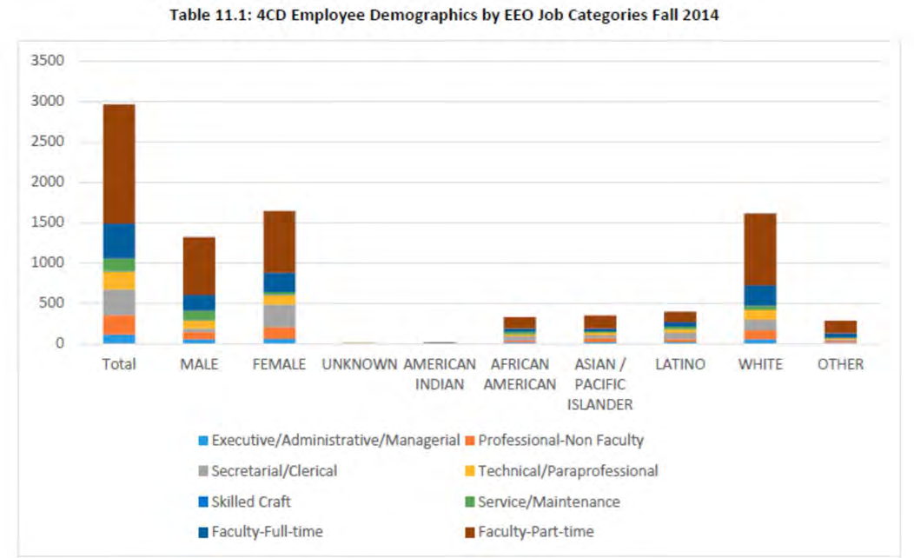

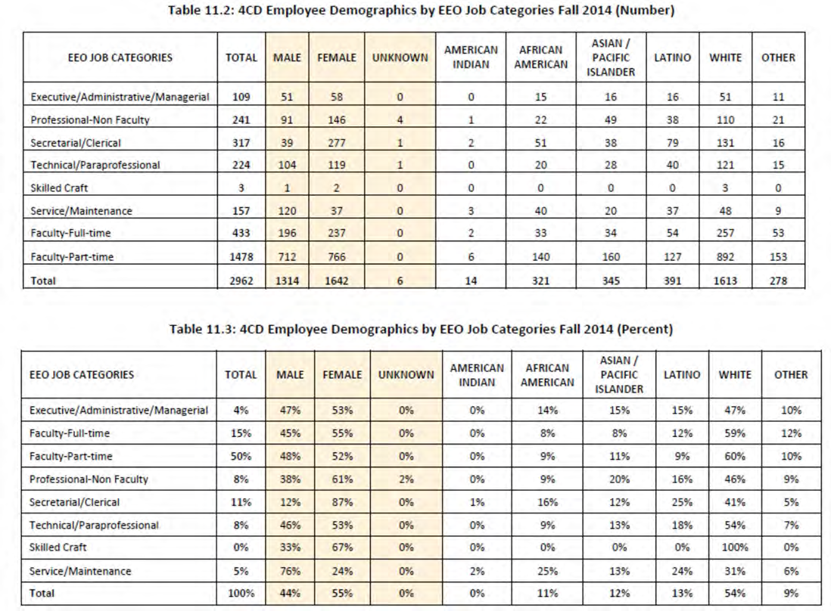

Contra Costa County is home to a population that includes 46% White, 25% Latino, 15% Asian, and 9% African American residents. The District’s student population includes 31% Whites, 30% Latinos, 16% Asian/Pacific Islanders and 11% African Americans.
Based on the data from Table 11.4, Latinos are significantly underrepresented in all employment categories except for classified hourly in comparison to student and county demographics. African Americans are underrepresented in both full and part-time faculty positions in comparison to our student population. Asian/Pacific Islanders are significantly underrepresented in all faculty positions in comparison to both our student and county population. Employees who identify as Other are significantly underrepresented in every employment category, except full-time faculty, in comparison to our student population.

Table 11.4: 4CD Percentage of Each Employee Group Compared to Group’s Representation among Student Population and the Adult Population within the Community Served

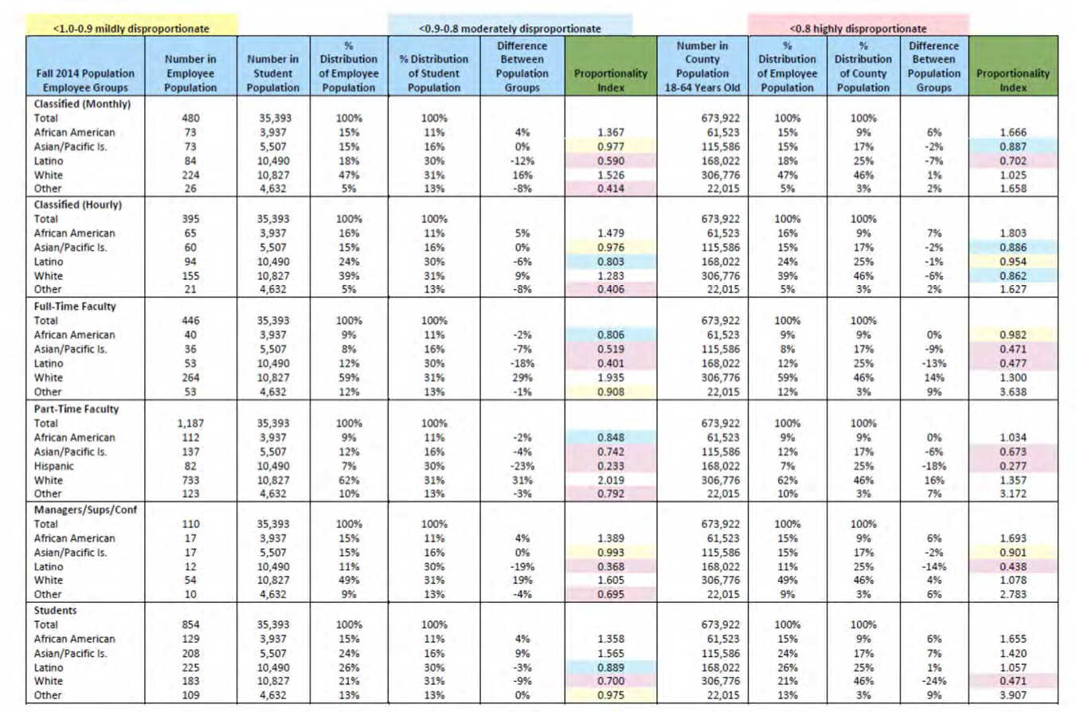

Table 11.5 provides information about applicant pools from 2012-2015 for all positions, except faculty and other instructional staff which is provided from 2013-2015. However it is inconsistent with our employee demographic data and makes it difficult to ascertain patterns or concerns with recruitment and hiring. In the future, the Plan will include more nuanced data on applications that includes better alignment with employee demographic data and number of recruitments conducted by the District.

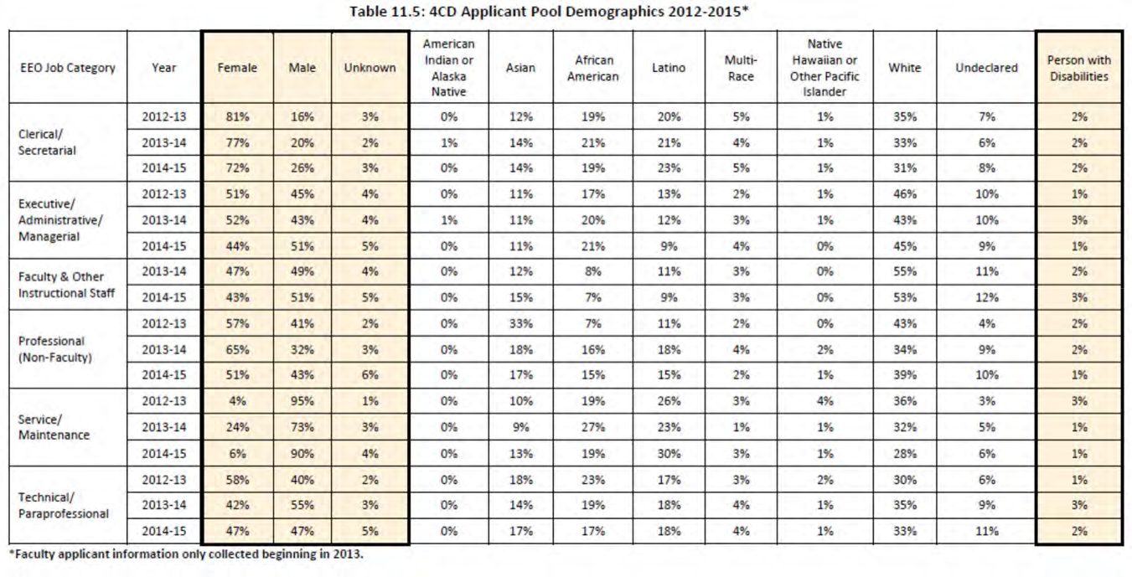
The overarching intent of this workforce and applicant pool analysis is to identify underrepresented populations in our recruitment, hiring and employment within the District. The current configuration and availability of demographic data makes it difficult to fully analyze and determine the full scope of underrepresentation and identify if, and how, the District should revise its recruitment and hiring policies and procedures. The District acknowledges that employee demographics may never keep pace with student demographics; however, the District is committed to hiring through a lens of diversity, recognizing the changing demographics of our student population. The District will develop a plan for improving our research protocols and a method of analyzing underrepresentation in order to determine priorities for improvement

RECRUITMENT AND HIRING PROCEDURES TO ENSURE EQUAL EMPLOYMENT OPPORTUNITY

Reference: Title 5, §§ 53021, 53022, 53023 and 53024
The District will ensure equal employment opportunity, which involves creating an environment that fosters cooperation, acceptance, democracy, and free expression of ideas, and that is welcoming to men and women, persons with disabilities, and individuals from all ethnic and other groups that are protected from discrimination. In so doing, the District places great emphasis on the recruitment of potential applicants in order to create a diverse pool of qualified individuals from which to hire.
With a diverse pool, the District takes steps within the screening/selection process to allow for the hiring of candidates with varied backgrounds who can contribute and effectively communicate in a diverse community. The equal employment opportunity provisions below are applicable to all full- time and part-time hiring, including any hiring meant to address the ratio of full-time to part-time faculty that may be required by Education Code Section 87482. 6.

Except as otherwise provided in Title 5, Section 53021, the District will actively recruit from both within and outside the District workforce to attract qualified applicants for all vacancies. This shall include outreach designed to ensure that all persons are provided the opportunity to seek employment with the District. The requirement of open recruitment shall apply to all full-time and part-time vacancies in all job categories and classifications, including, but not limited to, faculty, classified employees, categorically funded positions, and all executive/administrative/managerial positions. Recruitment for full-time faculty and educational administrator positions shall be at least statewide and, at a minimum, shall include seeking qualified applicants listed in the California Community Colleges Equal Employment Opportunity Registry and posting job announcements with the Registry. Recruitment for part-time faculty positions may be conducted separately for each vacancy or by annually establishing a pool of eligible candidates, but in either case full and open recruitment is required consistent with this Plan.

“In-house or promotional only” recruitment shall not be used to fill any vacancy for any position described above except when the position is being filled on an interim basis for the minimum time necessary to allow for full and open recruitment; provided however, that no interim appointment or series of interim appointments exceeds two years in duration. Where in-house or promotional only recruitment is utilized to fill a position on an interim basis, all District employees shall be afforded the opportunity to apply and demonstrate that they are qualified. The job announcement for the interim position shall comply with the requirements set forth in this Plan and the selection process will be consistent with the requirements of this section of the Plan.

For the purposes of this section of the Plan, a vacancy is not created, and the requirements of the above do not apply, when:

  - there is a reorganization that does not result in a net increase in the number of employees;

  - one or more lateral transfers are made and there is no net increase in the number of employees;
  - a position which is currently occupied by an incumbent is upgraded, reclassified, or renamed without significantly altering the duties being performed by the individual;
  - the faculty in a division or department elect one faculty member to serve as a chairperson for a prescribed limited term;
  - the position is filled by a temporary, short-term, or substitute employee appointed pursuant to Education Code;
  - a part-time faculty member is assigned to teach the same or fewer hours he or she has previously taught in the same discipline without a substantial break in service. For purposes of this section of the Plan, “a substantial break in service” means more than one calendar year of such different period as may be defined by a collective bargaining agreement; or
  - an individual not currently employed by the District, who is specifically training, experienced, and competent to serve as an administrator, and who satisfies the minimum qualifications applicable to the position, is engaged to serve as an administrator through a professional services contract. No appointment or series of appointments pursuant to this provision may exceed a period of two years.

To address any identified underrepresentation of monitored groups, the District will review, and, if necessary, revise its recruitment and hiring procedures and policies in accordance with the following provisions. These provisions will be in place henceforth, whether or not underrepresentation exists, because the provisions are also valuable in ensuring equal employment opportunity.

- Recruitment
It is the policy of the District to aggressively pursue a program of verifiable recruitment that is inclusive and open to all individuals. Efforts will be undertaken on a regular basis to develop and contact new recruitment sources that ensure diverse pools of candidates. Diverse pools should include, but not be limited to, men, women, persons with disabilities, and individuals from all ethnic and other groups protected from discrimination. College Equal Employment Opportunity Advisory Committees are encouraged to utilize and notify the District of additional recruitment options that may enable the District to obtain a diverse pool of applicants. All recruitment announcements will state that the District is an “Equal Opportunity Employer.” The District will include in the recruitment section of its recruitment and hiring procedures the following provisions.

  - For any job category where continuing underrepresentation exists, the District will apply the recruitment procedures set forth in Title 5, Section 53021 to conduct full and open recruitment for all new openings and will not invoke the provisions for in-house interim appointments or the exception under Title 5, Section 53021(c)(7) for engaging an administrator through a professional services contract unless the Chancellor or his/her designee first notifies the Governing Board in writing of the compelling reason to limit the persons who may be considered for a vacancy in a job category where underrepresentation persists.

  - Open positions that require recruitment shall include, but not be limited to, placement of job announcements in the following instruments:

    - general circulation publications and/or electronic media;
    - local and regional community newspapers and/or electronic media;
    - publications and/or electronic media in languages other than English and to low-income communities;
    - publications, including electronic media that are distributed to the general market and to newspapers and/or electronic media, publications whose primary audience is comprised of groups found to be underrepresented in the District’s workforce; and
    - recruitment booths at job fairs or conferences oriented to the general market and the economically disadvantaged as well as those events drawing significant participation by groups found to be underrepresented in the District’s workforce.

  - The District may host an open house for persons interested in employment with the District. The open house will allow potential candidates the opportunity to meet deans, division chairs, faculty, and classified employees of the District. Attendees will be provided with information regarding current job vacancies, the demographic makeup of the student body, hiring criteria and procedures, and information on the District’s commitment to equal employment opportunity and diversity. Efforts will be made to attract diverse groups of individuals to the open house.

  - District employees may be surveyed on a regular basis requesting resources and locations where open positions may be advertised to ensure recruitment is as inclusive and broad as possible and includes recruitment of monitored groups. The District Human Resources Office will compile, store, and update this list.

- Job Announcements
The District’s recruitment and hiring procedures section on job announcements, outlined in the Contra Costa Community College District Uniform Employment Selection Guide, shall include the following provisions.

  - Job announcements will state clearly job specifications setting forth the knowledge, skills, and abilities necessary to job performance. For faculty and administrative positions, job requirements will include demonstrated sensitivity to and understanding of the diverse academic, socioeconomic, cultural, disability, gender identity, sexual orientation, and ethnic backgrounds of community college students. Job specifications, including any “required,” “desired,” or “preferred” qualifications beyond the state minimum qualifications which the District wishes to utilize, will be reviewed by the equal employment opportunity officer or designee before the position is announced, to ensure conformity with equal employment regulations and state and federal

nondiscrimination laws. All job announcements shall state that the District is an “Equal Opportunity Employer.”

  - For identified public contact or community liaison positions, bilingual ability in the language spoken by a significant number of students may be a required qualification. Before bilingual ability in the identified languages can be made a required qualification, District Human Resources will conduct an analysis to ensure that such a requirement meets the standard for a bona fide occupational requirement. The District will identify the specific positions that may require bilingual ability and the language(s) needed and in which positions bilingual ability in a particular language may be listed as a required, preferred, or desired qualification.

- Review of Initial and Qualified Applicant Pools
Applicant pools will be reviewed by the chief human resources officer or designee for compliance with Title 5 and other applicable regulations. The District’s recruitment and hiring procedures, outlined in the Contra Costa Community College District Uniform Employment Selection Guide, will include the following provisions.

  - Application: The application for employment will afford each applicant an opportunity to voluntarily identify his or her gender, ethnic group and, if applicable, his or her disability. This information shall be kept confidential and shall be used only in research, monitoring, evaluating the effectiveness of the District’s equal employment opportunity program, or any other purpose specifically authorized by Title 5, Section 53023, or by any applicable statute or regulation.

  - Initial Applicant Pool: The initial applicant pool is composed of all complete applications received by the application deadline. After the application deadline has passed, the composition of the initial applicant pool shall be recorded and reviewed by the chief human resources officer or designee. All initial applications shall be screened to determine which candidates satisfy the job specification’s minimum qualifications set forth in the job announcement. The group of candidates who meet the job specification’s minimum qualifications shall constitute the “qualified applicant pool.”

  - Qualified Applicant Pool: The composition of the qualified applicant pool shall be reviewed and compared to the composition of the initial applicant pool. If the chief human resources officer or designee finds that the composition of the qualified
applicant pool may have been influenced by factors that are not job related, appropriate action will be taken. This applicant pool data shall be reviewed in conducting the analysis described Title 5, Section 53006(a). Once the qualified applicant pool is approved, the pool will be forwarded to the screening/selection committees for paper screening, interviews, and final recommendations for hiring consideration.

- Screening/Selection Committees Procedures
The District seeks to employ qualified persons with a broad range of backgrounds and abilities who have the knowledge and experience to work effectively in a diverse environment. The selection process is based on merit, and will extend to all candidates a fair, impartial examination of qualifications based on job-related criteria. The District’s recruitment and hiring procedures will include in its section on applicant screening by screening/selection committees the following provisions.

  - All screening or selection techniques, including the procedure for developing interview questions, and the selection process as a whole, will be:

    - designed to ensure that, for all positions, meaningful consideration is given to the extent to which applicants demonstrate a sensitivity to and understanding of the diverse academic, socioeconomic, cultural, disability, gender identity, sexual orientation, and ethnic backgrounds of community college students. “Meaningful consideration” means that candidates shall be required to demonstrate sensitivity to diversity in ways relevant to the specific position;
    - based solely on job-related criteria; and
    - designed to avoid an adverse impact, as defined in Title 5, Section 53001(a), and monitored by means consistent with this section of the Plan to detect and address adverse impact which does occur for any monitored group.

  - When possible, effort will be made, within the limits allowed by federal and state law, to ensure selection/screening committees include a diverse membership, which will bring a variety of perspectives to the assessment of applicant qualifications.
Selection/screening committees will be encouraged to include members from monitored groups.

  - Before a person can serve on a selection/screening committee, he or she must receive equal employment opportunity and diversity training as outlined in Section 9 of this Plan and Title 5, Section 53003 (c)(4).

  - At every level, interviews must include a question which assesses the candidate’s understanding of and demonstrated commitment to diversity, and his or her level of cultural proficiency. Reference checks shall also include one question assessing the candidate’s understanding of and demonstrated commitment to diversity, and his or her level of cultural proficiency.

  - Screening materials must be approved for compliance with equal employment opportunity principles.

  - The District will not designate or set aside particular positions to be filled by members of any group defined in terms of ethnic group identification, race, color, ancestry, national

origin, age, sex, religion, sexual orientation, marital status, disability, or medical condition, or engage in any other practice, which would result in discriminatory or preferential treatment prohibited by state or federal law. The District will not apply the Plan in a rigid manner that has the purpose or effect of so discriminating.

  - The District shall ensure that seniority or length of service is taken into consideration only to the extent it is job-related, is not the sole criterion, and is included in the job announcement consistent with the requirements of this Plan, Section 12, (see Title 5, §§ 53022 and 53024(c)).

  - Selection testing for employees will follow procedures as outlined in the Equal Employment Opportunity Commission’s “Uniform Guidelines on Employee Selection Procedures.”

  - The Governing Board or its designee shall make all final hiring decisions based upon careful review of the candidate or candidates recommended through the screening/selection committees. This includes the right to reject all candidates and to order further review or to reopen the position where necessary to achieve the objectives of the plan or to ensure equal employment opportunity.

  - The District will review the pattern of its hiring decisions over time, and if it determines that those patterns do not meet the objectives of the Plan, the District will request the Equal Employment Opportunity Advisory Committee to recommend new methods to meet the Plan objectives, or if necessary, to modify the Plan itself to ensure equal employment opportunity.

ADDITIONAL MEASURES TO SUPPORT DIVERSITY AND ENSURE EQUAL EMPLOYMENT OPPORTUNITY

Reference: Title 5, § 53006
- The District shall review the information gathered pursuant to Title 5, Section 53003, subdivision (c)(6) to determine if significant underrepresentation of a monitored group may be the result of non-job related factors in the employment process. For these purposes, the phases of the employment process include, but are not limited to, recruitment, hiring, retention and promotion. The information to be reviewed shall include, but not be limited to:

  - longitudinal analysis of data gathered regarding job applicants, to identify whether over multiple job searches, a monitored group is disproportionately failing to move from the initial applicant pool to the qualified applicant pool, and at each subsequent phase of the selection process;

  - analysis of data regarding potential job applicants, to the extent provided by the State Chancellor, which may indicate significant underrepresentation of a monitored group; and

  - analysis to determine whether the group is significantly underrepresented.

- Where the review described above identifies that significant underrepresentation of a monitored group may be the result of non-job related factors in the employment process, the District shall implement additional measures designed to address the specific areas of concern. These additional measures shall include the following.

  - The District will request that the Equal Employment Opportunity Advisory Committee, in conjunction with appropriate Human Resources staff, review the District’s recruitment procedures and make recommendations on modifications that would address the underrepresentation.

  - Review of locally established “required,” “desired,” or “preferred” qualification being used to screen applicants for positions in the job category to determine if it is job- related and consistent with:
    - any requirement of federal law; and
    - qualifications which the Board of Governors has found to be job-related through the community college system, including the requirement that applicants for academic and administrative positions demonstrate sensitivity to the diversity of community college students.

  - Discontinue the use of any locally established qualification that is not found to satisfy the requirements set forth in the previous paragraph and continue using qualification

standards meeting the requirements in the previous paragraph only where no alternative qualification standard is reasonably available which would select for the same characteristics, meet the requirements of the previous paragraph, and be expected to have a less exclusionary effect.

  - Consider the implementation of additional measures designed to promote diversity that are reasonably calculated to address the specific areas of need.

OTHER MEASURES NECESSARY TO FURTHER EQUAL EMPLOYMENT OPPORTUNITY

Reference: Title 5, § 53003(c)(9)

The District recognizes that multiple approaches are appropriate to fulfill its mission of ensuring equal employment opportunity and the creation of a diverse workforce. Equal employment opportunity means that all qualified individuals have a full and fair opportunity to compete for hiring and promotion and to enjoy the benefits of employment with the District. Equal employment opportunity should exist at all levels and in all job categories. Ensuring equal employment opportunity also involves creating an environment that fosters cooperation, acceptance, democracy, and free expression of ideas and is welcoming to men and women, persons with disabilities, and individuals from all ethnic and other groups protected from discrimination.

Having a District that has accepted principles of diversity and inclusion makes implementation and maintenance of an effective equal employment opportunity program much easier. For that reason, institutionalizing this program that is well-planned, well-funded and supported by the leadership of the District is of great value.

The District will promote learning opportunities and personal growth in the area of diversity and evaluate how the physical environment can be responsive to its diverse employee and student populations. The District may sponsor cultural events and speakers on issues dealing with diversity, and explore how to infuse diversity into the classroom, curriculum, and the workplace. The District shall exercise continuous good faith efforts to maintain, develop or improve its equal employment opportunity efforts by implementing a program which may include, but not limited to the following.

  - Commit to a formal diversity program that is part of the structure of the District and that will be adequately funded and supported by the District and college leadership.

  - Conduct site-specific climate studies to identify hidden barriers.

  - Include guest speakers from underrepresented groups who are in leadership positions and who may inspire students and employees alike.

  - Highlight the District’s equal employment opportunity and diversity policies in job announcements and in its recruitment, marketing, and other publications. Include in job announcements language indicating that candidates are required to demonstrate that they can infuse diversity into their major job duties.

  - Conduct diversity and implicit bias dialogues, forums, and cross-cultural workshops.

  - Work with the Human Resources and the District and college professional development committees to assist in the development of resources for employees interested in infusing diversity and inclusion into their instruction or services to students.

  - Review and revise college/District publications and other marketing tools to reflect diversity in pictures, graphics, and text to project an inclusive image.

  - Recognize and value staff and faculty who have promoted diversity and equal employment opportunity principles by awarding a yearly diversity recognition award.

  - Require a series of EEO/diversity workshops to be offered on instructional improvement days (flex week or staff development days).

  - Evaluate administrators yearly on their ability and efforts to meet the District’s equal employment opportunity and diversity effort.

  - Establish an “Equal Employment Opportunity and Diversity” online presence by highlighting the District’s diversity and equal employment opportunity, Americans with Disabilities Act (ADA), sexual harassment and nondiscrimination policies, procedures and programs on the District’s website. The website will also list contact persons for further information on all these topics.

  - Promote sabbaticals that will assist the District in achieving its equal employment opportunity and diversity objectives.

  - Promote various cultural celebrations at all locations.

  - Recognize multilingualism and knowledge of multiculturalism as a desired, and when appropriate, required skill and qualification for employees.

  - Have formal diversity and inclusion programs that are visible, valued and adequately funded.

  - Consider providing for alternative educational or experience requirements for nonacademic positions.

  - Develop leadership opportunities with current staff focusing on diversity.

  - Ensure involvement of community members and community-based organizations in the recruitment and other equal employment opportunity efforts of the colleges and District Office.

  - Ensure that top administrative staff support diversity objectives and that the diversity and/or equal employment opportunity officer position is maintained as a Cabinet or other high-level administrative position.

  - Seek direct contact with student, professional, community and other organizations that represent the diverse community we serve. These organizations can serve as resources for referring potential candidates.

  - Regularly review and disseminate research on best practices in diversity, recognizing and managing implicit bias, and equal employment opportunity.

  - Maintain an institutional commitment to diversity.

MAINTAINING INSTITUTIONAL COMMITMENT TO DIVERSITY

Reference: Title 5, § 53024.1

Pursuant to Board Policy 2059, Diversity, the District is committed to the integration of diversity into its recruitment, hiring, promotion, curriculum development, course offerings, teaching methods, employee/student retention, contracting, supervision, programs, services, evaluations, policies and procedures, staff development activities, workforce and student population. It is the District’s belief that educational experience grounded in this approach will better prepare our students and employees to work and live in an increasingly global society. The Chancellor, college Presidents, and the chief human resources officer shall ensure the following:

- modification of current, and inclusion of, new policies and procedures that ensure implementation of Board Policy 2059;

- systematic training for all employees on the value of diversity, educational equity, equal opportunity, and how to infuse the principles of diversity in their daily work in accordance with state law and collective bargaining agreements; and

- annual reporting to the Board on 1) training programs offered for employees; 2) student, employee, and service area ethnic demographics; and 3) modification of and updates to policies and procedures on diversity.

The District also recognizes that establishing and maintaining a richly diverse workforce is an on- going process that requires continued institutionalized effort. The District will develop and implement, on a continuing basis, indicators of institutional commitment to diversity. Such indicators may include, but are not limited to the examples listed in this section of the Plan:

  - conducting surveys of campus climate on a regular basis, and implementing concrete measures that utilize the information drawn from the surveys;

  - conducting exit interviews with employees who voluntarily leave the District, maintaining a database of exit interviews, analyzing the data for patterns impacting particular monitored groups, and implementing concrete measures that utilize this information;

  - providing training on elimination of bias in hiring and employment;

  - providing cultural awareness training to members of the District and/or college communities;

  - maintaining a variety of programs to support newly-hired employees such as mentoring, professional development, and leadership opportunities;

  - auditing and/or maintaining updated job descriptions and/or job announcements;

  - training the Governing Board on the elimination of bias in hiring and employment at least once every election cycle;

  - conducting timely and thorough investigations of all EEO complaints and all harassment and discrimination complaints filed under Subchapter 5 (commencing with Section 59300) of Chapter 10, Division 6, Title 5 of the California Code of Regulations, and takes appropriate corrective action in all instances where a violation is found;

  - complying with the requirements of Government Code, Section 12950.1 (Stats. 2004, ch. 933 [AB1825]), including all forms of harassment and discrimination in the training;

  - ensuring the District’s publications and website convey its diversity and commitment to equal employment opportunity;

  - ensuring the District’s hiring procedures require applicants for all positions to demonstrate sensitivity to and understanding of the diverse academic, socioeconomic, cultural, disability, gender identity, sexual orientation, and ethnic backgrounds of community college students in a manner specific to the position;

  - encouraging District staff members to serve as resources, consultants, mentors and/or leaders to colleagues at other districts in the areas of EEO and diversity enhancement;

  - maintaining updated curricula, texts, and/or course descriptions to expand the global perspective of the particular course, readings or discipline;

  - addressing issues of inclusion/exclusion in a transparent and collaborative fashion;

  - attempting to gather information from applicants who decline job offers to find out why, recording this information, and utilizing it;

  - conducting longitudinal analysis of various employment events by monitored group status such as: hiring, promotion, retention, voluntary resignation, termination, and discipline;

  - encouraging community college students to become qualified for, and seek employment as, community college employees; and

  - informing graduate students in local colleges and universities about the benefits of employment at a community college.

  - Identifying and adopting objective measures of success and periodically evaluating the EEO Plan and its components against them.

ACCOUNTABILITY AND CORRECTIVE ACTION

Reference: Title 5, § 53024.2

The District shall certify annually to the State Chancellor that they have timely complied with all of the following:

  - recorded, reviewed and reported the data required regarding qualified applicant pools;
  - reviewed and updated, as needed, the strategies component of the District’s EEO Plan; and
  - investigated and appropriately responded to formal harassment or discrimination complaints filed pursuant to Subchapter 5 (commencing with section 59300) of Chapter 10, Division 6, Title 5 of the California Code of Regulations.

Upon review of the District’s certification, data reports, or any complaint filed under this subchapter, the State Chancellor may review the District’s EEO Plan and strategies component pursuant to Title 5, Section 53024.1 for the required indicia of institutionalized and on-going efforts to support diversity and/or compliance with Title 5, Section 53006. Where the State Chancellor finds that the District’s efforts have been insufficient, he/she will inform the District of his/her specific area(s) of concern, and direct the District to submit a revised EEO Plan within 120 days.
Upon review of the revised EEO Plan, the State Chancellor will either:

- determine the revisions are sufficient, and provide a deadline by which the District must provide proof that the new measures have been implemented; or
- if the State Chancellor finds that the revised Plan is still lacking, he/she will direct the District to implement specific measures from those listed in Title 5, Section 53024.1, and provide a timeline for doing so.

PERSONS WITH DISABILITIES

Reference: Title 5, § 53025

Applicants and employees with disabilities shall receive reasonable accommodations consistent with the requirements of Government Code, Sections 11135 et seq. and 12940(m); Section 504 of the Rehabilitation Act of 1973; and the Americans with Disabilities Act. Such accommodations may include, but are not limited to, job site modifications, job restructuring, part-time work schedules, flexible scheduling, and auxiliary aids such as readers, interpreters and note-takers.

The college or District Human Resources offices are responsible for handling requests for accommodations from current employees. The District Human Resources Office is responsible for handling requests from applicants seeking such accommodations during the application process. Requests can be made on the “Request for Reasonable Accommodations” form. The District’s reasonable accommodation procedures can be found in Human Resources Procedure 1080.04 for job applicants and Human Resources Procedure 1080.05 for employees.

