The California Report

Homeless U: A College Student’s Life Without Shelter
By Brittany Hosea-Small and Laura Klivans December 8, 2016
“Most people don’t think that if you’re in college that you could possibly be homeless,” says social work professor Rashida Crutchfield of California State Long Beach. But her research has uncovered a troubling world where students struggle to survive both in and out of the classroom.
A study conducted by Cal State University revealed nearly one in 10 students in that system is homeless or teetering on the brink of homelessness. A similar study conducted at the community college level found this number to be almost one in three students.
Experts say the homeless undergraduate population is largely invisible: They often look just like the average student. To put a face on the issue, we followed a Laney College student, 24-year-old Brittany Jones, as she navigates the streets, classrooms and “safe spaces” that make up her world.
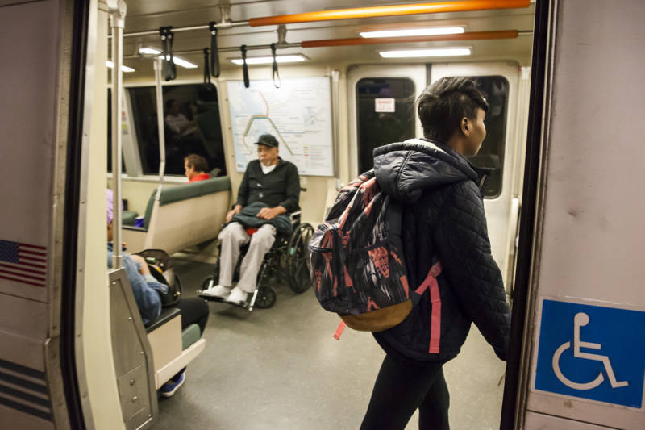
Brittany Jones boards a train on her way to her storage unit in West Oakland. “I know BART like the back of my hand,” she says. She spends several hours a day on BART getting around, or just spending time there as a way to rest.

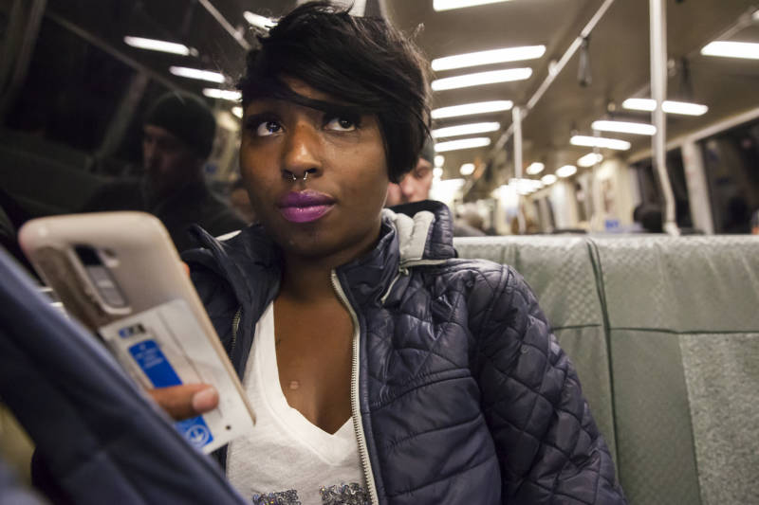
Riding the train, Brittany Jones looks for jobs on Craigslist on her phone. She’s currently unemployed, but in the past she’s worked in overnight security or as a grocery stocker. She wants something similar now. In the meantime, some state grants through the school help her get by.
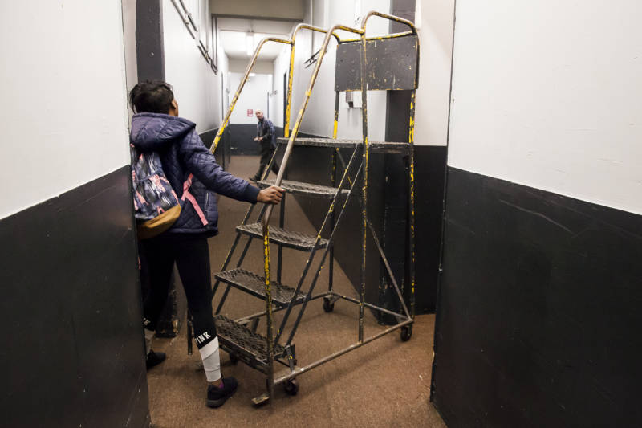
Brittany Jones’ life is a fine dance of details and logistics: Will she have enough money for dinner tonight? Will she be able to sneak into the seat next to the secret power outlet on BART to charge her phone? Will she find a free set of metal stairs so she can access her upper-level storage locker?

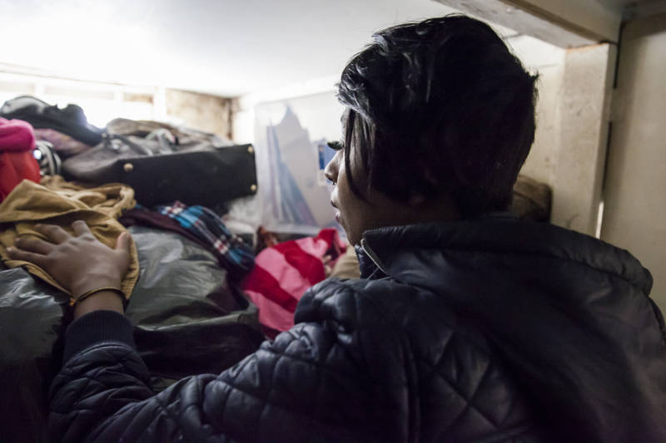
Brittany Jones’ storage locker is one of her few “safe spaces.” She spends up to three hours a day here, organizing her things, doing homework and writing in her journal. Her most significant possessions are in here, including a picture of her mother, who passed away when Jones was just 5 years old.

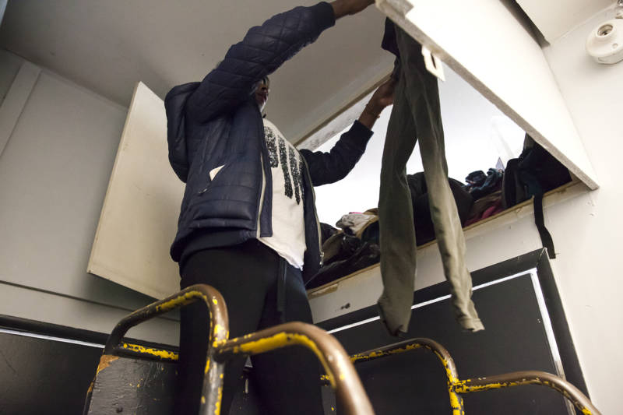
Brittany Jones prepares her bag for the next 24 hours. “I take a pair of clothes I’m going to change into, a pair of underclothes,” she says. She even carries small containers of laundry detergent. “I’m on the go, so everything is on the go,” she says.

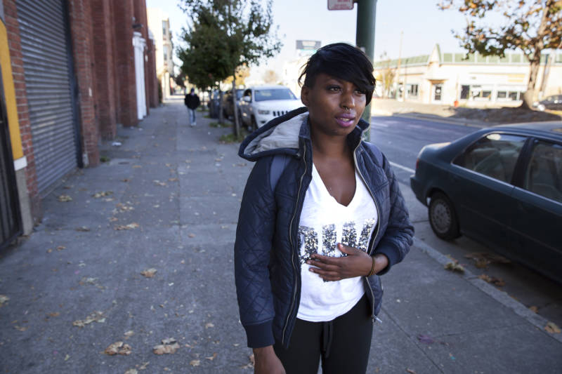
Brittany Jones’ parents both passed away when she was a child. Since then, she’s bounced between foster homes and the houses of friends and relatives. She’s close to counselors at school and select friends and family members. Largely, though, she draws on inner strength. “I just try to be my own support system, be my own encouragement,” she says.

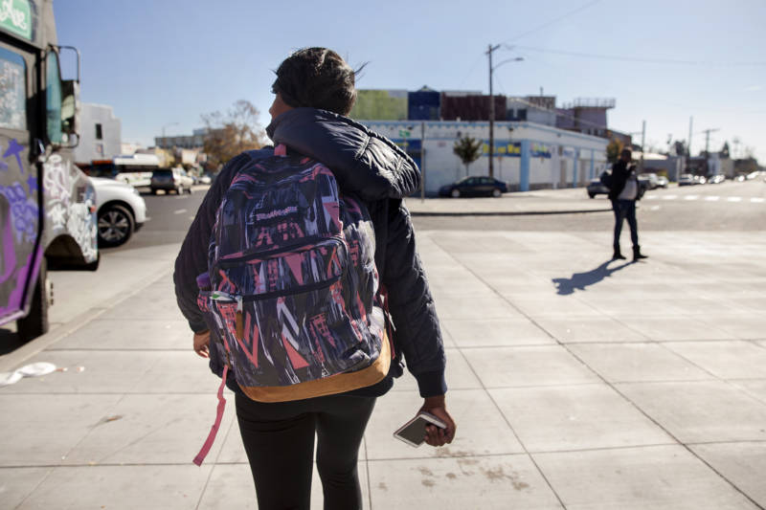
Since Brittany Jones aged out of the foster care system five years ago, she’s largely been homeless. She lost her most recent spot in a group home a year ago when she violated a policy, letting in a guest when she wasn’t supposed to.

Since losing her own housing, Brittany Jones relies on others to offer her a place to stay each night. She texts friends during the day, but never asks outright if she can spend the night. She doesn’t want to impose. Eventually, one of Jones’ friends replies and asks if Jones is coming to meet her — a coded invitation.
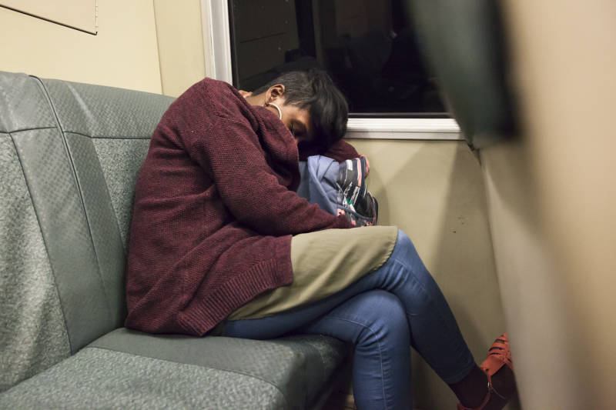
Back on BART, Brittany Jones heads to Richmond, where she’ll meet up with her friend. She takes a rest in a familiar place on the train. On nights when she isn’t staying inside anywhere, she’ll stay awake in a 24-hour restaurant or ride San Francisco’s all-night buses before she boards the earliest BART train of the day, sleeping until the rush-hour crowd arrives.

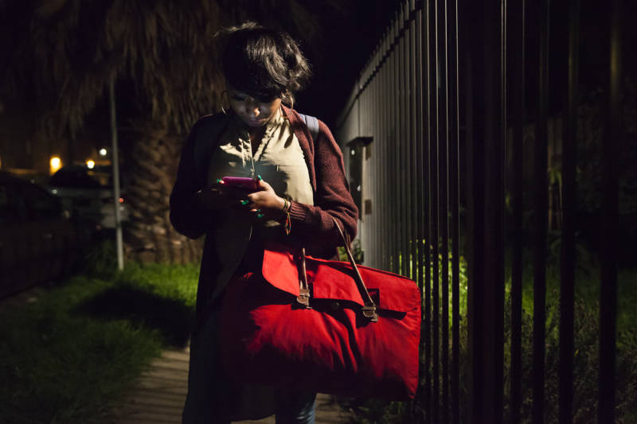
Brittany Jones checks in with her friend as she makes her way over. Her bright red bag is full of clothes, toiletries, homework and more.

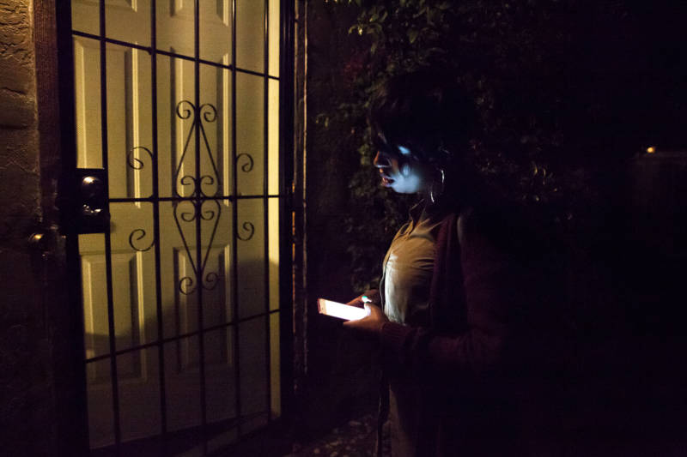
Brittany Jones meets her friend in Richmond. Tonight she’ll sleep on the floor of her friend’s bedroom.

