9-28-2015

Dear LMC Senators:

Hello! Per your request from the September 2015 Meeting, I have attached a copy of the Senate/Administration agreed upon "Budget" for the 2015-2016 academic year. Please note the following attachments:

**A: Board Policy 18.04**

**B: Human Resource Procedure 2090.07**

Please note, **prior** to Fall 2015, the Senate 100% Salary Leadership Allocation was as follows:

A: 60% (President)

B: 25% (Curriculum Chair)

C: 15% (Vice President)

When the District decided to **mandate** that all Senate President's be given **100% Reassigned Time** at all three colleges, 40% of the allocation from the Leadership Allocation, now had to be taken from the Senate Discretionary Budget. As a result of this, I was asked by the Senate to approach President Kratochvil and work out a plan for the 2015-2016 year. **I did as requested!** Also, during my first semester as President,  I was also strongly asked to encourage the administration to increase the Curriculum Chair's Reassigned Time from .25 to .40. **I followed this request exactly as instructed**.Moreover,  when I became President, our Clerical Assistant was only being compensated for four hours per week. This was increased to 8 hours per week**, based on Senate Office needs. Additionally, the Senate had agreed to pay $5,000.00 per semester for a Senate Secretary, while compensating a Recording Secretary.** Dealing with many conversations around these patterns encouraged the "Senate Leadership Team",  to desire more Budget Clarity. As a result of some to these agreements and request, along with the  loss of the 40% Leadership Faculty Allocation, the Senate now had a deficit, which compelled  all  operational expenses to come from the **Discretionary Budget**. Yes, the Senate was allocated $5,000. 00 more dollars from the district. However, we were still at a deficit due to earlier mentioned realities. I carefully spoke with Dr. Kratochvil about these concern and he kindly agreed  to assist our efforts so that we could operate and the 2015-2015 Budget could remain workable.We were encouraged to settle our **Secretary conflict** (Senate Secretary vs Recording Secretary), as we could only fund one position. Please review the email from Dr. Kratochvil:

**Email Sent: May 14, 2015**

**From:** Olatunji, Aderonke  
**Sent:** Thursday, May 14, 2015 2:49 PM  
**To:** Henderson, Silvester  
**Cc:** Kratochvil, Bob  
**Subject:** Feedback from President about 2015/2016 Academic Senate Budget Proposal

Hi Silvester,

Congratulations! For 2015/16, the President has agreed to fund your Office Assistant position at its current FTE- .20 (or 8 hours/week). This will provide you with an additional $5,828, towards your operating budget. Please keep in mind that your bottom line (previously estimated at -$6,143) will still be slightly over (new estimated bottom line will be about -$315). Please make every attempt reduce this amount to $0.

Please let me know if you have any questions.

Regards,

Ronke Olatunji

Director of Business Services

Los Medanos College

**(925) 473-7341 (New Number)**

The President has been extremely kind and helpful. I am grateful that he assisted the Senate so that we could operate, while the By Law Committee helped the Senate revise some of our concerns. Dr. Kratochvil as well as Director Olatunji were very supportive and extremely helpful. I appreciate both of them.

                                                                           Cordially,

                                                                                Silvester.

**Please note the following numbers came from the District as of 9-16-2015.**

       **Actual Allocated District Senate Budget:**  
  
                                                     **$34,195.50**  
                                                     - $2,142.80 (ASCCC Dues/Mandated)  
                                                     - $5,115.00 (Honorarium/Business Procedure 18.04)  
  
  
Operating Budget Minus Mandated Expenses:  
  
                                                    **$26,937.20**

**Agreed Upon Estimated Itemized Discretionary Budget Below (2015 - 2016)**

**From:** Olatunji, Aderonke   
**Sent:** Tuesday, April 07, 2015 2:59 PM  
**To:** Kratochvil, Bob  
**Cc:** Henderson, Silvester  
**Subject:** Discuss about 2015/2016 Academic Senate Budget Proposal

Hi Bob,

I met with Silvester and put together the below **1st draft (for discussion purposes only) idea** of the Academic Senate’s anticipated expenses/budget for 2015/16. This was just based on his thoughts but it has not been discussed with anyone else, yet. He will be discussing the budget with the Senate Council on April 22nd.

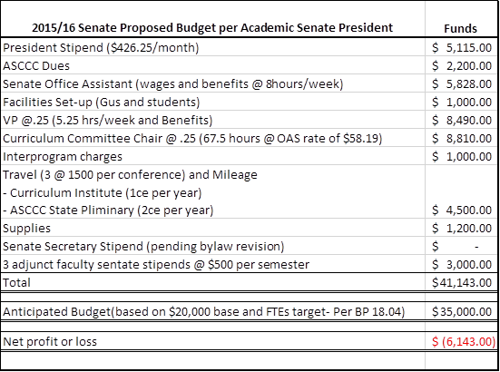

**He is short about $8,839, and has come up with a proposal for you to take on an additional $5,802:**

-              Additional .05% of curriculum committee wages which equals about 13.5 hours per semester (total amount of $2,302)

-              Travel expenses of approximately $3,500

He will then apply through the College for other Travel/Conference funding sources (PDAC, Equity etc.). Doing this will make the budget balanced for 2015/16.

Regards,

Ronke Olatunji

Director of Business Services

Los Medanos College

**(925) 473-7341 (New Number)**