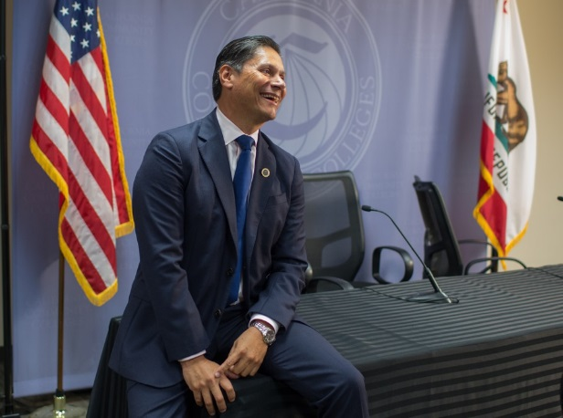
A Social-Justice Agenda for Community Colleges
Eloy Oakley sees expanding access to traditionally underserved communities as an economic imperative for the state and nation.

LONG BEACH, Calif.—Eloy Oakley isn’t shy about his plans to be much more “proactive” than previous chancellors when he takes over California’s mammoth community-college system in December.
“We’re going to take on a much more aggressive agenda with a clear lens on social justice and equity,” Oakley, who is in his final weeks as head of the Long Beach Community College District, told me during an interview at his office on the Long Beach City College campus.
Oakley, who is himself a product of the system and a first-generation college student who grew up in a family where higher education was not the expectation, is under no illusion that California’s community colleges alone can close the racial and socioeconomic educational attainment gaps that plague the state. But Oakley, who will be the first Latino to hold the position, wants California’s 113 community colleges to see eliminating the inequity and opportunity disparities that create those divides as part of their shared responsibility.
“I don’t think there is a greater equalizer than California community colleges in terms of the ability to take someone from a community where college hasn’t even been thought of and transform that individual and give them the opportunity to create a family that now thinks about college as an expectation,” he said.
And where some other higher-education leaders, particularly at the baccalaureate level, have been reluctant to characterize their work in economic terms, Oakley is intent on spreading the message that community colleges are a crucial driver of the state’s economic growth. “California is not going to prosper like it once did unless we have more people participating in and getting a credential from higher-ed institutions,” he said.
Oakley, who will actually take a slight pay cut with the new role, is particularly optimistic about the prospect of getting not only more Californians, but also a more diverse array of Californians, into postsecondary schools, and it was a driving reason for accepting the position. While about 43 percent of the state’s community-college students are Latino, and they make up approximately 39 percent of the state’s residents, degree completion is low. Only around 16 percent of Latinos over 25 in California have an associate’s degree or higher, compared with about 38 percent of adults in the state. When I asked why he wanted the job, Oakley said, “This is a very interesting time for our state, for our colleges, and for our nation … I feel that our colleges are poised to really have a major impact on the future of California, and at no point in time in my career as a community-college educator have I felt that colleges are as important and as recognized as they are now.”
There are likely to be some challenges. Not everyone is thrilled with Oakley’s record at Long Beach. And he acknowledges that getting 113 college leaders to agree on how much the system should change in the coming years will be tricky, noting that the system has often responded to issues instead of anticipating them. The level of “engagement” will be “a point of discussion” among the colleges, he said, choosing his words carefully.
With that in mind, the chancellor-to-be plans to spend his first weeks in the role listening to community-college leaders, faculty, businesses, and economic-development organizations before he puts together a team to outline a new agenda. “The first priority, for me personally, is really to meet with and hear from the various constituent groups that not only make up the community-college system, but really rely on the California community-college system,” he said. “I want to take a moment to hear from everybody.”

Related Story

The Missing Piece in the Debate Over College Costs
That the system—which, at 2.1 million students, is the nation’s largest higher-education apparatus—touches so many facets of the state makes it an unwieldy behemoth to wrangle by nature. But that’s also why Oakley was tapped for the job in the first place. He has a history of forging the connections and links that he, and those who selected him for the job, see as crucial for success. He was one of the main developers of the nationally recognized Long Beach Promise, which guarantees local students a tuition-free year at the city college and preferred admission to California State University Long Beach. Oakley, who spends his limited spare time reading about politics and traveling (preferably “someplace with a beach and lots of sun”) with his partner, Terri, has also facilitated local partnerships with Goldman Sachs that helped small businesses launch and grow, in part by funding community-college students and graduates. California’s governor, Jerry Brown, appointed him to the University of California Board of Regents, and he has a solid working relationship with both the governor and Janet Napolitano, who heads the UC system.
Oakley hopes he can use that experience to make the path from high school to community college to either a four-year college or the workforce smoother for the state’s students, something he already devotes time to doing for his own four children, who range in age from the early teen years to adulthood. The community-college system is designed to educate “the top 100 percent of students,” he pointed out, regardless of how old they are or where they come from. It’s supposed to serve both as a pipeline to the California State University and University of California systems, and as a place for people to earn credentials or certificates that open doors immediately to jobs. It’s seen, where it works well, as a facilitator of community growth and business development. “I think [the system] gives us the greatest opportunity to impact our communities,” Oakley said.
Yet right now, not all of those things are happening around all of the state’s community colleges. Transfer rates to four-year universities remain low. The UC system boasts some of the best public universities in the nation, and, especially in times of tight budgets where interest from stellar students willing to pay out-of-state tuition is ample, convincing schools to invest in transfer students can be tricky. “I think my role [on the UC Board of Regents] has been to help the UC really look back downstream at the Californians it serves and see the California community colleges as an asset to serve more Californians,” he said. “And I think, for the most part, that’s been embraced … I think over the last eight years or so of recession and difficult budgets, I think we’ve lost some of that, but I think there’s been a huge embrace of changing that equation.”
"I think we’ve gotten lost in this conversation about what free college means."
The recession also forced community colleges to scale back course offerings, delaying graduation for some students and effectively forcing others out altogether. Some of the schools, including Oakley’s alma mater, Golden West College, have been mired in accreditation controversies. Not all have done a good job of working with local K-12 schools and businesses to create a smooth pipeline into the workforce for graduates, or of reaching out to unemployed adults who might benefit from more workforce training.
“We’re going to really work on continuing to build those pathways,” Oakley said of his role as chancellor. But, perhaps interestingly for a deeply blue state that is not necessarily averse to top-down approaches, he favors a bottom-up tactic. The state has some 23 college-promise initiatives right now, and Oakley isn’t in any rush to consolidate or streamline them. And he’s fed up with the idea that making college free will solve access issues. “I think we’ve gotten lost in this conversation about what free college means,” he said. “When I talk about college-promise programs, that’s not what I’m talking about. What I’m talking about is using financial incentives as one arrow in the quiver to improve college completion.”
To Oakley, it’s not the free year that makes the Long Beach Promise work best, it’s the clear pathway to a degree and spreading the idea that college is a realistic prospect for local students and their families; it’s the local-business involvement and academic partnerships. He’s open to looking at a statewide program, like the Tennessee Promise, at some point in the future, but thinks that with so many different regional economies and dispersed regional leadership, he’ll be better off finding ways to promote innovation and experimentation that will let local leaders create their own thriving programs. It’s a path he seems to truly believe in, but also the path with the least resistance. “I just simply don’t think California is in a place right now where you can have a governor as dynamic and as committed as [Republican Tennessee Governor Bill Haslam] to just drive that through the legislature in California,” he said.

