15 State Community Colleges Get OK to Offer Bachelor’s Degrees
Nanette Asimov | on January 20, 2015
- 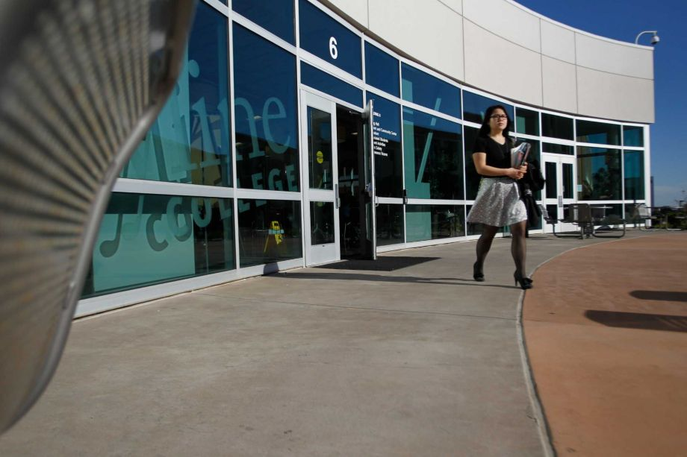
Photo: Mathew Sumner / Mathew Sumner / Special To The Chronicle
A student walks to class at Skyline College in San Bruno in 2013.
Image 1 of 1
A student walks to class at Skyline College in San Bruno in 2013.
Jubilant education officials chose 15 community colleges on Tuesday — including two in the Bay Area — to be California’s first to offer bachelor’s degrees in high-need fields as part of a pilot program meant to boost the economy and help students avoid costly for-profit programs.
Sometime before fall 2017, colleges up and down the state will offer bachelor’s degrees for about $10,000 in such fields as automotive technology, bio-manufacturing, emergency services, airframe manufacturing and mortuary science — fields that are hiring but which need better-skilled workers, college officials said.
Foothill College in Los Altos Hills will offer dental hygiene, and Skyline College in San Bruno will offer respiratory care — and students are already excited about it.
“It’s time for us to advance in our profession,” said Heather Esparza, who helps sick babies breathe as a respiratory therapist at California Pacific Medical Center in San Francisco. She has a string of life-and-death responsibilities and is licensed to teach doctors and nurses about resuscitating the sickest children — yet there is a hole in her own education.
“My New Year’s resolution was to get my bachelor’s degree,” Esparza said. “There’s a lot more to learn. I can’t wait.”
Brice Harris, the state’s community college chancellor, called it a “historic day in the history of our community college system,” as the system’s Board of Governors prepared to approve the 15 schools. Each will offer one bachelor’s program in areas of health, science and technology not already offered at the California State University or the University of California.
California joins 21 other states where community colleges offer bachelor’s degrees. The pilot program will run until 2023 and shakes up California’s Master Plan for Higher Education. For 54 years, the Master Plan has defined separate roles for the state’s three higher-education systems, with community colleges able to offer only two-year associate’s degrees or vocational certificates.
But as health, science and technology jobs demand more schooling, students have run into trouble: The only programs open to them are often for-profit schools where quality is uncertain and price tags are high.
“There aren’t enough public schools with cheap tuition to provide this kind of education, and students are being moved to private schools with very high tuition,” said Joseph Bielanski Jr., who serves on the Board of Governors.
So the new program “is a major step in keeping California’s higher-education system affordable and accessible while also keeping our state economically competitive in the future,” said Sen. Marty Block, D-San Diego, who wrote the bill signed into law in September.
Block, a former community college trustee whose earlier two efforts to create such a law never made it out of the Legislature, said he kept trying because studies show that California needs 1 million more workers with bachelor’s degrees by 2025.
Under the law, each college can offer a four-year degree program in one field and charge $84 per unit of upper-division course work. Lower-division courses will still cost $46 a unit.
Of the state’s 112 colleges, 34 competed to be in the program and submitted detailed applications in the fall. Those included the Bay Area’s Napa (respiratory therapy), Solano (bio-manufacturing), Laney in Oakland (sustainable facilities management) and Ohlone in Fremont (respiratory care).
Programs were selected for quality, need in the labor market and geographic diversity.
“The important thing for us was that we wanted people in this area to have access to those jobs,” said Regina Stanback Stroud, president of Skyline College, where the bachelor’s in respiratory therapy is expected to be offered beginning in fall 2016. The program will be small, with only 25 students.
“We’re expecting that we’ll have an excess number of students applying for a limited number of seats,” she said.
The 15 winning programs still need to be reviewed by UC and CSU. And all will need approval by the Accrediting Commission for Community and Junior Colleges.
Nanette Asimov is a San Francisco Chronicle staff writer. E-mail: nasimov@sfchronicle.com
Bachelor’s programs in high-need fields
Here are the 15 community colleges to offer a bachelor’s degree in certain fields:
Airframe manufacturing technology, Antelope Valley College
Industrial automation, Bakersfield College
Emergency services and allied health systems, Crafton Hills College
Mortuary science, Cypress College
Equine industry, Feather River College
Dental hygiene, Foothill College and West Los Angeles College
Bio-manufacturing, Mira Costa College
Respiratory care, Modesto Junior College and Skyline College
Automotive technology, Rio Hondo College
Health information management, Mesa College
Occupational studies, Santa Ana College
Interaction design, Santa Monica College
Health information management, Shasta College
Nanette Asimov|Education Reporter

