A Newer Education for Our Era
Students need not only to adapt to a changing world but to be able to change the world
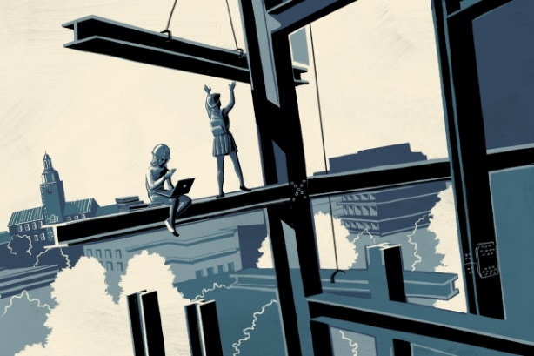
Pat Kinsella for the Chronicle
By Cathy N. Davidson September 27, 2017
In 1869, Charles W. Eliot, a disillusioned young Harvard University graduate and former professor there, published a long and stirring critique of higher education in The Atlantic Monthly. It was called "The New Education."
Eliot had nearly abandoned the academy to go into business but decided at the last moment to take a position at a new, experimental institution modeled on the European polytechnic university: the Massachusetts Institute of Technology. He began his essay by answering a provocative question posed by a father pondering his son’s college education (presumably at Harvard): "What can I do with my boy?" The father worried that his son was not cut out for the careers for which elite colleges prepared students — namely, to become a "preacher or a learned man." "Here is a real need and a serious problem," Eliot responded, and then cataloged the many ways in which the era’s higher education was obsolete.
We need to redesign higher education systemically and systematically, from the classroom to the board of trustees.
Eliot wrote his piece a few years after the Civil War and after a series of financial catastrophes had left America’s future in question. In it he described his vision for revolutionizing the university to train students for the new kinds of professions, institutions, and companies created by industrial capitalism, while educating them deeply enough to assume important roles in a fragile democracy. In what has become a legendary story in the history of U.S. higher education, Eliot was offered the president’s role at Harvard in his mid-thirties. He served for 40 years, over which time he and his colleagues worked with the era’s industrial philanthropists (some would call them Robber Barons) to transform nearly every aspect of higher education — its structure, infrastructure, admissions apparatus, assessment systems, financial-aid opportunities, majors, minors, graduate school, professional school, and on and on. They worked to create major research institutions outside the Northeast (such as Johns Hopkins and Stanford Universities, and the University of Chicago), charted the course for new land-grant universities, helped found junior colleges, formed commissions to design elementary and secondary education, and developed ranking and accreditation systems that judged colleges’ success.
Indeed, for all the changes we may think we see in higher education, the basic structure — the ranking criteria, reward system, disciplinary divisions, and much more — remains remarkably intact more than 100 years later. And that is exactly why today, we need a "New Education" for our own time.
The prescriptive, disciplinary, and specialized training worked well for most of the 20th century. But it makes a lot less sense for our postindustrial, post-internet world, in which the boundaries between work and home are far less distinct, work itself is more precarious, income inequality is rampant, middle-class wages are largely stagnant, automation is expanding, democratic institutions are failing, professions are disappearing, and the next shock to the economy is on the horizon, even if we can’t see it yet.

Today, we find ourselves at a similar tipping point as Eliot: We need to redesign higher education systemically and systematically, from the classroom to the board of trustees, from the fundamentals of how we teach and learn to how we measure results, award credentials, and accredit in this hyper-connected, precarious time. Students today need a new education that emphasizes creativity, collaboration, and adaptability over expertise in a single, often abstract discipline.
The development of a "new education" requires innovation in the face of traditionalists who insist that nothing needs to change (even in the face of plummeting enrollments at some colleges), but it also requires working against two powerful reform movements that are taking higher education in exactly the wrong direction.
First, there are those who try to sell technological solutions to solve the problems presented by new technologies. Far too often, they propose video lectures of famous professors or online courses that don’t change learning paradigms but simply digitize the old, one-way transmission models of teaching.
The second group of reformers, often motivated by conservative political and financial ideologies, wants to drastically reduce public funding for higher education, by eliminating so-called "frills" and focusing on "skills" that make students "work-force ready." The result has been devastating, with more than half of faculty appointments now held by part-time, contingent faculty members while students are required to pay soaring tuitions that exacerbate income inequality. The impoverished form of "skills education," work-force studies have consistently found, may help students obtain entry-level jobs but sets them up for obsolescence in a rapidly changing, automating world.
Fortunately, all over America, educators are championing new kinds of active, engaged, student-centered learning rather than credential-centered learning. They may be working at centers and institutes at the margins of traditional departments, but they are breaking down barriers between ossified fields of study and presenting students with methods for applying deep learning and creative thinking to complex world problems. At elite institutions as well as at regional public universities, at liberal-arts colleges and community colleges alike, innovative professors are teaching students not just what to think, but how to think. They are helping them master the skill that lasts a lifetime: learning how to learn. Here are a few notable examples I came across while researching my new book, The New Education: How to Revolutionize the University to Prepare Students for a World in Flux.
• At Arizona State University, the mathematician Sha Xin Wei, director of the School of Arts, Media, and Engineering, trains students in what he calls "synthesis" with an aim of having "palpable impact" in the world beyond school. Students are challenged to address intransigent, complex problems by considering the historical, theoretical, social, scientific, and cultural impediments that have precluded solutions in the past. Each year, Sha presents students with a seemingly intractable problem, such as "What will life be like in Phoenix when there is no water?" To address a problem of such complexity requires not just interdisciplinary collaboration but grasping how each discipline might offer different tools and solutions. Sha wants engineers to learn, for example, from those who dream — artists — and who realize their most extravagant visions through whatever materials they can get their hands on, sometimes literally.
• At Borough of Manhattan Community College, part of the City University of New York (the nation’s largest public, urban system), Joshua Belknap coordinates a pioneering program in English as a Second Language. At a campus where large numbers of students are first-generation-college students, first-generation Americans, or live below the poverty line, Belknap might have students who speak 25 different native languages in a single class. Using his "translingual learning model," he begins by telling students that, among elites, speaking more than one language is considered an asset, not a stigma. Before he corrects a single mistake in English, he asks his students to research two notable features of their own native language and present their research to the classmates — all in English. Rather than a deficit model, this method begins with students’ collective contribution to a rich, multilingual, semiotic, and grammatical understanding of the components of language as a foundation for improving their English.
• At Kansas State University, the anthropologist Michael Wesch teaches "The Anthropology of Aging: Digital Anthropology." The goal of this class is for students to create an educational video game that allows the player to think about decisions that one must face near the end of life, whether for an aging parent or for oneself. Students read widely and deeply in the cross-cultural scholarship of what aging means, how societies treat their elderly, and how policy is shaped by cultural assumptions, in fields as disparate as pharmacology and neurobiology. They also learn game design and the aesthetics of game narrative, and computer-science students in the group learn the notably complex coding languages required for successful game design. There is one more feature, though, that truly distinguishes this course: Students leave their dorms for a term and actually move into a retirement community. There, they learn about aging from housekeepers and other staff members, as well as from their next-door neighbors — senior citizens for whom making actual life decisions is anything but a game.
Everywhere, there are exciting models of the new education. Now, we need a movement to spread the innovation more widely. As in Eliot’s day, there is no one-size-fits-all. A key component of the new education calls for flexible rankings that do not require that every institution be judged against our most elite (and expensive) institutions. We need to revolutionize our colleges, vigorously support them as a public good, and redesign them so that they are also good for the public. The new education must prepare our students to thrive in a world in flux, to be ready no matter what comes next. It must empower them to be leaders of innovation and to be able not only to adapt to a changing world, but also to change the world. That is the core requirement of the new education. All the rest is merely elective.
Cathy N. Davidson is a distinguished professor and director of the Futures Initiative at the Graduate Center of the City University of New York. This essay was adapted from her new book, The New Education: How To Revolutionize the University to Prepare Students for a World in Flux (Basic Books 2017).

