They Once Cheated in Class. Now They Teach.
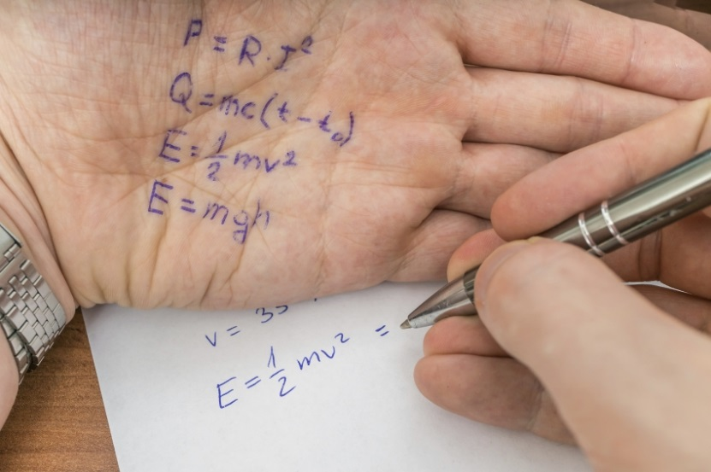
By Sam Hoisington October 10, 2017

Being caught cheating can tank a student’s academic career — it can mar a reputation, result in a failed class, or even, in extreme examples, lead to expulsion. In some cases, the difference between a scholar being able to climb the ladder of academic success or not is as simple as not being caught when cheating.
When The Chronicle asked instructors to tell us whether or not they had ever cheated during their studies, the majority replied emphatically in the negative (several had multiple exclamation marks). But a few admitted their misdeeds.
Some of those who spoke to The Chronicle wouldn’t admit to academic misconduct in a publication read by their peers. For that reason, we agreed to keep identities confidential in order to hear the full story of why they cheated, how they cheated, and how that experience changed their teaching.

The theology professor
Today, he’s an assistant professor at a small Christian college, teaching classes on the Bible and theology. During his undergraduate years, he admits he wasn’t the ideal student, eventually graduating with a GPA just above 2.0.
During his senior year, he had 48 hours to write a paper on a historian as well as finish his senior thesis, which was already months overdue. With time against him, and the pressure to graduate weighing on him, he turned in someone else’s paper and claimed it was his.
"A friend of mine had taken the course a couple years before, and I had access to his paper. I borrowed it, and I pretty much just shifted a little bit around, just enough I suppose, hoping that the professor wouldn’t remember, and I guess that worked," he said. "I submitted that one, and then I started writing my senior thesis."
He’s a theologist, but he’s no cheating apologist, saying that he "still feels all sorts of shame and guilt for that." When he discovers students cheating or plagiarizing work, he tries to be understanding.
"Whenever something like this happens, the first thing I do is sit down and talk to them," he said. "I don’t assume they know what plagiarism is and so on. My first goal is always to seek to understand," he said.
Many of his students are first-generation, and many work while going to college. Complicated or unpleasant life situations factor into some students’ decisions to cheat, he said.
“One of the reasons I was such a poor student was that my family was falling apart.”

"Sometimes they just get so caught up in their work schedule and their other classes that they don’t have time to do it, so they cut and paste something," he said. "I’ve found that faculty members take this stuff really personally, like it’s a personal offense when a student plagiarizes, and I emotionally don’t feel that way. I realize there’s normally something else going on."
He says he can relate to some of those students. During his undergraduate years, his home life was in disarray. "One of the reasons I was such a poor student was that my family was falling apart," he said. "So I went from having really good grades to having really crappy grades."
Graduate students, though, can expect no mercy from this one-time plagiarizer.
"If you’re in a master’s-level program and you’re cheating or plagiarizing, I think you should just go because there’s no point. For undergraduates, I’m not sure we really help them sometimes by giving them a zero and sending them off to a dean."

The biology professor
Just like so many other students, she was trying to fit in — and that’s where she went wrong. Always a studious pupil herself, she had a not-so-studious sorority sister who asked to copy her exam answers in a geology class.
"Her first name was the same as mine, and she was in my sorority and she was popular," she recounted, decades after the experience. "I wanted to be popular, wanted someone to like me. So I let her copy off my exam, and she copied the whole exam."
“I wanted to be popular, wanted someone to like me. So I let her copy off my exam.”

When she went to pick up her test, there was a 98 at the top, she recalled. Next to it was "see me," scrawled in red ink. Her sorority sister confessed to copying answers, and got a significant academic punishment. But the future biology professor was able to pass with an A, as long as she wrote a research paper on her home county’s geology over her spring break.
She spent the break visiting museums and conducting research. She didn’t tell her parents why. "It wasn’t till this year that I told my parents, and they remembered me doing that paper," she said. "It wasn’t till just now, as an adult, that I told them why."
Now teaching biology at a community college, she’s told some of her students the story. "I want them to know that I’m not perfect. I may have a Ph.D., but I’m not perfect," she said.
Just because she once dipped a toe into academic misconduct doesn’t mean she’ll let cheating go unanswered in her courses.
"For me, I think it’s made me understand my students," she said. "I don’t tolerate cheating, but it’s made me understand it, and maybe flavors the way I deal out the punishment."

The contract instructor
This contract instructor in Canada isn’t as far removed from undergraduate studies as some of our other respondents. Currently in a doctoral program, she also teaches human-anatomy courses.
She once cheated on an exam in a human-physiology class. The professor used tests created by the textbook manufacturer, and the answers were all available online. She, along with many of her classmates, shared the questions and answers before a test.
“At some point, if it's on a large scale, we have to be failing the students somehow.”

The professor was able to deduce that large-scale cheating had gone on because the class average was significantly higher than normal, but no one was disciplined or called out individually.
She didn’t express the same overwhelming remorse that some other respondents did. "The cheating seems to stem not just from being lazy, but feeling like there’s no other option and the teacher has somehow failed us ahead of time," she said. "At some point, if it’s on a large scale, we have to be failing the students somehow. Or we’re not making the test accessible. For my teacher, it was 100 multiple-choice questions. Not everyone can do that. There’s a lot of learning disabilities and things like that.
"There’s definitely students that are lazy and are just cheating for the fun of it, but I think a huge part of it is how we’re teaching," she said.

The community-college instructor and former administrator
This instructor was formerly a college administrator. He was also a regular cheater during his undergraduate years.
While working full time, he carried a full course load. He had to hide this fact from instructors because his college would limit the number of classes students could take if administrators knew they were working full time.
“I just felt it was something I had to do to get by. I've never felt guilty about it.”

That wasn’t the only thing he was hiding. In physics and chemistry classes, he would write formulas on his fingers and refer to them during exams.
"I’d write it real small on the inside of one of my fingers. If that formula was needed during the test, all I needed to do was look at my hand," he said. "And it was really easy to cover up because if the teacher came by, you’d just hide your fingers."
He then went on to graduate school, where doesn’t recall cheating like he had as an undergraduate.
"I got better, I guess, at memorizing the formulas," he said.
As for his undergraduate cheating, he feels no remorse. "I just felt it was something I had to do to get by. I’ve never felt guilty about it," he said. "I guess I rationalized it, figuring there were probably other students doing something some way or another to assist themselves."
When it comes to the students in his community college, he has a philosophy that might surprise other instructors. The college has policies about cheating that he has to enforce, but if he doesn’t catch the cheaters, he doesn’t consider it a problem.
"I tell them, ‘To be honest, when I was an undergraduate, I cheated in some of my classes, and I know that some of you are probably going to cheat. If you want to cheat, that’s fine as long as I don’t catch you. Because if I catch you, of course, I have to fail you. If you’re smart enough or lucky enough for you to cheat and me not catch you, then more power to you.’"

