Closing the Gap for First-Generation Students
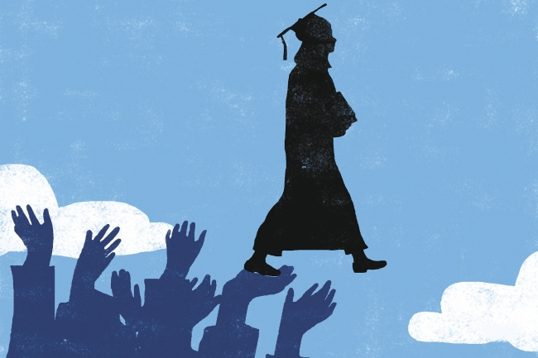
Gwenda Kaczor for The Chronicle
By Kathleen McCartney April 16, 2017
Many high-school seniors this month are learning the status of their college applications. Was I accepted? Will I fit in? Will I succeed? For some, the news will end months of anxiety; but for many students who are the first in their families to go to college, the next step will feel equally daunting. I know because I was once one of them.
My father worked as a machinist in a factory, and neither of my parents went to college. Despite my achievements inside and outside the classroom, my high-school guidance counselor discouraged me from applying to top colleges. I had to persuade him to support my application to Tufts, a great university in my hometown. Thanks to generous financial aid, I was able to attend while living at home. After graduation, with a professor’s encouragement, I headed to a doctoral program at Yale and a fulfilling career as an academic. It could have been otherwise for me, and it is otherwise for so many American students.
Studies show that first-generation students are less likely than their peers to graduate in four years or to graduate at all. UCLA’s Higher Education Research Institute reported a 14-percentage-point gap in graduation rates for first-generation and other students. Many first-generation students come from low-income families and are eligible for federal Pell Grants. The Education Trust compared the graduation rates for Pell Grant-eligible and other students and also reported a 14-point gap.
At Smith College, where I am president, a longstanding, collegewide commitment to student access and success has narrowed the gap in graduation rates for first-generation, Pell Grant-eligible, and other students. In some years the graduation rates for our Pell and first-generation students have exceeded those of their peers. Here are five lessons we have learned.
Make admissions decisions in context. Admission officers should evaluate applicants in the context of available opportunities. Did the high school offer Advanced Placement, International Baccalaureate, honors or college-prep courses? Did the student have access to affordable SAT prep? Did she or he have to work to support the family? Applicants who haven’t had the advantage of strong academic preparation often demonstrate their talents through deep commitment to activities at school and in their communities through organizations like College Match, Schuler Scholars, and Upward Bound. Context matters in recommendations, too. Teachers and college counselors at underresourced schools might not have time to write a two-page, single-spaced, detailed recommendation for each of their students, as their counterparts at private schools do. Instead, they might convey in five key sentences that the student has what it takes to succeed; often, that is enough.
Go beyond school counselors. First-generation students and low-income students are more likely to attend high schools with guidance counselors who are stretched thin or who may not grasp the potential of the students they advise, much like my guidance counselor. To bridge that gap, colleges can partner with community-based organizations like Minds Matter, Summer Search, or Bottom Line. These organizations, and many others, provide coaching and mentoring for students from underresourced schools with the goal of encouraging them to apply to a broader range of colleges, including those that might seem a stretch. This is what the best-resourced high schools, public and private, do for all their students.
Partner with community colleges. For many students, community colleges provide a pathway to a four-year degree. At Smith, we have collaborative agreements with four of them: Miami Dade and Santa Monica Colleges, and Greenfield andHolyoke Community Colleges in Massachusetts. Some of our 100 community-college transfers are traditional-age students; some are older, and they bring their life experience into the classroom and into the social life on campus. Regardless of age, our community-college transfers are admitted in a process as competitive as the one for first-year students. They use campus resources and supports at the same rate as traditional students, and graduate into the same range of jobs, careers, and postgraduate programs as their classmates. Don’t think of transfers as an add-on; see these students as the valued members of your academic community that they can be.
Help families see beyond the sticker price. A common misperception among first-generation students is that public colleges are more affordable than private ones. In fact, studies have shown the opposite is often true, especially for qualified low-income students. Colleges need to make a strong statement to families that higher education is within reach for their children. Financial-aid calculators help. As important, colleges need to send admissions representatives to as many high-school financial-aid events as possible and to national programs such as College Goal Sunday.
Level the playing field. Many first-generation and low-income students start college with less preparation than their peers. Mentoring is a powerful way to close that gap. One example is our Achieving Excellence in Mathematics, Engineering, and Sciences program, which connects students with faculty and peer mentors, engages students in faculty-supervised research, and creates a network of academic and social support and encouragement. Students in the program perform as well as peers in gateway science courses, persist in the natural sciences at higher rates than their peers, and participate in natural-science honors and independent research at rates equivalent to their peers. One of our students joined a biology professor’s lab during her first year on campus. She has conducted summer research and presented her work at academic conferences. She aspires to be a professor — and then a college president.
In his 2018 discretionary budget, President Donald Trump proposed deep cuts to the Federal Work-Study and Supplemental Educational Opportunity Grant programs — cuts that would make it harder for students with backgrounds like mine to attend college. The new ideas, people, and experiences encountered in college can change a person’s life trajectory.
The federal government and higher education each have a key role in building an educated work force, economic prosperity, and equity for all. Social mobility through education is an essential part of the American dream. We can and must do more to make this dream available to all qualified students.
Kathleen McCartney is president of Smith College.

