By the Numbers: More Black Men in Prison than in College? Think Again!
​A Washington Post editorial published in June referenced a 2007 quote from then-Senator Barack Obama. In this quote, Obama stated that “we have more black men in prison than we have in our colleges.”
For nearly a decade, this statement has been popular with those attempting to illustrate the plight of African-American males. It is a compelling statement. It is also, quite simply, untrue.
The origin of this statement is a 2000 report from the Justice Policy Institute titled Cellblocks or Classrooms? The Funding of Higher Education and Corrections and Its Impact on African American Men. The report found that more African-American males were under the jurisdiction of a federal, state, or local penal system (791,600) than were enrolled in higher education (603,032). The report attributed this sobering finding to increased state investment in corrections and decreased support for higher education throughout the 1980s and 90s.
Needless to say, this garnered much attention in the press, and more than a decade later still serves as a tidy talking point for encapsulating the social challenges facing African-American men.
However, the statement is no longer accurate and in fact probably never was. This table compares incarceration and higher education enrollment data between 2000 and 2010. The college enrollment data used in Cellblocks or Classrooms only counts African-American males attending degree-granting institutions who enrolled for the fall semester.
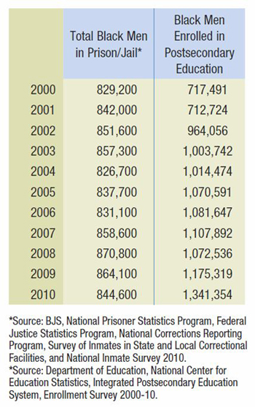
The numbers in the chart paint a clearer picture of African-American male enrollment; they include students at vocational campuses, non-degree-granting institutions, and students who enrolled after the fall semester—and reflect an 86 percent increase in the number of black men enrolled in postsecondary education.
By 2002, African-American males in college outnumbered those incarcerated. Moreover, because a large portion of postsecondary institutions did not begin counting students who enrolled after the fall semester until 2002, it is quite possible that even in 2000 more African-American males were in college than in prison or jail.
Highlighting the inaccuracy of the “more black men in prison than college” claim is in no way meant to suggest that the societal challenges many African-American males face are somehow overstated. Indeed, African-American men still face huge challenges in terms of accessing and completing higher education. But in the meantime, there is no need to continue trotting out a figure that, while compelling and easy to understand, is not—and may never have been—correct.

Bryan J. Cook is the director of ACE’s Center for Policy Analysis.

