Want to Change Education? Start With the Universities
(11/20/2017 08:59 am ET)

John M. Eger, Contributor
Zahn Professor of Creativity and Innovation is also the Van Deerlin Endowed Chair of Communications and Public Policy, and Director of the Creative Economy Initiative at San Diego State University (SDSU).
For too many years we have experimented with our educational system, making additions or altering existing ways of doing business, but the lack of accountability and the failure to acknowledge that a changed world requires significant changes in what we learn, changes in how we learn, changes in what teachers teach and how too, remains a mystery.
There is widespread agreement we have a problem with K-12 education, but there is not a widespread recognition that it starts at the top... at the university level.
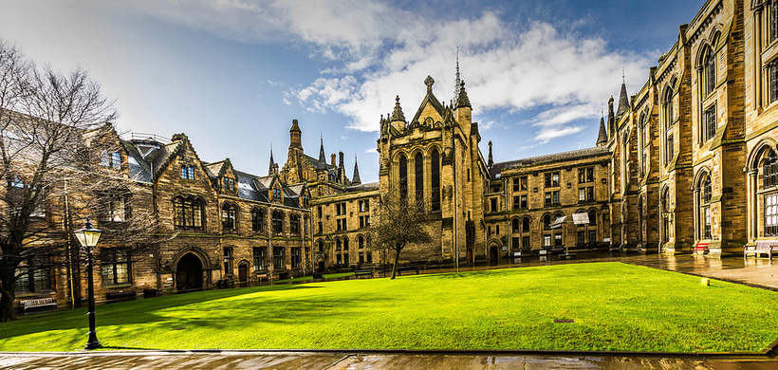
Most higher education institutions do a credible job distinguishing themselves so that students and their parents can pick and choose, but they provide no reliable statistics about whether real learning takes place, or whether the student is prepared to enter the emerging workforce.
Therein lies a large part of the problem
In a rather controversial book, Academically Adrift: Limited Learning on College Campuses by professors Richard Arum and Josipa Roksa, it was reported that 45 percent of the 2300 students included in the study “demonstrated no significant gains in critical thinking, analytical reasoning, and written communications during the first two years of college.”
The Chronicle of Higher Education, reporting on the study, said, “that a significant percentage of undergraduates are failing to develop the broad-based skills and knowledge they should be expected to master.”
As serious may be the way students are encouraged to apply to universities and are accepted, if at all. Given the sheer number of applications received, most universities rely on GPA and SAT scores to help them make the cuts. The students (and usually parents as well) pore over their applications and accompanying letters relatively unaware that they won’t be examined closely unless or until they make the first cut.
The more serious complaint may be that SAT scores and GPAs are not effective measurements anyway, and success in college is not a determinate of success in life, or the job market either.
There is little agreement what college is about. According to a Pew Study, “Just under half of the public (47%) says the main purpose of a college education is to teach work-related skills and knowledge. Another 39%, however, says that college is an opportunity for students to grow personally and intellectually.”
And the students themselves “value college most for job and career preparation, with intellectual objectives close behind.” Also, “students strongly or somewhat preferred the statement that a college education prepares you for a career or profession,” with 83 percent indicating that they strongly preferred that statement. They also strongly preferred a college education that enabled them to “acquire values, habits, and skills that prepare you for many different opportunities.”

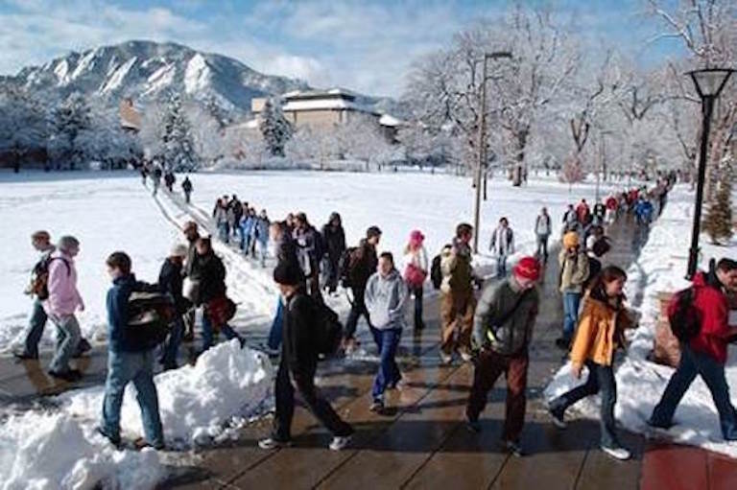
The question is are they getting career or life preparation? Are they learning how to learn because that’s what they must do to stay aware and always prepared to meet the challenges of an extremely fast changing world?
The Chronicle of Higher Education, once offered the theory that “Majors are scholarly silos standing in the way of learning” and are part of the difficulty administrators and faculty have such a difficult time making changes that count.
Universities are doing little to remove these silos. They have recognized changes in the knowledge base, and often established new courses to meet such changes; they have even created new majors but seldom eliminate any majors or courses or merge them. K-12 schools similarly, have made some changes to the curriculum, but this is like moving the chairs around on the Titanic.
Wholesale change across K-12 and the university system is needed. If the University is willing to state unequivocally what it is looking for in an applicant, K-12 schools will rise to the occasion.
In the wake of the worldwide spread and influence of the Internet, the computerization of news archives and libraries available on the Web, literally thousands of references are available at the click of a mouse. The challenge today is not acquiring information; it is determining which information is relevant.
There is no longer a need to fill the student’s brain with information that almost anybody can google. This has dramatically changed the entire system of education. Yes, it’s harder to grade students progress if the teacher can’t simply have them regurgitate what they may have learned in class. But new methods of learning and new rubrics for assessing progress in a must.
Learning how to learn, acquiring new thinking skills to meet the challenges of an economy looking for creativity and innovation, discovering one’s interests and aspirations if possible and having experiences that prepare them for this new bold future is vital.

