The Power of Dialogue
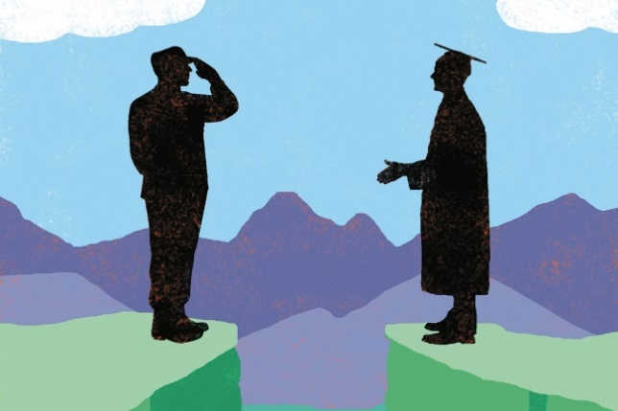
Gwenda Kaczor for The Chronicle
By K. Elizabeth Coggins and Gregory Laski September 24, 2017
The 2016 presidential election revealed the American electorate to be deeply divided across a host of economic and social issues. As we complete the first months of Trump’s presidency, and commence another academic year, many are asking: Where do we go from here? It’s a good question, and we want to share our perspective from our work with the Democratic Dialogue Project, an exchange that brings together students from the United States Air Force Academy and Colorado College in an attempt to enrich citizenship by creating opportunities for exchange across various divides — conservative and liberal, urban and rural, military and civilian.
It’s that last boundary, between soldiers and civilians, that is the immediate occasion for the DDP. Funded by the Andrew W. Mellon Foundation, our organization joins other federal service academies and liberal-arts colleges in recognizing a commonality that too often goes overlooked: Despite the differences between these types of institutions, both endeavor to form our country’s future leaders. On the one hand, many Colorado College students will go on to work in the public sector and lead their communities — as entrepreneurs, scientists, professors, elected officials, political advisers, and more. On the other hand, Air Force Academy cadets will go on to serve as commanders, pilots, Pentagon officials — but also, after they fulfill their military obligations, as civic leaders, just like their Colorado College peers.
It is the ways in which these students’ lives and careers overlap that the DDP seeks to cultivate during the crucial college years. Well before the emergence of Donald Trump on the political landscape, we saw an opportunity to bring together these young adults early in their academic tenures, before they may meet again later in life as civilian and military leaders of our country. Our goal is to enable meaningful, democratic dialogue between these two distinct classes of Americans who may too infrequently be called upon to interact, compromise, and most important, listen to each other.
Our political system depends upon civilian control of the military, yet there are too few occasions for civilians to come to know the realities of soldiers — realities that should inform their political decisions about questions of peace and war, security and diplomacy. Similarly, if those in the military, who make up less than one-half of one percent of Americans, feel ostracized from civilian society, they lose contact with the very population that they are expected to serve. Identifying opportunities for dialogue across this boundary is crucial.
Yet the idea behind the project seeks not just to lessen the civil-military gap, but also to address a larger problem. Important research in political science finds that a sizable chunk of the American public holds conflicting ideological viewpoints. Most intriguing is that many Americans have liberal social and economic preferences but call themselves conservatives. The reasons are many, and the consequences are significant: Ideological identities are important social markers for many Americans, and their tendency to see those who identify differently as the "them" of the world is strong. This is especially true in today’s increasingly conflict-laden political environment.
In the Democratic Dialogue Project, we press our students — through film screenings followed by shared meals, campus exchanges, and organized debates — to talk about preferences in robust ways. When they watched the movie American Sniper, for instance, the conversation that ensued was enlightening for everyone. Discussions about student life — schedules, dorms — gave way to bigger questions about the fantasies and realities of war and diplomatic strategy.
That particular interaction, and our project more broadly, can be seen as a response to a commentary by Stanley Fish in which he reminds professors to "stop opining about Trump." He raises the interesting question: Just what are the responsibilities and limitations of college teachers? The question is one that strikes at the heart of the meaning of education in a democracy.
We share Fish’s sense that professors should not "equate the possession of an advanced degree with virtue." But as professors who study democracy as a political system, we worry about the narrow way he defines politics and the political space of the classroom. We believe it is our duty not to shy away from these difficult discussions.
As Fish himself suggests, it is the job of historians to teach students about history in the academic sense: to handle archival materials and build persuasive accounts of disputed events, among other worthy assignments. But as professors at liberal-arts colleges we are not simply, or even primarily, training specialists to earn Ph.D.s. We are preparing students to interact meaningfully and democratically with the world — and the world consists of people of different ideologies, races, ethnicities, heritages, and creeds.
College is not the world, but it should be a window onto it. This is especially crucial if, as Andrew Delbanco has argued, the purpose of college is a "rehearsal space for democracy." A classroom beyond the classroom, the DDP reminds us that if college is to be such a space, then the rehearsal must provide training for open but difficult dialogue.
What we need now is more of what social theorists call "bridging ties" that link people from different social classes. The evidence is clear: Such linkages lead to sharper communication between dissimilar groups, lift intellectual performance, and as we hope for the DDP, improve understanding. We strive to show our students that in a democratic society, dialogue neither turns its back on divisive issues nor demonizes difference. Such an end requires work, but we owe an attempt, at the least, to our students and our country — and we invite others to imagine such opportunities on their own campuses.
K. Elizabeth Coggins is an assistant professor in the department of political science at Colorado College,and Gregory Laski is an assistant professor in the English department at the United States Air Force Academy. His book,Untimely Democracy: The Politics of Progress After Slavery, will be published by Oxford University Press in October.
A version of this article appeared in the September 29, 2017 issue.

