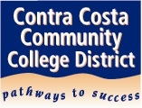
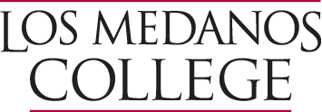

SECOND Annual 4CD District Plenary Study Session
Monday April 10, 2017
3:00pm-5:00pm
District Office 6th Floor Board Room
Join us for a meeting of Academic Senate Representatives
from
Contra Costa College,
Diablo Valley College,
and
Los Medanos College
Topics for discussion will include:
A Strong Workforce (presentation and Q & A)
CTE hiring challenges
Equivalencies
Diversity in Hiring
Guests will include:
Dr. Fred Wood – CCCCD Chancellor
Tina Dodson – DVC Manager Workforce Development
RSVP by April 3 to Ann Patton apatton@dvc.edu
Light refreshments will be provided

