University of Michigan to invest $85 million in diversity programs
David Jesse , Detroit Free Press Published 10:12 a.m. ET Oct. 6, 2016 | Updated 4:54 p.m. ET Oct. 6, 2016

University of Michigan to invest $85 million in a variety of programs to increase diversity on its Ann Arbor campus.
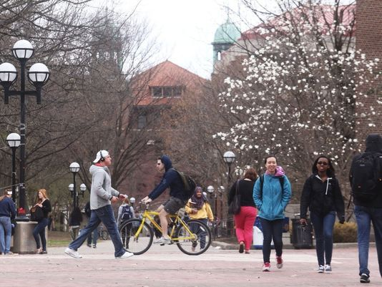
(Photo: Ryan Garza, Detroit Free Press)
The University of Michigan will invest $85 million over the next five years into programs aimed at boosting diversity, President Mark Schlissel announced Thursday as the Ann Arbor school rolled out a new diversity strategic plan.
"The campus-wide plan we are unveiling today is a set of actions for today," Schlissel said. "Our dedication to academic excellence for the public good is inseparable from our commitment to diversity, equity and inclusion. We are prepared to make the investments needed for this plan."
Several students said they like the ideas put forth in the plan, but remain skeptical that it will bring about change.
"Seems like there's been a lot of talk, but I don't know if anything has really changed," said Jessica Worthy, 22, a senior. "I'm really upset by the things that've gone on here with the flyers being posted and everything. I don't think the university is doing enough to make it a safe place for black students and other minorities. Hopefully, this plan helps, but we'll see."
Among the programs announced Thursday:
- A program for incoming freshman to help assess and then develop skills for navigating cultural and other differences, addressing the fact that new students to U-M come from varying backgrounds, the school said in a news release.
- Enhanced educational programming for all new faculty on inclusive teaching methods, led by U-M’s Center for Research on Learning and Teaching. The goal of the program is to provide resources and tools that will help faculty make learning more inclusive and effective across diverse groups of students. This will be rolled out to all faculty members in future years.
- Several new outreach programs to recruit and retain a more diverse pool of students, faculty and staff, including an urban school initiative for new undergraduate students and enhanced partnerships with Minority Serving Institutions for increasing the pipeline of diverse graduate students for U-M.
- An innovation grant program to catalyze new ideas from students, faculty and staff for addressing issues of diversity, equity and inclusion
The school rolled out not only an overall strategic plan, but also plans for each of the universities' 49 individual schools, colleges, academic units and departments.
For instance, the College of Literature, Science, and the Arts plans to initiate a two-year postdoctoral fellowship to recruit extraordinarily promising scholars whose research, teaching and service will contribute to diversity and equality in higher education. Recruiting up to 50 fellows over five years, LSA will convert these positions to tenure-track lines upon successful completion of the fellowship. Also, the Stamps School of Art & Design will revise approximately three academic or studio courses each year over the next few years on subject-related diversity issues.
The university also touted the Wolverine Pathways program, which officials are hoping will help increase the critical mass of underrepresented students as it creates a pipeline to the university for students from the Ypsilanti and Southfield communities. The program will expand to Detroit in fall 2017.
Also within the past year, the university launched the HAIL Scholars initiative. HAIL — High Achieving Involved Leader — is a two-year pilot effort that is testing a new approach to reaching — and enrolling — high-achieving, low-income students from across the state. It provides resources that remove some of the barriers proven to stop some students from applying to the university. For students who apply and are accepted, the HAIL Scholarship provides four years of free tuition — a value of about $60,000.
The university also said it will conduct a climate survey of the university.
"I think that will be really interesting to see what the results are," said U-M junior Tony Williams, 20, of Grand Rapids. "I wonder if they (administrators) will ask real questions and really pay attention to the results, or if just another thing to say they did."
The announcement comes two days after several hundred faculty and staff rallied on the Diag for diversity. The rally came after last week's discovery of racially charged "alt-right" flyers in various spots on U-M's campus.
Last week, posters were found in several locations across campus. One poster argued that white women should not date black men, while a separate poster depicted a “STOP!” sign while urging “Euro-Americans” to stop “living in fear” and “denying (their) heritage." The posters both carried an “Alt-Right” logo. They first appeared in Haven and Mason halls.
Schlissel addressed those incidents during his speech.
"When members of our community are attacked, it's a problem for all of us," he said.
The issue of race on U-M's campus has been in the spotlight for several years, starting with the Being Black at U-M hashtag, where students took to Twitter to share stories of discrimination and intimidation on campus. The Black Student Union also issued several demands for change, including a new multicultural center on campus, which the university agreed to build. Even that, however, caused controversy when U-M Regent Mark Bernstein donated $3 million toward the building, only to withdraw after students complained about his and his wife's name going on the building in place of William Trotter, the only black person for which U-M has named a building. Bernstein was at Tuesday's rally.

