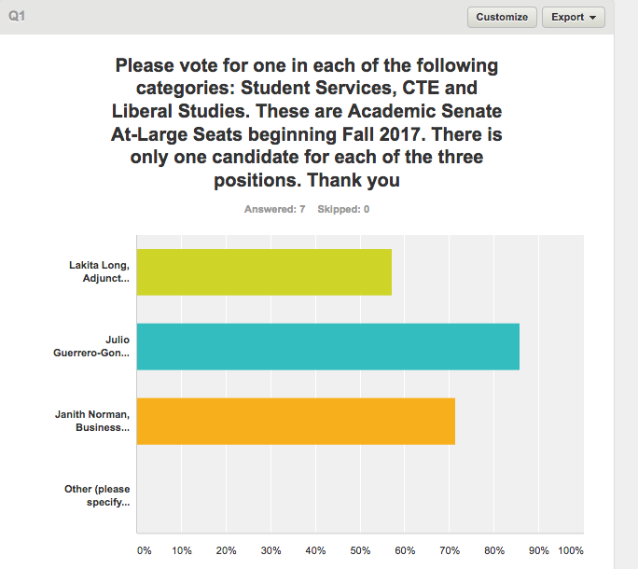
AT-LARGE PT POSITIONS – VOTING RESULTS

