In annual survey, Californians give public colleges high marks but say affordability is key
Rosanna Xia
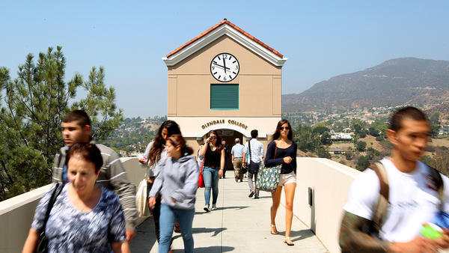
Students head to class at Glendale Community College. (Christina House / Los Angeles Times)
Most Californians think affordability is a big problem in public higher education, and many say the UC and Cal State systems and the state's community colleges should do more to ensure that all students have affordable housing options, according to an annual statewide survey released Thursday.
The majority of Californians surveyed by the Public Policy Institute of California gave the institutions high marks for quality, but more than three-quarters said they believed that students have to borrow too much to pay for a college degree and that college costs prevent qualified and motivated students from pursuing higher education.
“Many say the public higher education system is going in the wrong direction and needs to change, with concerns being raised about affordability, funding and spending,” said Mark Baldassare, president of the San Francisco-based nonpartisan institute.
Student housing, in particular, was a big issue this year, Baldassare said. “In response to the state’s housing crisis, Californians want colleges and universities to do more to make sure that students have affordable options,” he said.
The survey asked Californians about a variety of subjects including tuition, free speech and immigration policies.
Among the findings:
- Most surveyed (62%) said the current level of state funding for higher education is not enough, but about a third (32%) also said they believed that colleges waste a lot of money.
- Almost 80% of those surveyed — spanning all political parties, races, ethnicities, incomes and education levels are against increasing student fees.
- Higher taxes for higher education are supported by 57% of Democrats, 26% of Republicans and 40% of independents.
- A little over half (52%) said they were dissatisfied with the way campus officials are handling the issue of free speech, and a solid majority (64%) said they were dissatisfied with the way campus officials are handling the issue of sexual assault.
- Almost two-thirds (63%) said that in the upcoming governor’s race, candidate views on higher education were very important to them.
The Public Policy Institute of California surveyed 1,703 California adults in English and Spanish from Oct. 8 to Oct. 17. The survey’s margin of sampling error was about 3.3 percentage points.

