Political turf wars slow push to educate more Californians

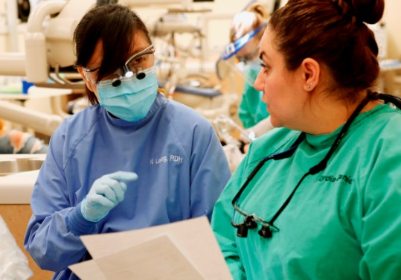
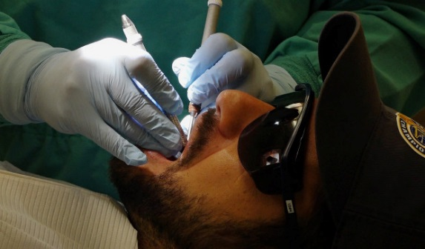
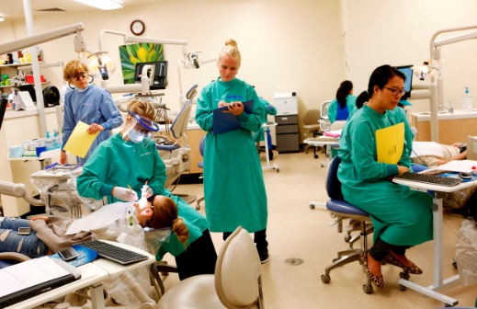
Community colleges want to offer more bachelor’s degrees but some at the CSUs have mounted serious opposition.

Students work on live patients at the Dental Hygiene Program at Foothill College in Los Altos Hills, California, on Thursday, July 13, 2017. The school is one of the few community colleges in California that offers a bachelor's degree in dental hygiene. (Gary Reyes/ Bay Area News Group)
The 27-year-old lives in Gilroy and works as a dental assistant. She’d like to be a dental hygienist. Increasingly, making that transition requires a bachelor’s degree.
But until recently, only a handful of schools in California, all of them private or for-profit, ran bachelor’s programs in dental hygiene. They’re expensive — in the $40,000-$60,000 range. That’s not feasible for Olmos.
Lawmakers and college leaders want to expand a pilot program that could be a lifeline for students like her. They would like more community colleges across the state to offer bachelor’s degrees in fields with high demand for workers and where none of the schools in the California State University or University of California systems compete. The cost to students like Olmos? A relatively affordable $10,500 for all four years.
​
But community colleges are ​facing opposition from unions and the state’s other public higher education providers who are intent on guarding what they see as their turf.
“They’re not necessarily equipped to do it and certainly not funded to do it,” said Susan Green, who holds leadership positions in both the California Teachers Association and the California Faculty Association, which represents CSU faculty and opposes expansion. The CSUs are better suited to offer bachelor’s degrees than the community colleges, she argued.
Under the pilot program launched in 2014 and set to end in 2023, 15 community colleges began offering bachelor’s degrees. Now some lawmakers want to extend the program and allow more schools to participate.
It’s too early to tell exactly how successful the pilot programs are, but initial data suggest there is high demand. At Foothill, which launched a dental hygiene bachelor’s program last fall, about 100 students applied for 24 spots in next fall’s class.
Up the Peninsula, Skyline College in San Bruno is testing out a bachelor’s in respiratory care. In the East Bay, Solano Community College will start a biomanufacturing bachelor’s degree this fall.
“You take students from very modest backgrounds and you embed them firmly in the middle class,” said Jim DeKloe, who is overseeing planning for the Solano program.
The unions and several other groups, including some faculty at community colleges, argue that it could hurt students who want to transfer to a CSU or UC after two years. They maintain it could take resources from traditional associate’s degree programs and put them toward new bachelor’s degree programs.
But some community college leaders aren’t buying it.
“The people who say this is mission creep are really people who are not taking the time to take a deep breath and sit down and see what kind of workforce-oriented degrees these are,” argued Constance Carroll, chancellor of the San Diego Community College District.
Carroll’s district is offering a health information management bachelor’s degree, which teaches students how to digitize health records. That’s not something that even existed a generation ago, but it’s a growing field now.
According to federal labor statistics, employment of dental hygienists is expected to grow 33 percent from 2012 to 2022, and median pay is north of $70,000. Foothill says the move to offer a bachelor’s makes sense because more employers are looking for employees with four-year degrees.
For Phyllis Spragge, director of the dental hygiene program at the school, it’s a matter of making sure students from minority backgrounds traditionally underrepresented in higher education have equal access to college.
According to the Public Policy Institute of California, 38 percent of jobs in the state will require a bachelor’s degree or more by 2030 but only around 33 percent of the state’s working-age adults are set to have degrees by then. And they’re likely to be mostly Asian-American and white. California needs to produce another 1.1 million college graduates and, to do that, it needs to make sure Latinos and African-Americans have equal access to higher education.
Ray Hernandez, dean of science, math and technology at Skyline College, which includes the school’s bachelor’s in respiratory care program, thinks that community colleges should be allowed to step up and help fill growing educational needs, particularly in areas the state’s other systems have largely avoided. “If you look at the CSUs and UCs,” he said, “they historically haven’t run programs where they’re technically based.”
For Green, the solution is increasing funding so CSUs can boost their offerings and expand access. But that’s not necessarily the way CSU as a system wants to go. Christine Mallon, assistant vice chancellor for academic programs and faculty development at CSU, would certainly like to see the state beef up funding for the CSU, but she doesn’t have a problem with community colleges carving out niches “outside the scope of our mission,” she said.
Currently, the parameters of the pilot program lock community colleges into those niches. The schools offer bachelor’s degrees in fields such as mortuary science and automotive technology that, by the pilot’s design, aren’t available at a CSU or UC. And the scope of the pilot also is limited. More than 30 community college districts in the state expressed interest in offering bachelor’s degrees, but the pilot only allowed for 15.
Some community college leaders want to do away with all of those limits. Judy Miner, chancellor of the Foothill-De Anza Community College District, wishes “that every program that wanted to offer a bachelor’s could do it,” she said during an interview in her office.
That’s where things get complicated. Take nursing, for instance. As Baby Boomers age, the need for nurses is growing. At the same time, hospitals are increasingly looking for nurses with 4-year degrees rather than 2-year degrees. Some community colleges would like to expand their associate’s degree programs into bachelor’s degree programs. But a number of CSUs, including San Jose State and CSU East Bay, offer bachelor’s degrees in nursing, and CSU doesn’t want the community colleges treading on what it sees as its turf.
“Nursing,” Spragge said, “is not going to happen. It’s like a third rail in this state.”
DeKloe agreed, but offered a blunt challenge. “If they’re worried about competition,” he said, “then do it better than us.”
The bottom line is that for years, such political and bureaucratic turf wars over which public schools in the state should be allowed to offer which degrees have made accessing higher education hard for some of the state’s lowest-income students, overwhelmingly young people of color — people such as Olmos.
“I don’t know how you make a student-centered argument around this and not end up at a place where you at least have to try to see if these pilot programs can start to address what we know is a significant gap” between the number of degrees the state is producing and the number it needs, said Lande Ajose, executive director of California Competes, an organization that studies the state’s higher education and workforce needs.
The process for sorting out which degrees community colleges should offer and where is clearly messy.
Hernandez just hopes it doesn’t take too long to decide what happens going forward. “I don’t think,” he said, “our students have that time and space.”

Community colleges piloting bachelor’s degrees
Antelope Valley College – airframe manufacturing technology
Bakersfield College – industrial automation
Cypress College – mortuary science
Feather River College – equine industry
Foothill College – dental hygiene
Mesa College – health information management
MiraCosta College – biomanufacturing
Modesto Junior College – respiratory care
Rio Hondo College – automotive technology
Santa Ana College – occupational studies
Santa Monica College – interaction design
Shasta College – health information management
Solano Community College – biomanufacturing
Skyline College – respiratory care
West Los Angeles College – dental hygiene
By Emily DeRuy | ederuy@bayareanewsgroup.com | Bay Area News Group
PUBLISHED: July 28, 2017 at 6:00 am | UPDATED: July 31, 2017 at 3:07 pm

