Breaking the 4-year myth: Why students are taking longer to graduate
By Nika Anschuetz, Waynesburg University 3:08 pm EDT December 16, 2015
Securing a college degree takes four years, right? Well, maybe not. The new reality is that a vast majority of students don’t end up graduating in the traditional four-year window.
Most college students at public universities end up completing their bachelor’s degree in six years, according to a study by Complete College America
Complete College America is a non-profit organization that works with states to help close the college degree attainment gap, making it easier and more cost effective for students to pursue higher education.
In their Nov. 2014 report, the group tackled the four-year graduation myth, stating most students at public universities don’t graduate on time.
For a non-flagship public university, only 19% of students graduate on time and even at flagship research public universities, the on-time graduation rate is only 36%. Only 50 of the more than 580 public four-year institutions have graduation rates above 50%.
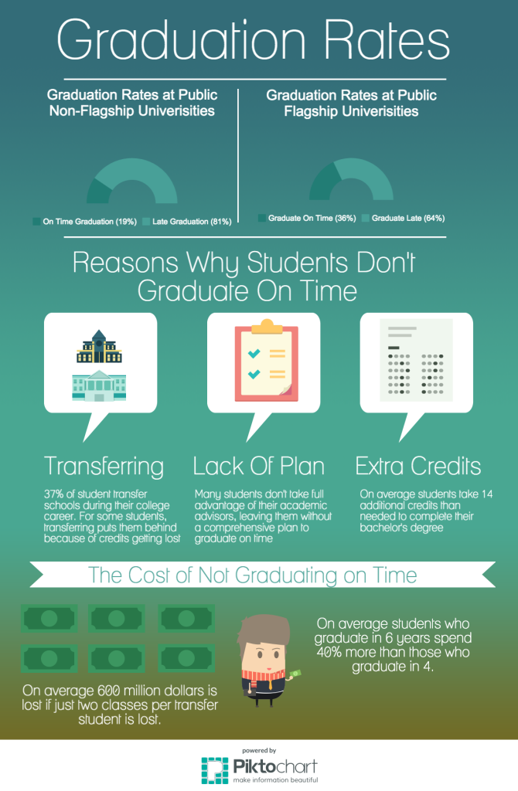
Information from Complete College America, The National Student Clearinghouse Research Center (Graphic by Nika Anschuetz)
Straying from the traditional four-year completion path has another downside, it costs more money — a lot more.
According to 2013 data from the University of Texas at Austin, students who graduate on time will spend 40% less than those who graduate in six years.
In order to help shift the trend back to the traditional four-year model, it’s important to understand the reasons students aren’t graduating on time.
Here is a closer look at the four main reasons students are no longer graduating on time:

1. A lack of a clear plan or advising
According to Dr. Bob Neuman, a former associate dean of academic advising at Marquette University, when students enter into college freshman year they often take relaxed approach to college.
“Students aren’t sure what’s sure what’s going to happen to them once they start college,” Neuman tells USA TODAY College. “They aren’t thinking about how college should connect them with a career when they get out of college.”
At Marquette University, Neuman implemented a program where students had to meet with their academic advisors at least once per semester.
“Students don’t take advantage of advising,” said Neuman. “Whether your grades are high, medium or low. Talking with an advisor is helpful. It always helps to be talking with somebody.”

2. Change of Majors
According to the National Center for Education Statistics approximately 80% of students change their majors before they graduate. And depending on when you change your major, it can delay your expected graduation date.
Brianna Watt, says she knows that experience all too well.
Watt entered Waynesburg University as a freshman in the fall of 2011 as nursing major and after almost a year and a half of nursing, she decided to switch her major to early childhood and special education.
While she was able to use some of her nursing credits as general education credits, she was unable to replace nursing classes with education department classes. Due her new, required courses, Watt will graduate in 5 years.
“I had to take out another loan, but I don’t regret it because I am actually doing something I love,” says Watt. “I would rather stay in college for another year and do something that I love for the rest of my life than graduate on time and be miserable.”
If a change in major causes students to fall behind, Donald Asher —author of the book Cool Colleges — suggests utilizing the summer to take a additional courses.
“Use summer classes to catch up,” says Asher. “If you fall behind and you need to catch up, pick up something in the summer.”

3. Change of Universities
The National Student Clearinghouse Research Center reports 37% of college students end up transferring during their college career. Unfortunately, credits for completed courses don’t always transfer to the new school.
Hannah Stepanian started out her college career at Kent State University, double majoring in sociology and Spanish.
During the past three years, Stepanian has attended three different academic institutions. She says her switch from Kent State to Slippery Rock University is where the majority of her credits were lost.
“There were at least three classes that I took at Kent that I just didn’t get credit for,” says Stepanian. “It was frustrating. Because there was nothing equivalent at Slippery Rock, I just didn’t get credit for it.”
While losing credits can be an unfortunate part of transferring schools, Asher suggests keeping the course catalog and description of the courses that you take.
“Keep all of your old past catalogs and print out the descriptions,” says Asher. “Sometimes if you have a description of a class, you can get them to count it. They can take some of your classes and help you graduate.”

4. Unnecessary courses taken
Many students take additional credits that they don’t need to graduate. On average, a bachelor degree program requires 120 credits, while most students end up taking an average of 134 credits to obtain their bachelor’s degree, according to Complete College America’s report.
Students often times don’t realize that taking additional credits might not be helpful to them in the long run said Asher.
Asher said it’s nice to take those extra “fun” courses, but make sure you’re taking the required classes to graduate.
Nika Anschuetz is a student at Waynesburg University and a fall 2015 USA TODAY Collegiate Correspondent.

