Program Review
Program Review is a systematic process for the collection, analysis, and interpretation of data and information concerning student service, administrative, instructional units or programs that is used to formulate program improvement plans.

The purpose of program review is for programs/units to address their role in fulfilling the College mission and in achieving the goals and objectives of the LMC Educational Master Plan 2020-2025, consistent with the core values of the College. The program review process results in recommendations to support continuous improvement in student learning and institutional processes. This process promotes ongoing, self-reflective, transparent dialogue to ensure that the college’s programs effectively use available resources to respond to evolving community needs.

Los Medanos College (LMC) conducts a comprehensive program review of all its instructional, student services, and administrative programs/units every five years. A five-year program review cycle was established in the 2017-2018 academic year and is consistent with the Title 5 requirements related to periodic updates to assessment cycles and Course Outlines of Records (COORs). The first year of the program review cycle (Year One, 2017-2018) is the year of Comprehensive Program Review. While no program review updates are conducted in the second and fourth years (Year Two and Year Four), it should be noted that course assessments continue to be conducted annually. All program review updates are reported in the third and fifth year (Year Three, 2019-2020 and Year Five, 2021-2022). LMC’s last Comprehensive Program Review was conducted during the 2017-18 academic year. Adhering to the program review cycle, the 2019-2020 (Year Three) program review update was reported in February 2020 and the 2021-2022 (Year Five) program review update is due in February 2022. The integration of the Program Review, Assessment, and Course Outlines of Records cycle is displayed in the Table 1 below.

Table 1. Program Review and Assessment Cycle
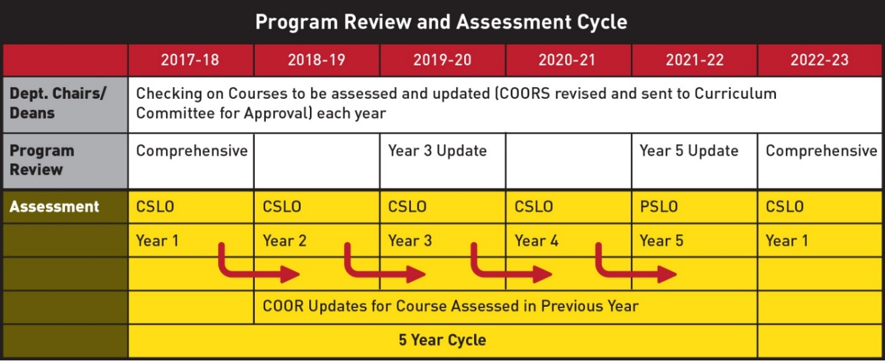
The Administrative Program Review (APR), Student Services Program Review (SSPR), and Instructional Program Review (IPR) share similar templates and timelines, but each process is distinguished in certain aspects to best address the unique needs of each.

Program Review Units
There are about 69 Program Review Updates that were conducted in 2019-20 (Year Three) as an example.
- 13 Administrative Program Reviews (APR)
- 38 Instructional Program Reviews (IPR)
- 18 Student Services Program Reviews (SSPR)
  - 5 Learning Community Program Reviews
  - 13 Student Services Program Reviews

Integration of Resource Allocation
The Resource Allocation Process (RAP) is embedded in the program review process. A standardized form used to submit a resource request is in the program review template including the following three separate funding categories:
- Operations, supplies, equipment, services
- Personnel (non-full-time faculty or classified staff)
- Professional development.
These categories were included in the program review templates to align program/unit needs with resource requests. The Business Services Office then created a centralized budget request database (BRD) to store all submitted resource requests for review and evaluation by the Shared Governance Council (SGC), President’s Cabinet, Office of Instruction, Office of Student Services, and categorical funding agents. The centralized budget database has viewable access for all faculty and staff. Additionally, SGC approved the amendment to the resource request review and allocation cycle to twice a year (in October and April).

A process was implemented to ensure that all allocated funds are used as outlined in the program/unit resource request. The Business Services Office requires funded programs/units to file a report detailing how the budget augmentation was used and the impact of the funding in meeting the specified goals. These reports are required to be submitted at the end of each academic year and provided to SGC for information.

Program Review Evaluation, Validation, and Planning Committee

LMC has integrated program/unit review and resource allocation into a comprehensive process that led to the accomplishment of its mission, and improvement of institutional effectiveness and academic quality. In an effort to assess the effectiveness of this integration, the Planning Committee leads the charge on the evaluation process including (a) validation and (b) program review survey feedback that is conducted following completion of every program review process (March and May). This evaluation assists LMC in determining if the activities (including timeline, milestones, tasks, responsible parties, reports, etc.) were implemented as intended and resulted in projected outputs. The results strengthen LMC’s ability to report on activities and provide information to inform the improvement of the next program review process.

Program Review Validation (March-May)
The purpose of the validation is to improve our program review process—including timeline, template questions, professional development, communication, and gauging progress in attainment of goals as well as informing college leaders of possible emerging “big ideas”—themes and initiatives identified.
LMC has implemented four levels of program review validation with specific Cross-Section Theme reports prepared by the Office of Planning and Institutional Effectiveness for program/unit review and decision-making.
- The Deans review each section of the submitted program reviews for their assigned programs/units. The report is then discussed with the department chair(s) or program/unit lead(s) according to the program review submission timeline. Following that, the Deans then certify the completion of the report and note the overall effectiveness of their programs/units.
- The Deans update their respective Vice President on the strengths and challenges of their respective programs/units.
- The Vice Presidents update President's Cabinet on the strengths and challenges of their respective programs/units.
- The Program Review Cross-Section Theme Reports are prepared and disseminated to appropriate committees/offices for review and feedback.
Cross-Section Theme Report: Program Update, Enrollment, and Labor Market prepared for:
a. Office of Instruction – Deans and Vice President of Instruction
b. Office of Student Services – Deans and Vice President of Student Services
c. Strategic Enrollment Management Committee
Cross-Section Theme Report: Vision for Success Goals prepared for:
a. Planning Committee
b. Academic Senate
c. Strategic Enrollment Management Committee
d. Office of Equity & Inclusion (Goal #5)
Cross-Section Theme Report: Assessment prepared for:
a. Teaching and Learning Committee
b. Student Services Student Learning Outcomes Committee
c. Academic Senate
d. Strategic Enrollment Management Committee
Cross-Section Theme Report: Curriculum prepared for:
a. Curriculum Committee
b. Academic Senate
c. Strategic Enrollment Management Committee

Program Review Survey Results (March-May)
The Planning Committee develops and sends the “Program Review Process Survey” via e-mail to all faculty, classified professionals, and managers following the conclusion of program review. The survey is designed to obtain input on all facets of the program review process (template, data, timeline, training, etc.) As the Resource Allocation Process (RAP) is the charge of SGC, any comments pertaining to RAP will be forwarded to SGC for review.

Timeline of Reviews

Program Review
Tasks |  |  | Timeline/Month
Review/Revise Program Review (PR) Unit List |  |  | August
PR Data available |  |  | September
Review/Revise Program Review Template |  |  | September
Draft PR Year 3 Template to Academic Senate, Dept. Chairs, and Program Managers for feedback |  |  | September
PR Year 3 Template approval by the Planning Committee |  |  | October
Instructional Units | Student Services Units | Administrative Units | Timeline/Month
Deans to provide training to support completion PR—Assessment and Curriculum |  |  | September
Due to Instructional Dean |  |  | September 30
Deans to provide training to support completion PR—Program Update |  |  | October
Due to Instructional Dean |  |  | October 30
Instructional Units | Student Services Units | Administrative Units | Timeline/Month
Deans and PIE Dean to provide training to support completion PR—Vision for Success Goal Setting and Data Analysis |  |  | November
Due to Instructional Dean |  |  | November 30
 | PR 1st draft due |  | November 15
 | PR 2nd draft due to direct supervisors |  | December 15
 | Student Services PR final draft due to direct supervisor |  | January 15
Office of Business Services provide training to support completion PR—Resource Request on cost estimation if needed |  |  | February
PR final draft due to VPI | PR due to VPSS | PR due to President | February 3
Program Review Report Due to PIE |  |  | February 15
All PR Reports and Cross Section Theme Reports posted on the PR Website |  |  | March 15
Resource requests (if they have not incorporated in the PR) due to the database |  |  | March 27
Resource Allocation Reviewed and Recommended by SGC |  |  | April-May

Evaluation Process (Validation and Survey)
Tasks | Timeline/Month
- Deans review each section and discuss with dept. chairs/program leads each month, certify the completion, and note the effectiveness of the program | Sept—Feb
- Deans update their VPs on the strengths and challenges on their respective programs | March
- VPs update the President's Cabinet on the strengths and challenges on their respective programs. | April
- The PR Cross Section Theme Reports are disseminated to the appropriate Committees. (see details on page 3-4) | March
- Program Review Survey Distribution | April
- Share Program Review Evaluation Report (including program review survey results) for improving next program review process | May

Program Review Flow Chart
This graphic illustrates the process and general timeline followed in the program review process.
Note: Planning Committee constituency representatives responsible for reporting this information to their respective Senates/committees and bringing feedback to the Planning Committee.

Compliance/Reference:
Education Code 78016
Board Policy 4008
Approval History:
INITIAL ADOPTION:
Approval by SGC:
Approval by the Planning Committee:

Feedback History:
- Proposed to the Planning Committee: 11.5.2020
- Accepted by the Planning Committee:
- Academic Senate:
- Teaching and Learning Committee:
- Classified Senate:
- SGC:
- President:

