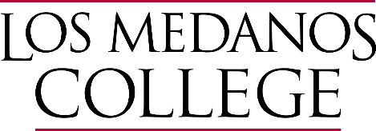

Midterm Report

Submitted by

Los Medanos College
2700 East Leland Road
Pittsburg, CA 94565

to

Accrediting Commission for Community and Junior Colleges

October 15, 2024

Certification

To: Accrediting Commission for Community and Junior Colleges

From: Dr. Pamela Ralston
Los Medanos College
2700 East Leland Road
Pittsburg, CA 94565

This Midterm Report is submitted to the ACCJC for the purposes of 1) highlighting recent improvements or innovations and 2) providing an update on institutional performance regarding student outcomes since the last comprehensive peer review. The Midterm Report reflects the nature and substance of this institution, and its best efforts to align with ACCJC Standards and policies. It reflects participation and review by the campus community.

Signatures:

[Chief Executive Officer of Multi-College District, if applicable] | [Date]
Mojdeh Mehdizadeh, Chancellor, Contra Costa Community College District  [Chief Executive Officer] | [Date]
Dr. Pamela Ralston, College President, Los Medanos College  [Chairperson, Governing Board] | [Date]
Rebecca Barrett, Governing Board President, Contra Costa Community College District  [Name, Title, Representing] | [Date]
Honeymiel Montecillo, Associated Students President, Los Medanos College  [Name, Title, Representing] | [Date]
Dr. Adrianna Simone, Academic Senate President, Los Medanos College  [Name, Title, Representing] | [Date]
BethAnn Stone, Classified Senate President, Los Medanos College  [Name, Title, Representing] | [Date]
Ryan Pedersen, Accreditation Liaison Officer, Los Medanos College

Table of Contents
A. Reflections on Continuous Improvement Since Last Comprehensive Review 1
B. Reflections on Institution-Set Standards and Other Metrics of Student Achievement 17
C. Reflections on Assessments of Student Learning 25
D. Looking Ahead to the Next Self-Evaluation and Comprehensive Review 29

Reflections on Continuous Improvement Since Last Comprehensive Review
Provide brief responses to the prompts below, referring to the Peer Review Team Report for the last comprehensive peer review. Suggested length for Section A is 3 pages.

1. Briefly describe major improvements or innovations since the time of the last comprehensive peer review, focusing on areas where your institution is excelling or showing significant improvement with regards to equitable student outcomes, educational quality, and/or mission fulfillment.

Los Medanos College (LMC) has made significant strides supporting our educational master plan goals to “strengthen a culture of equity diversity, and racial justice” and to “increase and maximize equitable opportunities for students to successfully complete courses and programs.” The college has prioritized initiatives that contribute to this mission fulfillment.
Diversity, Equity, Inclusion & Belonging:
LMC is committed to Diversity, Equity, Inclusion, and Belonging as a cornerstone of its mission, underscored by a range of impactful initiatives. The college has increased the number of equity-focused events and professional development that actively bring the community together. A Heritage and Identity Recognition Committee meets monthly to plan a year-long calendar, hosting events and programming such as the Pride365 – National Coming Out Day, Barbie the Movie – Feminist Icon?, Equity in Action, Undocumented Student Action Week, Black History Month 365, and guest speaker sessions that create vibrant spaces for dialogue, engagement and inclusivity.
Beyond on-campus activities, the college consistently invests in student participation and attendance at equity focused conferences, including the African American Male Education Network and Development (A2MEND) summit, the Asian Pacific American in Higher Education (APAHE), the LGBTQ+ Summit, the National Conference on Race and Ethnicity (NCORE), the Puente Motivational Conference, and the Umoja State Conference.
LMC is one of 50 community colleges that received the Asian American, Native Hawaiian, and Pacific Islander (AANHPI) Student Achievement Program grant for $129.5K over two (2) years. LMC will use the grant to develop culturally relevant curriculum and learning opportunities, promote awareness, bring to campus guest speakers, and provide funding for staffing. The goal is to foster a rich understanding of AANHPI cultures within the academic community.
The implementation of Social Justice Studies and Ethnic Studies programs along with associated robust and diverse course offerings in these disciplines stand as a testament to LMC’s commitment to a diverse curriculum. The Academic Senate and College Administration endorsed Ethnic Studies courses and approved programs. This reflects the college’s dedication to providing a well-rounded and inclusive educational experience. Further, the college added an Ethnic Studies position on the Academic Senate and the curriculum committee and created a District Ethnic Students Council to support faculty across the Contra Costa Community College District (4CD). In so doing, the college has incorporated its core values into its institutional structure, demonstrating its long-term commitment to diversity, equity, inclusion and belonging.
The Curriculum Committee, General Education Committee, Learning and Student Outcomes Committee, and Teaching & Learning Committee ensure that student equity is woven into the fabric of LMC’s academic structure. From the Curriculum Outline of Record (COOR) to Student Learning Outcomes (SLOs) and Learning Support Outcomes (LSOs), to the inclusion of a diverse perspective General Education Student Learning Outcomes (GESLO), these committees are instrumental in creating an academic environment that is responsive to the diverse needs of our student body.
The integration of an equity rubric into the Distance Education California Virtual Campus (DE CVC) underscores the college’s commitment to ensuring that the online learning environment is as inclusive as it would be in traditional classrooms.
The creation of a new institutional metrics website has served as a mechanism focus work on common metrics. This resource serves to facilitate discussions and increase awareness of strategies to support prioritized populations, particularly Black/African American students. The Black Student Success Initiative (BSSI) and the revival of the Brothers of Excellence Program (BOEP) further energize the college’s efforts to address disparities in student success.
LMC’s commitment to reducing financial barriers include the expansion of the Zero Textbook Cost (ZTC) initiative as well as the Tech Equity Program. The college obtained LMC Foundation financial support to expand the on-campus pantry, known as LMC Marketplace. The marketplace provides the college community with free food, clothing, and other necessities and wellness resources. The expansion included a new full-time basic needs program coordinator.
Collectively, these initiatives showcase a comprehensive approach to fostering diversity, equity, inclusion, and belonging, and create a learning environment where every student can thrive.
Shared Governance/Participatory Governance:
LMC is committed to shared governance and participatory decision-making as a driving force in shaping the trajectory of our college. Evidence of this commitment includes the recent work of a Participatory Governance Task Group whose work in Fall 2023 – Spring 2024 was to review the college’s participatory governance structure and processes and identify areas for improvement. The college expects this work to result in key changes to its committee structures and processes for more inclusive, transparent, and efficient decision-making.
The College Senates both play a pivotal role in supporting stakeholder engagement that leads to mission driven decisions. The Classified Senate (CS) established goals for the 2021-24 period that align seamlessly with the College's Educational Master Plan (EMP) goals and the Student Equity and Achievement (SEA) Plan. Underpinning the governance structure is the CS's practice of determining goals each semester. This dynamic approach involves a continual reassessment of objectives, allowing the college to adapt and respond to the evolving needs of the educational community. The CS sets overarching goals and identifies potential activities to achieve these objectives, fostering a responsive and proactive governance model.
The Academic Senate has embraced an increased sense of empowerment through improved communication. Members report feeling better informed, appreciating the increased detail, care, and attention to educating the constituency. This emphasis on transparency and communication ensures that stakeholders have the information needed to engage in the decision-making process.
More broadly, LMC fosters a student-centered culture geared toward advancing student success. This culture is rooted in a participatory framework based on student data that informs professional development and resource allocation. The college participatory governance structure includes committees and workgroups consisting of equal representation from students, faculty, classified professionals, and management. This approach encourages broad participation and leadership and ensures the sound application of student success strategies. Decisions are inclusive. The college uses human and financial resources to achieve goals of its Educational Master Plan and the Student Equity and Achievement Plan. The Shared Governance Council (SGC) serves to ensure the highest level of participation in institutional decision-making. College Assemblies serve as forums to inform stakeholders, promote college-wide engagement, and encourage collective decision-making. This further serves to bridge metrics with goals of the Educational Master Plan, Student Equity and Achievement Plan, and the State Chancellor’s Vision 2030 Plan. LMC’s Strategic Enrollment Management Committee works with Instruction and Student Services to develop structural changes, operational practices, and campus activities to assist students from application to completion as part of the Guided Pathways implementation.

Student and classified senates also extend fiscal support to help students facing financial challenges. This support including Los Medanos College Associated Students (LMCAS) scholarships for textbook costs and funding for student clubs. The Classified Senate also makes annual awards to help students in their academic pursuits.

LMC’s shared governance practices embody a commitment to flexibility, transparency, and inclusivity, creating an environment where all voices are heard, and decisions are made collaboratively for the betterment of the educational community.
Curriculum and Pedagogy:
LMC provides a cutting-edge and inclusive educational experience. Students benefit from an innovative curriculum, pedagogy, and diverse course modalities. The college prides itself in updating courses and programs to align seamlessly with industry standards. In Fall 2022, the college began offering a non-credit certificate in drone piloting to continue our ongoing commitment to serve local small business employment needs. The Academic Senate created of an artificial Intelligence (AI) taskforce to explore the applications, benefits, risks, and ethical implications of integrating AI into teaching and learning at LMC. These measures ensure students obtain the most relevant knowledge and skills demanded by the job market.
LMC continues to recognize the transformative potential of technology. The COVID-19 pandemic, which necessitated an abrupt shift toward the use of technology for instruction, which LMC has since used as momentum to power a continuous expansion of technologies for enriching the learning experience and preparing students for a digital future.
When the COVID-19 pandemic hit our communities, the award and implementation of the Pathways Grant made it possible for LMC to immediately began funding the training of Faculty and building the infrastructure for the online support for both Faculty and students that still exists today. This grant was the basis for the nearly 40 fully aligned courses through CVC/OEI that are currently being scheduled and taught at LMC.
LMC has since enhanced its Distance Education (DE) initiatives, including the DE California Virtual College (CVC) course alignment, coupled with a deliberate transition to supporting students in online/hybrid environments. These actions underscore LMC’s commitment to making education accessible and flexible.
The college is continuing to train and badge faculty in accessibility, and the CVC-OEI Rubric to increase the number of courses that meet OEI Standards. The introduction of a DE Support Hub in Canvas provides additional assistance and guidance for students navigating the online learning environment.
LMC has undertaken a robust upgrade of its technology infrastructure and security measures. Campus-wide WiFi upgrades, improvements to core infrastructure servers and services, the establishment of a new virtual desktop environment, and the provision of enhanced software packages collectively contribute to a technologically advanced and secure learning environment.
LMC established an Early Childhood Education (ECE) degree pathway tailored specifically for working students. This pathway recognizes the diverse needs of our student body and demonstrates the college’s commitment to fostering educational opportunities that accommodate various lifestyles. Notably, this ECE degree pathway includes courses that use Open Educational Resources (OER) exclusively, eliminating financial barriers and ensuring affordability for all.
To ease transfer support, the college hired an Articulation Counselor. This addition to the team aims to pave the way for student to have seamless transitions throughout their academic journey, ensuring that their prior coursework aligns with their educational pursuits.
The college’s curriculum and pedagogy efforts are dynamic and forward-thinking, incorporating industry relevance, technological advancements, and inclusive pathways to meet the needs of a diverse student body. These initiatives reflect the high-quality, accessible, and innovative educational experience at LMC.
Student Services/Support/Outreach/Engagement:
The Center for Academic Success (CAS) serves as an illuminating example of LMC’s commitment to student services, support, outreach, and engagement. Academic support services include in-person, online, and e-mail consultations. In addition, our mathematics tutoring services are available both in-person and online, providing students with flexible options tailored to their preferences and needs.
The Study Slam, a semester-long initiative offering drop-in studying, tutoring, and reading and writing consultations is another example of LMC’s culture of collaborative and inclusive learning. This holistic approach is complemented by free food and childcare services. LMC also expanded its Brain Food Project, initially launched in the Center for Academic Support (CAS), to provide free food and snacks to students across the Pittsburg and Brentwood campuses, further addressing basic needs and promoting student well-being.
LMC’s student services departments are increasingly data informed. This includes all departments developing and tracking Learning Support Outcomes (LSOs). For instance, LMC’s Extended Opportunity Programs and Services (EOPS) conducted a baseline survey to assess student knowledge of resources and services. This data then informed the creation of the EOPS mentorship program to address specific needs and fill critical gaps in support that students identified.
LMC also used survey results to launch a variety of intentional communications to students to guide them through steps in the enrollment process, term-to-term persistence, and the completion of transfer-level math and English. Each semester, the college identifies groups of students in various stages of the process and calls each student on the phone to help them get to the next step.
Our student services initiatives are diverse, inclusive, and responsive, working to ensure that every student has the support and resources needed to thrive academically, personally, and professionally.

2. Briefly describe actions taken in response to any recommendations for improving institutional effectiveness or feedback noted in the Peer Review Team Report for the last comprehensive peer review.

Per the action letter provided by the Accrediting Commission for Community and Junior Colleges dated January 27, 2022, “The Accrediting Commission for Community and Junior Colleges, Western Association of Schools and Colleges, at its meeting January 12-14, 2022, reviewed the Follow-Up Report and related evidentiary materials submitted by the College. The Commission also considered the Peer Review Team Follow-Up Report prepared by the follow-up team that visited the institution on November 2-3, 2021. The purpose of this review was to determine whether the College has addressed the deficiencies identified by the peer review team during the fall 2020 comprehensive visit and demonstrated compliance with the Standards cited in the Commission’s February 1, 2021, Action Letter. Upon considering the information noted above, the Commission acted to Reaffirm Accreditation for the rest of the cycle. The Commission finds that the College has addressed the compliance requirements, corrected deficiencies, and meets Standards III.A.5, IV.C.3, IV.C.7, IV.C.11, and IV.C.12.”

3. How are the actions described above helping your institution deepen its practices for continuous improvement and transformation in relation to the 2024 Accreditation Standards?

The actions outlined in Section A1 of this report, have positioned Los Medanos College (LMC), with enhanced practices and processes, for continuous improvement to meet the ACCJC 2024 Accreditation Standards.

In meeting ACCJC 2024 Accreditation Standard 1, LMC has measurably advanced its mission of creating a learning environment that ensures equitable opportunities and outcomes for all students. For example, the college significantly increased the number of equity-focused events that bring the community together, acquired funding to support activities and initiatives that fosters understanding of the cultures within the academic community. Through the implementation of the Social Justice Studies and Ethnic Studies programs LMC demonstrated its commitment to a diverse curriculum and a well-rounded and inclusive educational experience. LMC has also worked to ensure that student equity is woven into the fabric of its academic processes, by creating an academic environment responsive to student needs. For example, the integration of an equity rubric into the Distance Education California Virtual Campus (DE CVC) ensures the online learning environment is as inclusive as traditional classrooms. The Strategic Enrollment Management Committee has worked with the college to support the student journey from application to completion through the implementation of Guided Pathways.

LMC developed a method of tracking and sharing institutional metric for evaluating its progress and informing institutional planning to ensure institutional accountability. The college unveiled its new Institutional Metrics website during the Fall 2023 opening day. The presentation demonstrated for faculty, students and other employees how the information can be used to focus work on institutional metrics and create a collegial understanding of LMC’s strengths, priorities and areas for continued improvement. The website serves as a home for information that tracks and communicates progress toward achieving the institutions mission goals to internal and external stakeholders. The disaggregation of the data in the Institutional Metrics website informs planning efforts. The college community review facilitates strategic discussions related to prioritized populations, particularly Black/African American Students. This approach, which resulted in the Black Student Success Initiative (BSSI) and the revival of the Brothers of Excellence Program, has helped us reduce disparities among Black/African American students.

The expansion of our Zero Textbook Cost (ZTC) initiative and Basic Needs programs have helped reduce financial barriers for students. LMC attributes a 20% increase in Black/African American Student course success to ZTC. The Tech Equity Program helps bridge the digital divide and ensures students have the technology resources needed for academic success.
In our robust Comprehensive Program Review 2021-22 Process, programs and units designed mini-strategic plans for their unit with SMART goals aligned with the LMC Educational Master Plan 2020-25 goals and objectives. This connected their program review to a Resource Allocation Proposal (RAP) for funding needs. The process includes a review of programmatic disaggregated data, curriculum analysis, enrollment trends, course scheduling/sequencing/ modality, learning assessment, retention/success/outcomes, equity practices, professional development, and five-year program goals. Program Review at LMC encourages dialog within each program/unit, and advances institutional improvement, innovation, and equitable student outcomes.

The LMC Classified Senate (CS) established 2021-24 goals that are SMART and in alignment with institutional plan goals. The senate regularly reviews of goals and objectives to identify innovative activities to fostering a responsive and proactive governance model.

Los Medanos College meets ACCJC 2024 Standard 1 and is committed to continuous improvement, and equitable access to educational opportunities and support services so all students can reach their academic and career goals.

In meeting ACCJC 2024 Accreditation Standard 2, LMC continues to deliver high-quality programs that engage and support students through their individual educational journeys. LMC’s programs promote equitable student success, and through evaluation of student learning and achievement, informs improvements and advances equitable outcomes. The college regularly updates courses and programs to align with industry standards and ensure students obtain current and relevant knowledge and skills for jobs in their field of study. The Career Technical Education (CTE) committee developed a template for CTE programs to use as a guide for discussions with relevant industry and community advisory boards. The template helps ensure that curricular changes the college makes addresses the needs of local employers.

The institution recently implemented the eLumen College Catalog which provides information regarding programs and courses. Prospective and current students can review degree and certificate programs, including course descriptions, and view course sequencing to assist in planning for their unique educational journey.

LMC created a framework for students to develop broad knowledge, skills and competencies related to communication, quantitative reasoning, critical thinking, information literacy, civic responsibility and cultural competence. This framework includes:
- New Social Justice Studies and Ethnic Studies programs
- the addition of an Ethnic Studies position on the Academic Senate and the Curriculum Committee,
- Curriculum Outline of Record (COOR)
- Student Learning Outcomes (SLOs)
- Learning Support Outcomes (LSOs)
- Inclusion of a diverse perspective GESLO

Furthermore, the Center for Academic Success (CAS) provides support services, offering in-person, online, and e-mail consultations for students with flexible options tailored to their preferences and needs. Students that use these services have demonstrably higher persistence rates, for traditionally underserved populations. LMC also has specific interventions, such as the Bring Your Own Brain (BYOB) project, a collaboration of academic and student service departments to support successful course completion for Black/African American students.

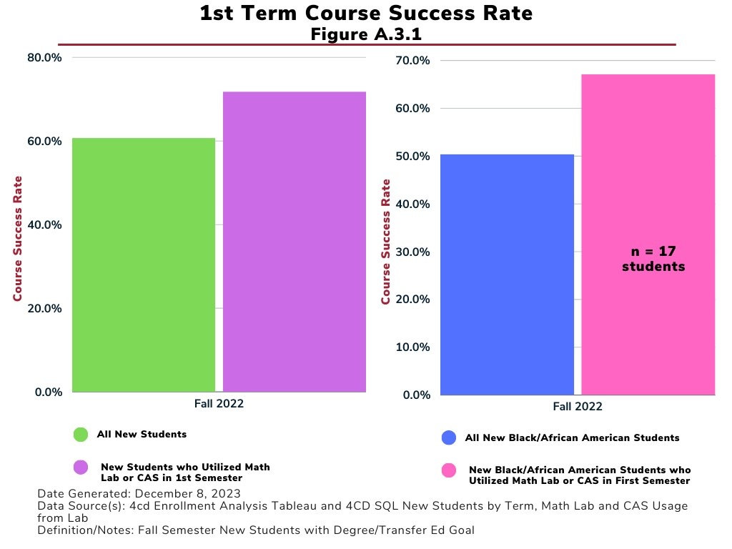

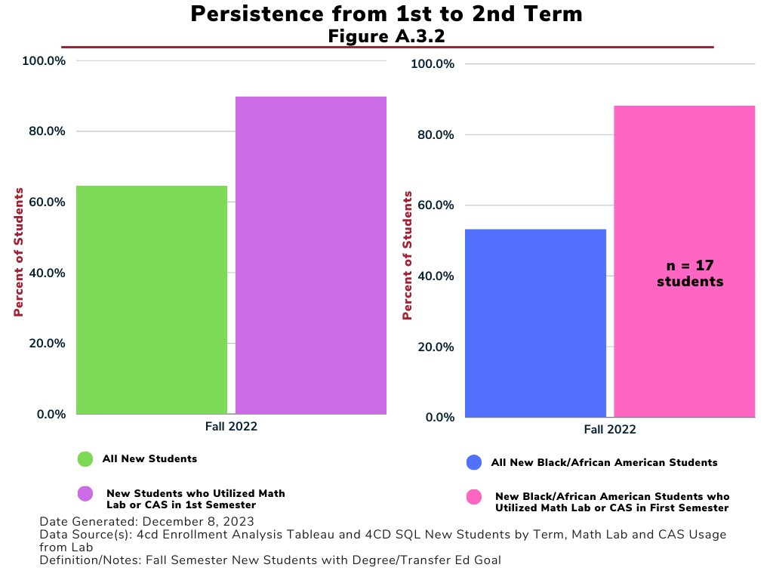
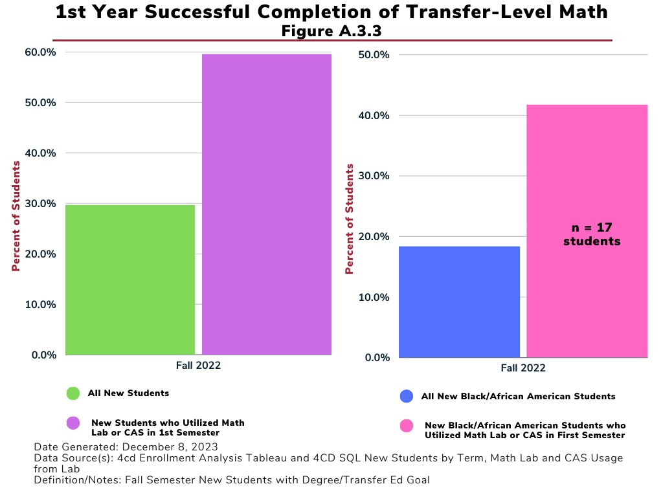

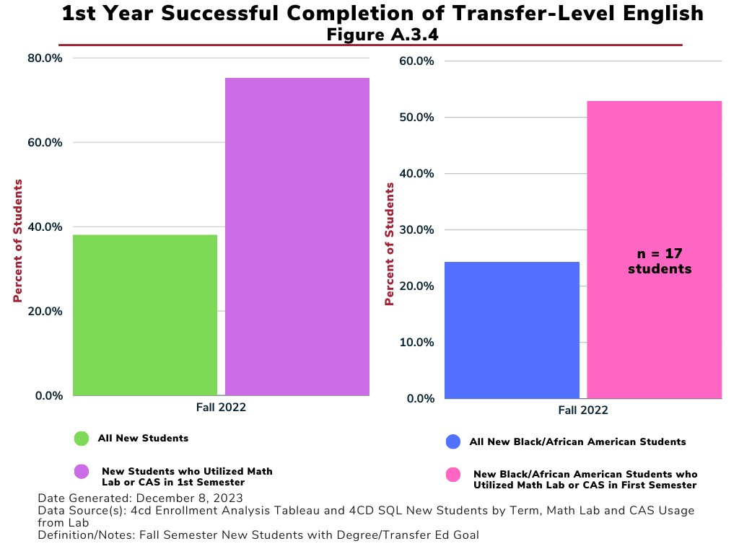

Another example of LMC’s culture of collaborative support and wrap-around services is the Study Slam. This activity addresses academic and non-academic student needs. Through this semester-long initiative students can take advantage of drop-in studying, tutoring, reading and writing consultations, and get free food and childcare services. Similarly, the Brain Food Project, a collaboration with the Center for Academic Support and the LMC Marketplace, provides free food and snacks to students. The LMC Childcare Center offers affordable daycare services to students, so they can attend classes while their children are cared for on campus.

LMC’s Student Services departments make data-informed decisions when implementing improvements to best support equitable student achievement. In their regular Learning Support Outcomes (LSOs) Assessment, the Student Services Leadership Team determines the changes needed support programs and/or services to increase student persistence and completion. For example, in partnership with our Black Student Success Initiative and its focus on first year completion of transfer-level math and English, departments collected data on new degree/transfer seeking students who do not enroll in transfer-level math and/or English in their first term. Armed with that information, the departments sought to increase the percentage of students who would enroll in transfer-level math and/or English for a second term. To that end, the college phoned each student identified in the data to encouraged them to enroll in the next semester. The calling campaign achieved the desired result as illustrated in the tables below:

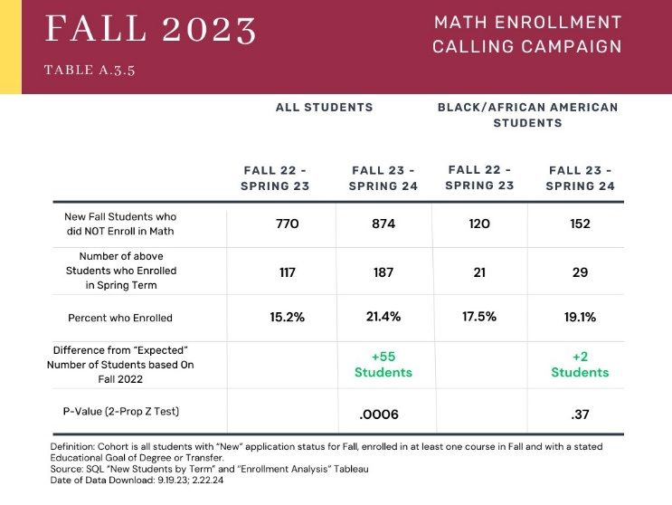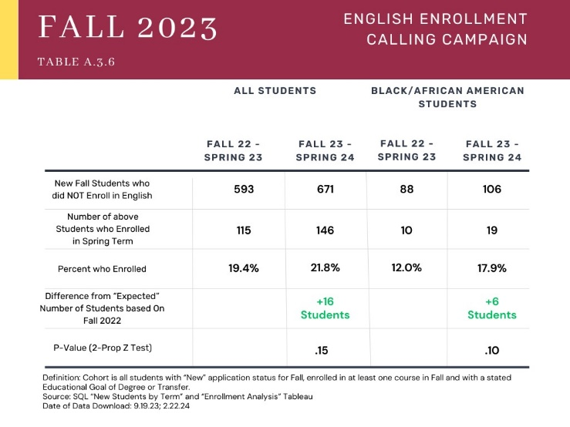

LMC aims to foster a sense of belonging through its communities – MESA, Honors, Umoja, Puente, Transfer Academy, and Career Center. These communities support students with resources, a coordinator designated to serve their needs, and cohort-style courses to build a sense of belong among students, faculty and staff.

After a pause from 2020-2022, LMC brought back tour opportunities related to transfer and career exploration. The college coordinated student trips to visit an average of seven baccalaureate colleges and universities per year in 2022-2023 and 2023-2024, and 165 students attended. The college reinitiated an annual student trip to visit Historically Black Colleges and Universities (HBCUs) in 2023, after a pandemic-related pause from 2020-2022. LMC funded a cohort of eight students in 2023, and 12 students in 2024, to visit eight HBCUs. The college implemented the Learning Aligned Employment Program (LAEP) in 2023 to increase employment and work-based learning opportunities for eligible underrepresented students. LAEP allows participating students to conduct research that relates to their area of study, career objectives, or the exploration of career objectives. LAEP is a form of financial aid and is included in a student's financial aid package. Students who participate in LAEP internships receive the funds in a paycheck as they earn them, based on hours they work.

LMC hired success coaches through its LMC Pathways (Guided Pathways) initiative. This team of coaches offers general information on majors within a student’s assigned pathway, acquainting them with college resources, and establishing warm handoffs to all departments. Success coaches provide basic tech-support for Canvas, Zoom, and the InSite Portal, ensuring students navigate these platforms seamlessly for remote educational services. They monitor academic progress, offering timely intervention, and can schedule counseling appointments. The coaches can serve as a guide for a student’s entire educational journey.

The Student Life Program and LMC Associated Students offer opportunities for engagement and connection to campus life. Through the Inter-Club Council, students can participate more than 20 established clubs or start a new club. Student Life, in partnership with the Office of Equity & Inclusion, organize events such as Black Food Matters, Celebrate the Year of the Dragon, and the Equity Speaker Series, featuring Yosimar Reyes, Gideon Egbuchulam, and Juan Gonzalez.

Since the COVID-19 pandemic, LMC has shifted toward increasing the use of instructional technology in the physical and virtual classroom environment. To promote equitable student learning and achievement, LMC uses delivery modes and teaching methodologies that meet student and curricular needs. For instance, the DE California Virtual College (CVC) course alignment and the introduction of a DE Support Hub in Canvas enrich the learning experience and demonstrate a commitment to making education accessible and flexible. LMC offers students the choice between online and in-person courses to best suit their needs and schedule. LMC is expanding and improving upon existing programs to meet student needs, including the establishment of an Early Childhood Education (ECE) degree pathway tailored for working students. The college also hired an articulation counselor to further strengthen its commitment to easing students’ transitions, and ensuring their prior coursework aligns with their educational pursuit.

LMC meets ACCJC 2024 Standard 2 and is committed to equitable student learning and achievement, and to ensuring all our students are successful in reaching their educational journeys. LMC has proven its commitment to design and deliver academic programs at its two campuses and in all delivery modalities that reflect relevant discipline and industry standards. This includes a framework for equitable attainment of learning outcomes, and diverse student engagement. The framework aims to help ensure students complete a degree/certificate program in an expected period. LMC’s design and delivery of supports and services in varied modalities address the academic and non-academic student needs.

In meeting ACCJC 2024 Accreditation Standard 3, LMC supports educational services and operational functions with effective infrastructure, qualified personnel, and stable finances. Continuous opportunities for professional growth and development among its employees is among LMC’s ongoing priorities.

LMC is focused on hiring qualified faculty and staff. Various committees support the recruitment process and work to improve diversity, equity, inclusion, and belonging across the institution. The Institutional Development for Equity and Inclusion (IDEA) committee developed a Toolkit for Recruiting a Diverse Workforce, and the Equal Employment Opportunity committee monitors diversity data while facilitating ongoing professional development. New faculty and classified professionals participate in cohort programs like the NEXUS Program and NEXUS experience, respectively. These programs introduce new employees to LMC's history, resources, and community engagement while fostering mentorship and collaboration. The Pedagogy Innovation Project and the Caring Campus initiative further promote a culture of collaboration, reflection, and proactive student support.

The Office of Equity & Inclusion (OE&I) delivers learning and leadership opportunities, onboarding programs, and community-building activities. The Classified Senate, Caring Campus, and OE&I collaboratively sponsor the "Equity in Action" series, empowering classified professionals with tools and skills for diversity, equity, and inclusion. Also, new technology deployment comes with targeted professional development, ensuring faculty, staff, and students acquire the necessary skills. The college's comprehensive approach prioritizes professional growth, inclusivity, and technological proficiency to create an equitable learning environment.

LMC addresses performance gaps through strategic measures, including the allocation or reallocation of human, fiscal and other resources. The Resource Allocation Process (RAP) guides budgetary decisions. The Shared Governance Council (SGC) and the President review all requests to ensure staff and operational resources align with institutional objectives. LMC uses the RAP to make non-emergency Higher Education Emergency Relief Funding (HEERF) decisions. HEERF resources were instrumental in establishing a technology loan program for students, facilitating equitable outcomes during and post-pandemic. This initiative included procuring laptops, Chromebooks, and Wi-Fi hotspots for distribution. Additionally, HEERF addressed in-classroom technology and office equipment upgrades for staff and faculty, supporting remote and hybrid instruction. LMC used HEERF to build a new virtual desktop infrastructure (VDI), ensuring consistent access to software and tools for students, reducing equity gaps and technology barriers. HEERF also supported student financial payments and funded faculty training in online instructional methods. LMC's strategic allocation of resources has effectively addressed performance gaps and bolstered the college's ability to adapt to evolving educational needs. The college upgraded its campus-wide WiFi, improved core infrastructure servers and services, established a new virtual desktop environment, and provided enhanced software packages. These improvements contribute to an advanced and secure working and learning environment. These technology initiatives were included in the Technology Master Plan. In addition, the institution started developing a new Facilities Master Plan for a 10-year horizon.

LMC’s Office of Equity & Inclusion has spearheaded the development of the NEXUS Program for new employees and the "Equity in Action" series, empowering Classified Professionals with tools and skills for diversity, equity, and inclusion. The Shared Governance Council and College President have worked to ensure staff and operational resources are aligned with institutional priorities via our Resource Allocation Process and demonstrated using HEERF funds to reduce equity gaps and technology barriers for our students. In the development of its Technology Master Plan and a new Facilities Master Plan, LMC has aligned institutional goals with its mission of student success. These activities, initiatives, processes, coupled with use of resources to meet student needs demonstrate how LMC meets ACCJC 2024 Standard 3.

In meeting ACCJC 2024 Accreditation Standard 4, LMC governance practices support the achievement of its mission. LMC has clearly defined, communicated, and effectively used decision-making structures and ensured its practices support a climate of collaboration and innovation for equitable student outcomes. To assess and to increase inclusivity, transparency and efficiency in shared governance and participatory decision-making at LMC, the Shared Governance Council (SGC) developed the Participatory Governance Task Group in early Fall 2023. The group will have completed their review and presented their findings to the college in spring 2024. The college is undertaking improvements to transparency and communication to ensure all stakeholders are informed and can participate in the decision-making process.

The Los Medanos College Associated Students (LMCAS) started a scholarship program to assist with textbook costs and award funding requests for student clubs. The Classified Senate hosts multiple community fundraisers annually to disburse scholarship awards to support students in their educational journey. The Academic Senate, Classified Senate and Associated Students held a Joint Senates Meeting in Spring 2023 which opened the floor to faculty, staff, and students to receive consistent information, voice concerns, and provide input on shared governance and institutional projects/initiatives. This resulted in a more collaborative approach to shared governance whereas all three (3) Senate Presidents were aware and included in conversations affecting the college.

Shared governance practices demonstrate flexibility, transparency, and inclusivity, while creating an environment where all voices are heard. For example, College Assemblies provide an avenue in which the college community provides input, receives information, and participate in activities that promote equitable student achievement. Furthermore, All College Days are held at the beginning of every semester and provide an opportunity for the college to review and discuss institutional metrics and standards, progress towards meeting goals, celebrate successes, identify areas of improvement, and design activities to promote student engagement and success. At the fall 2023 and spring 2024 All College Days, the campus community heard from an LMC student panel which offered insight into the student experience, including areas in which the institution is thriving and areas that need additional improvements or innovation.

LMC and the Contra Costa Community College District (CCCCD) are committed to the principles of academic freedom, academic integrity, and freedom of inquiry as outlined in
District Governing Board Policy 2018 (“Academic Freedom”), and Board Policy 2001 (“Nondiscrimination Policy”). These policies are included in the Los Medanos College Catalog, Faculty Handbook, the Student Code of Conduct, and on relevant institutional webpages. These policies reflect the college’s principles of academic freedom of faculty, administrators, classified professionals, and students to teach, study, conduct research, write, and challenge viewpoints without undue restriction. Furthermore, LMC establishes and publishes policies and procedures that promote honesty, responsibility, and academic integrity. The college also disseminates guidance on academic integrity through the Office of Instruction, which provides all faculty with instructions on developing their syllabi. The Office of Instruction encourages faculty to include statements on classroom conduct and academic dishonesty in their syllabi. District Board Policy 4005 (“Grade Changes”), Curriculum and Instruction Procedure 4005 (“Grade Changes”), and Student Services Procedure 3028 (“Recording Grade Changes and Securing Grade Records”) include the College’s grading policies and appeal processes, ensuring transparency and integrity in the recording and securing of grades.

Los Medanos College has demonstrated clear and effective governance practices and ensured institutional decision-making processes are collaborative and provide opportunities for meaningful participation and inclusion of relevant stakeholders in alignment with ACCJC 2024 Standard 4.

Evidence:
Pride 365-National Coming Out Day Announcement/Flyer
Heritage and Identity Recognition Committee Notes/Minutes
Barbie Event Email Announcement/Flyer
Equity in Action Workshops Email, Flyer
Undocumented Student Action Week Email/Flyer
Black History Month 365 Email/Flyers
Puente Motivational Conference Email/Flyer
Umoja State Conference Email/Flyer
NCORE Email Announcement/Application Process
African American Male Education Network & Development A2MEND Summit Email/Flyer
Announcement of AANHPI Student Achievement Program $129.5K Grant
LGBTQ+ Summit Email/Flyer
Announcement Email of SJS & ETHN Studies programs approvals
AS Minutes of Ethnic Studies position approval
Email announcement of District Ethnic Students Council creation
CC minutes of infusing equity into processes
TLC minutes of infusing equity into assessment processes
SS LSO Committee minutes of equity infused into LSO processes
GE Committee minutes of the inclusion of a diverse perspective into GE SLOs
DE Committee minutes of integration of equity rubric into DE CVC
Institutional Metrics Website
College Assembly FA23 of new Institutional Metrics Website
College Assembly FA23 on discussion of Institution Set Standards
BSSI meeting notes/announcements of work
Brothers of Excellence Program website/emails announcing work
Tech Equity Program website/application/process
ZTC Courses/website/information
LMC Marketplace website, e-mails announcing opportunities+
SGC minutes creating Participatory Governance Assessment Task Group
Participatory Governance Assessment Task Group Report/Findings
Minutes from Focus Group Sessions with PGATG (i.e. CS Minutes, IDEA)
CS 2021-2024 Goals
CS Website w/ Mission
LMC Educational Master Plan 2021-2025
LMC SEA Plan 2023-25
CS Emails with Meeting Summary Communications
Strategic Enrollment Management Committee Minutes/Agenda
LMC Pathways website
Email announcement of Success Coaches
LMCAS Scholarships Flyer/Announcement
Email announcing LMC Scholarships application opening
List of LMC Scholarships
FA22 Announcement of Drone NC Certificate program
AS minutes of AI taskforce
DE Committee website/CVC course alignment
Website/Email on DE Support Hub in Canvas (i.e. maybe screenshot in Canvas?)
Email/announcement of campus wide WIFI upgrades & new virtual desktop environment
Announcement of ECE degree pathway
OER website/email/information
Minutes/notes on approval for hiring of Articulation Counselor
CAS website
Study Slam announcement emails
Brain Food Project emails/flyers
SS LSO Committee minutes of EOPS survey results and discussion
SSLT minutes for calling campaigns and results
Data from calling campaigns
HBCU Spring Break 2024 Tour Flyer
Spring 2024 Campus Tours
Financial Aid LAEP Website
ACCJC Action Letter January 27, 2022
ACCJC Action Letter February 1, 2021
SJS & ETHN Studies Catalog screenshot of program courses
SEM Committee minutes on implementation of pathways
Basic Needs Program Website
Comprehensive PR Process Webpage
Comprehensive PR Process Data Packet Example
Comprehensive PR Process Templates
Comprehensive PR Completed Report Example - Instruction
Comprehensive PR Completed Report Example - Student Services
Comprehensive PR Completed Report Example - Administrative
RAP Email Announcements FA 23 & SP24
RAP Website: https://www.losmedanos.edu/businessoffice/resourceallocation.aspx
SGC Minutes on RAP review and approval
Documentation of example of course & program updates to align with industry standards (ETEC/PTEC/Nursing)
eLumen College Catalog website
Data/graphics on use and success of students accessing CAS tutoring services/disaggregated if possible
Childcare Center Website/Application/Information
Math Lab website/information
English Lab website/information
ESL Lab website/information
Email/Flyer on Bring your own Brain/Books Project
Email/Announcement of Library books/special events promoting diversity
Learning Communities Website(s)
Transfer Center Website - Campus Tours/Resources
Career Work Experience Program Website
LMC Student Life - Student Clubs Webpage/site
Flyers/Announcements oof Black Food Matters, Celebrate the Year of the Dragon, Galentines Day
Flyers/Announcements of Speakers - Yosimar Reyes, Juan Gonzalez, Gideon Egbuchulam
IDEA Committee Website
Toolkit for Recruiting a Diverse Workforce
Uniform Selection Guide: https://www.4cd.edu/gb/policies-procedures/hr/Uniform.pdf
EEO Committee Website: https://www.losmedanos.edu/eeo/
EEO Committee Resources: https://www.losmedanos.edu/eeo/resources.aspx
NEXUS Website/Canvas Shell
Caring Campus Initiative Announcements/Website
Equity in Action Series Website -- FA23 & SP24 Announcement/Flyer
PIP Project Website/Announcement/Information
RAP Sharepoint Folder: https://www.losmedanos.edu/businessoffice/rap.aspx
HEERF Expenditures: https://www.losmedanos.edu/financialaid/care.aspx
SGC Minutes on RAP Review and approval of allocations using HEERF funds
Instructional Technology website
IT website
Technology Master Plan: https://www.losmedanos.edu/tag/techplan20-25.aspx
Facilities Master Plan: https://www.losmedanos.edu/facilitiesplanning/facilitiesmasterplan23.aspx
Email on Joint Senates Meeting SP23
Email/Flyer of Winter Gala, Fun Run, Crab Feed
Email announcement of Bowling Night
Email announcement of AS activities (i.e. mixer)
All College Day announcement and e-mail/website information on FA23 & SP24 content
BP 2018 Academic Freedom
BP 2001 Nondiscrimination Policy
College Catalog -- Nondiscrimination Policy Page
College Catalog -- Academic Freedom Policy Page
Faculty Handbook
Student Code of Conduct
Office of Instruction Website - syllabi instructions on classroom conduct and academic dishonesty
BP 4005 Grade Changes
CIP 4005 Grade Changes
SSP 3028 Recording Grade Changes & Securing Grade Records
CTE Advisory Board Template
College Catalog -- Grade Changes Page

Reflections on Institution-Set Standards and Other Metrics of Student Achievement
Provide a brief response to each question below, referring to Standards 1.3 and 2.9 for additional context. You may insert graphs, charts, or other similar visuals as needed to support your narrative. Suggested length for Section B (not counting any visuals) is 3 pages.

- Review the most recent ACCJC Annual Report and other meaningful metrics of student achievement. Has the institution met its floor standards? Exceeded its stretch goals? Describe any patterns or trends you see in performance against your institution-set standards and other metrics of student achievement.

In collaboration with the Institutional Effectiveness and Partnership Initiative (IEPI), Los Medanos College established baseline Institution-Set Standards during the 2016-17 academic year. These standards were set for Course Success Rate, Degrees and Certificates Awarded, Transfer Degrees, and Units Accumulated, using data from that academic year as the reference point. The college set goals, aiming for 2% above baseline for course success rate, 20% above baseline for degrees and certificates awarded, 35% above baseline for transfers, and a reduction of 18% from baseline for units accumulated.

In 2019, aligning with the California Community College Chancellor’s Office (CCCCO) Vision for Success goals and Assembly Bill 1908, the institution used the 2016-17 outcomes as a baseline for setting stretch goals. The college integrated its Vision for Success and Institution-Set Standards with program-level goals, which were reviewed and updated to contribute to overall institutional success. In October 2021, a comprehensive review of data against aspirational goals indicated that, despite challenges posed by the pandemic, LMC remained above baseline goals for most indicators but fell short of meeting aspirational goals, particularly in the course success rate.

LMC chose to maintain the 2016-17 baseline and aspirational standards, reinforcing its commitment to continuous improvement. In fall 2023, the Planning Committee, divided into project teams, assessed strategies for reporting and reviewing Institution-Set Standards. A survey was conducted to gather input on reporting formats and methodologies for setting standards. After review of the survey, the Planning developed criteria for setting floor and stretch goals for our institution set standards. The committee researched new methodology on the premise that the process for setting floor and stretch goals should:
- Foster institutional progress
- Be reasonable and achievable and
- Compare our college to itself rather than an external comparison group

In spring 2024, the college decided to set floor goals at 1 standard deviation below the preceding 5-year average and stretch goals at 1 standard deviation above the 5-year average. There is ongoing discussion about maintaining a standard deviation approach to setting the floor/stretch goals, but potentially raising both to be more aspirational. LMC will review this methodology over the course of the 2024-2025 academic year after working with these new goals for a year.

Reviewing the Institution-Set Standards against the institutional data for 2020-23, some areas of challenge were identified. The successful course completion rate remained at approximately 73%, just below our stretch goal.

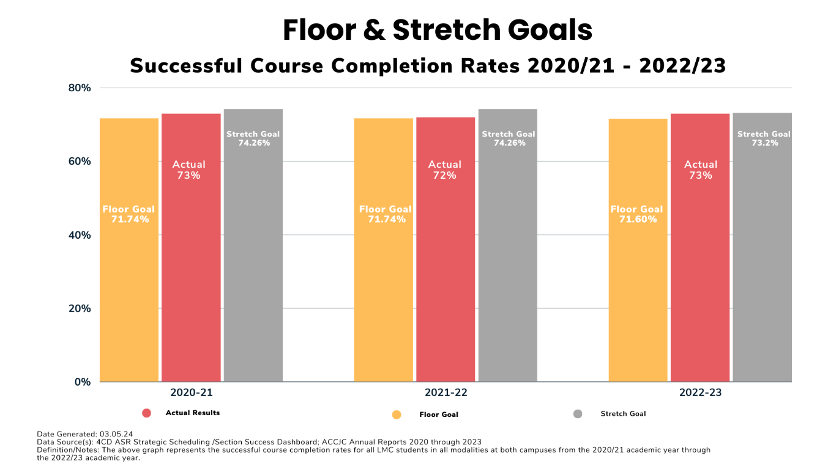

The number of certificates LMC awarded has declined over the past 2 years resulting in the college falling below its floor goals. This is a concerning trend that we are hopeful of reversing as we continue to recover enrollment lost during the pandemic. However, the sharp decline in certificates is not fully explained by the loss of enrollment during the pandemic, and the college is working to identify new ways to bolster short-term outcomes for students that lead to employment and increased earning potential.

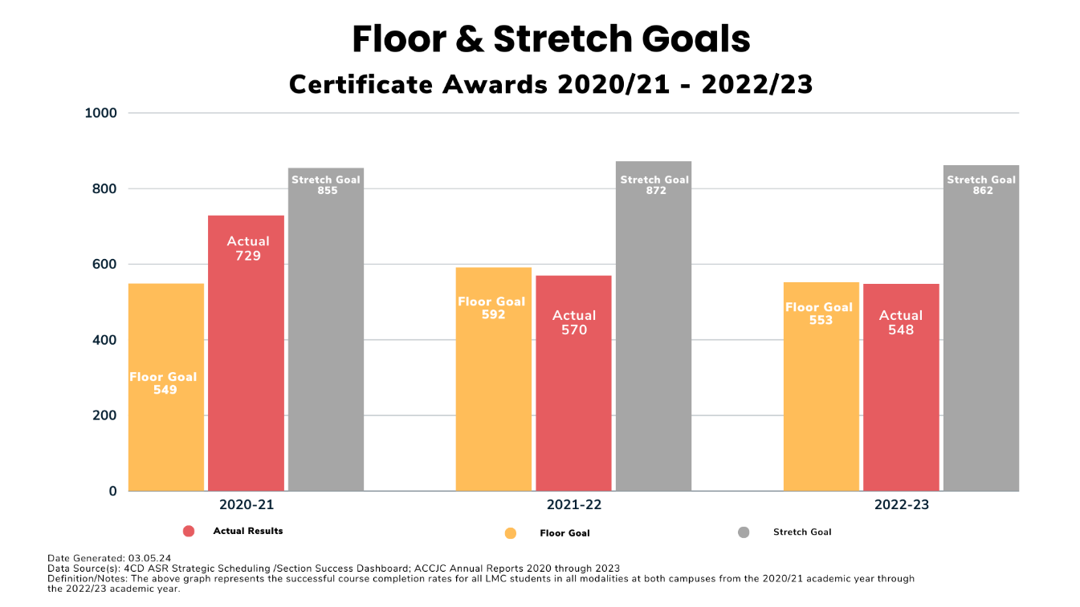,

Outside of this metric, the college remains solidly between its floor and stretch goals for degrees awarded and transfers with strong optimism that these numbers will rise in the next few years as our efforts to implement guided pathways are realized.

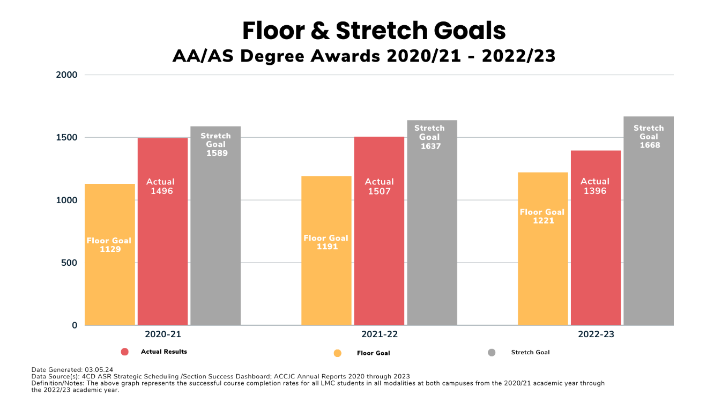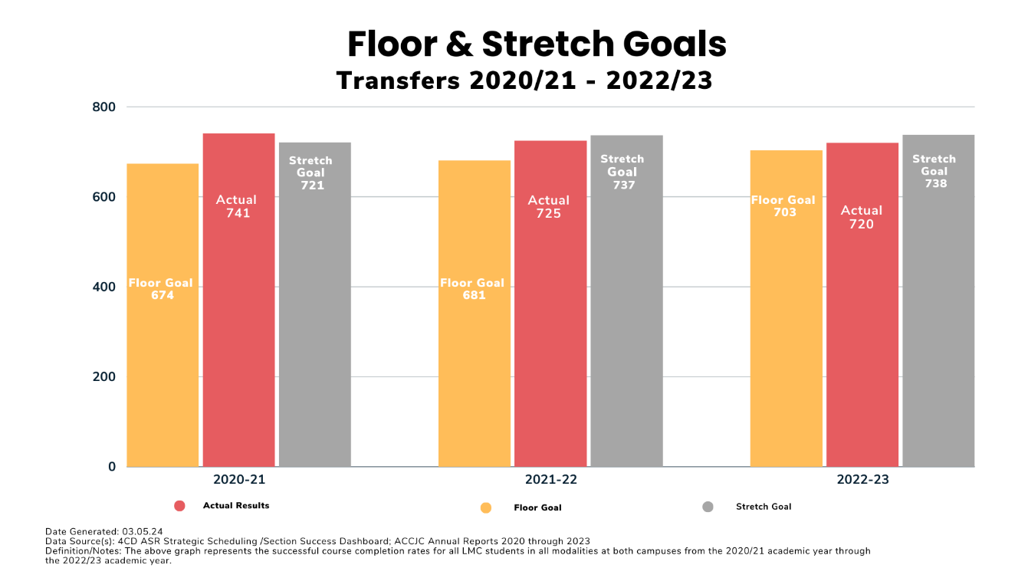

Despite overall declines in enrollment, the college implemented various services, programs, and support for student success. The college directed special attention toward Black/African American students and Foster Youth students, as highlighted in the 2022-25 Student Equity & Achievement Plan. The college set goals and targets, developed metrics to measure progress, and engaged in campus-wide discussions on strategies to advance these goals.

In summary, while LMC has faced challenges, particularly in meeting aspirational goals during the pandemic, its commitment to data-driven decision-making and continuous improvement remains unwavering. LMC addresses challenges, refining reporting methodologies, and implementing targeted initiatives to enhance student success.

2. When you disaggregate the data for the institution-set standards and other meaningful metrics of student achievement, what do you see related to equitable student achievement outcomes (i.e., equity gaps)? What patterns or trends excite you? What patterns or trends concern you?

Building upon the work of a decades-long commitment to improving outcomes for its Latine population as an HSI (Hispanic Serving Institution), LMC has seen improvements in several key metrics for this population. These include course success rates, early completion of transfer-level math and English, and increases to graduation and transfer volume. These improvements have been accomplished as the result of a commitment to Title V and Title III HSI grants along with key partnerships with the University of Southern California’s Center for Urban Education. This collaboration was instrumental in tracking data from stakeholders and practitioners in math and English. The findings from this inquiry emphasize the critical role of early success in math and English courses as key indicators of long-term transfer success, and helped the college focus its efforts on key metrics for the support of its Latine population.
The LMC Fast Facts provides access to data for student populations to internal and external campus communities As of the 2022-23 academic year, LMC’s student population is predominantly Latine, with 44.2%, followed by Caucasian/White students at 18.3% and Black/African American students at 10.7%. While the college has made significant gains regarding our Latine population, disaggregated data for 2021-22 highlighted equity gaps in achievement outcomes for other populations. LMC has seen slight increases in enrollments for Black/African American students since 2021-22, but a concerning trend emerges. Achievement gaps persist across key indicators, including enrollment, transfer-level math and English completion, first-term persistence, transfer, and degree/certificate completions. Namely, only 10% of Black/African American first-time students successfully completed transfer-level math and English in their first year, compared to 18% of the overall LMC first-time student population and only 54% of new Black/African American students persisted from their first to second term.
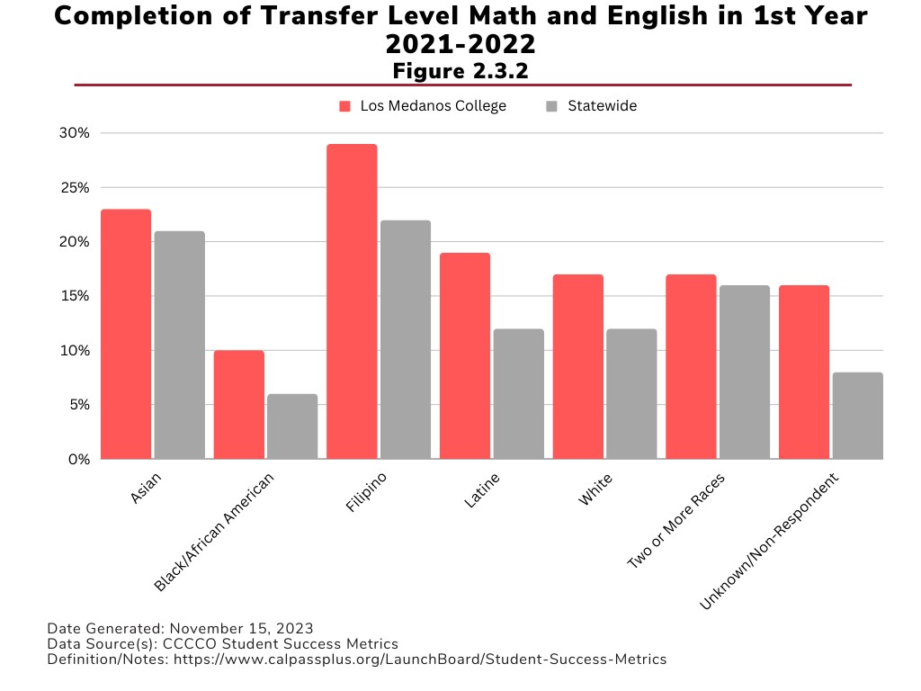

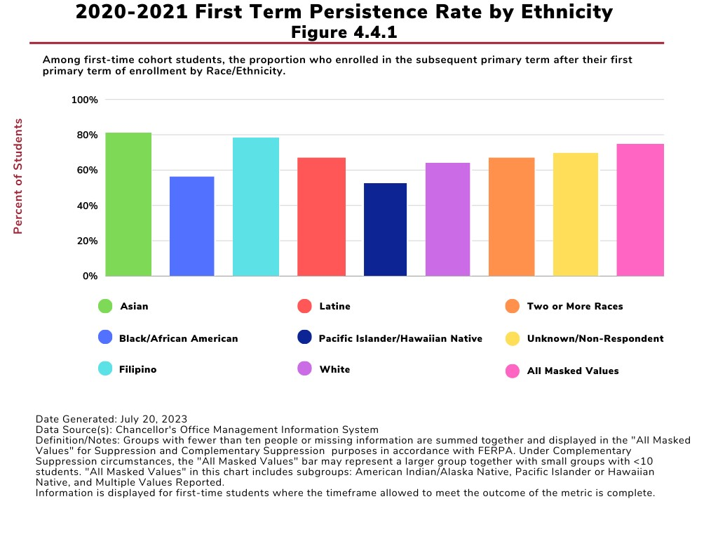
In terms of transfer, Los Medanos College has seen an overall 30% increase in the total number of transfer enrollments at UC/CSU in the last decade with an 82% increase for our Latine student population. However, in this same timeframe, the number of Black/African American students enrolling at a UC or CSU from LMC has remained the same.
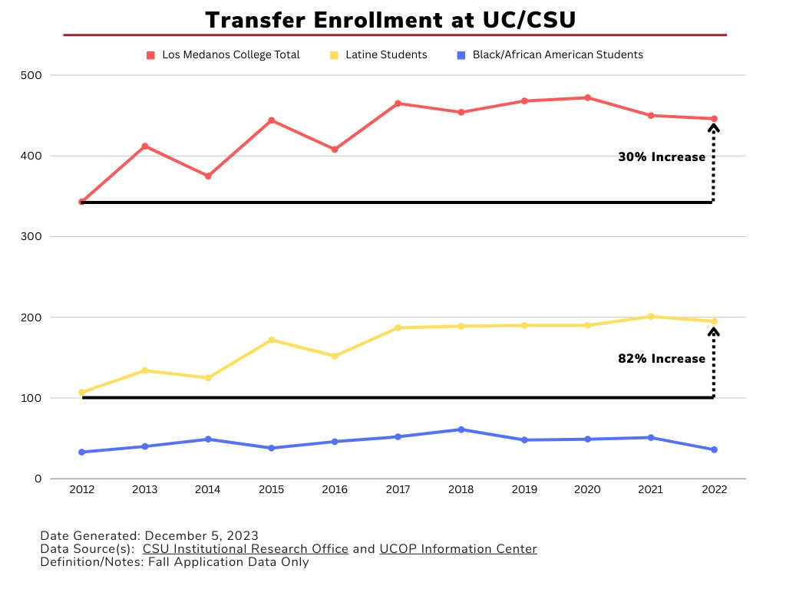

LMC monitors cumulative and disaggregated student workforce outcome data based on state Chancellor's Office dashboards (LaunchBoard) and the annual Career Technical Education Outcomes Survey (CTEOS). LMC benchmarks against state averages and sister colleges in the Contra Costa Community College District (4CD) and strives to close gaps. Data analysis reveals that LMC’s 2019-20 cohort (the most current period for which full data are available) of Black/African American students was disproportionately affected. Black/African American students: persisted fall-to-fall at 4 percentage points below the college average; earned 9+ career education units that year at roughly half the rate of white students; and achieved median annual earnings as Career Technical Education students at 70% of what white students received.

3. What actions has your institution taken/is your institution taking in response to the patterns and trends discussed above? How will you monitor the results of these actions to inform future improvements and innovations in support of equitable student achievement?

Acknowledging these challenges, LMC is working to duplicate and extend the results for Latine students to its Black/African American students and other traditionally underserved populations. In support of this, the college implemented services, programs, and interventions tailored to support underserved students.
Targeted Programs and Initiatives: LMC recognizes the need for targeted support, and to this end, the college has implemented specific programs to address the unique challenges Black/African American students face. The Brothers of Excellence Program, the establishment of the Black Student Success Initiative (BSSI), the launch of NextUP, and the creation of Learning Communities are key initiatives that aim to enhance student learning and achievement. LMC has partnered with the City of Pittsburg on two initiatives – Future Build and My Brothers’ Keeper – designed to create educational and employment opportunities for youth of color. Taken together, these programs aim to decrease the achievement gap between underserved male students of color and their counterparts through mentoring, an emphasis on student involvement and job training, while prioritizing safety from violent crime. Specific grant applications, including the successful 2022 Perkins Reserve Innovation Grant, emphasize supporting the needs of vulnerable populations. LMC has invested in Open Educational Resources (OER) and Zero Textbook Cost (ZTC) Faculty redesigned curricula to align with ZTC principles, ensuring every student can attain an education without the financial burden of textbooks. In 2022-23, LMC offered 360 ZTC courses.
Student Success Coaches: LMC Pathways’ Student Success Coaches play a crucial role in providing individual support to students. These coaches offer personalized services, including counseling, educational planning, financial aid guidance, tutoring, and more. This approach ensures each student can navigate the college structure and succeed in their educational journey.
Institutional Metrics Website: LMC has worked to enhance data accessibility and foster campus-wide awareness. The new Institutional Metrics website, launched in fall 2023, offers a user-friendly interface with data visualizations categorized into Access/Enrollment, Early Success Indicators, Momentum, and Success/Completion. These visualizations highlight key metrics aligned with CCCCO indicators, enabling stakeholders to easily identify areas that require attention and make our goals with regards to equity for our Black/African American students transparent and clearly quantified.
SEA Plan Implementation: The 2022-25 Student Equity & Achievement (SEA) Plan serves as a guiding framework for the college's interventions and strategies. The plan's target goals and metrics provide valuable insights, helping LMC to implement evidence-based interventions to address and minimize achievement gaps, particularly for Black/African American students.
Regular Reviews and Discussions: LMC is committed to continuous improvement and regularly reviews disaggregated data, engages in discussions with the campus community, and fosters increased awareness of strategies to support prioritized populations. This ongoing dialogue ensures that the college remains responsive to emerging trends and adjusts its interventions as needed.
Monitoring and Future Improvements: The commitment to addressing challenges is evident in LMC's dedication to continued access to disaggregated data, regular reviews, and discussions of the SEA Plan metrics and target goals. The college remains optimistic that these efforts will contribute to enhancing the level of service and support for all students, irrespective of background.
Alignment of Human Resource and Fiscal Allocations to Institutional Priorities: LMC closes performance gaps by implementing strategic measures, including the use of human resources, fiscal allocations, and an engaged process for decision making. The Resource Allocation Process (RAP) guides budget decision while the Shared Governance Council and the President review requests to ensure staff and operational resources are aligned with institutional objectives.
While some of the observed trends are concerning, we are optimistic that with continued access to disaggregated data, regular reviews, and discussions of our SEA Plan metrics and target goals, the College can enhance its level of service and support. LMC’s commitment to addressing these challenges is unwavering. The college remains dedicated to fostering an inclusive environment where all students can achieve success.
Evidence:
Institution-Set Standards 2016-17 (IEPI) Website
Institution-Set Standards 2016-17 College Assemblies
College Assembly (w/Greg Stoup) on ISS, Data and alignment with VfS
College Assembly October 2021 w/ Chialin on reviewing data for ISS
Planning Committee minutes FA23 on development of project teams
Planning Committee minutes December 2023 on survey results from assembly
Planning Committee minutes SP24 on ISS Project Team next steps
Data from FA23 ISS College Assembly
Institutional Metrics Website
SEA 2022-25 Plan
SEP Metrics-At-A-Glance
2022-23 LMC Quick Facts Website
2022-23 Enrollment Data Disaggregated
Transfer to 4-year university data disaggregated overall vs Black/African American Student population
Transfer level English and math successful completion rate overall vs Black/African American Student population
CTEOS 2022-23 Dataset
NextUP Announcement/Flyer and Website
BSSI meeting notes/announcements of work
Brothers of Excellence Program website/emails announcing work
Future Build Project w/ City of Pittsburg
My Brother's Keeper w/City of Pittsburg
2022 Perkins Announcement/Website Information on Reserve Innovation Grant
Open Educational Resources Website: https://www.losmedanos.edu/oer/
ZTC Courses/website/information
LMC Pathways website
Email announcement of Success Coaches
Institutional Metrics Website
SGC Minutes of SP24 RAP process and allocations
RAP Website: https://www.losmedanos.edu/businessoffice/resourceallocation.aspx
College Assembly Emails/Announcements of college-wide discussions on interventions based on data

Reflections on Assessments of Student Learning
Provide a brief response to each question below, referring to Standards 1.3, 2.1, 2.2, and 2.9 for additional context. You may insert graphs, charts, or other similar visuals as needed to support your narrative. Suggested length for Section C (not counting any visuals) is 3 pages.

- Review the results of learning outcomes assessment. Describe any patterns or trends related to attainment of learning outcomes observable in these data that may be relevant as you implement improvements and innovations in the design and delivery of academic programs?

LMC has multiple initiatives that demonstrate its dedication to excellence in teaching and learning. Assessment of student learning outcomes, the follow-up in curriculum redesign and the integration of this process with program review, promote continuous quality improvement of learning activities both in and out of the classroom. Faculty at LMC actively engage in innovative teaching strategies, followed by rigorous self-evaluation. Staff at the LMC see the critical role they play in student learning and seek to tailor their services to the unique needs of students interacting with their departments.

Examples of critical initiatives that support student learning include the Pedagogy Innovation Project (PIP), wherein faculty experiment with teaching strategies, practice self-reflection, peer coaching, and assess results based on student outcomes. In addition to audio/video pedagogy and instructional design, PIP has also added a new component titled Questions about Teaching – QTs. These three major pieces are action-oriented and reflective of teacher-driven projects in the program. Additionally, new full-time faculty members participate in a two-semester NEXUS program that includes training in course planning, formulating learning objectives, designing assessments, and developing instructional materials and learning activities. Subsequently, faculty participate in a collaborative cohort that explores educational theories rooted in culturally responsive pedagogy and adult learning theory.

The college moved to eLumen (an enterprise technology tool) for assessment and curriculum in 2021-22. ELumen has assisted the institution with streamlining our assessment and curriculum processes and enriched the assessment data for faculty to evaluate their students’ attainment of learning outcomes. Assessment reflection questions were also developed in eLumen for all faculty to access to close the assessment loop. LMC’s Teaching & Learning Committee (TLC) spearheads assessment of learning and teaching excellence on campus. TLC's leadership supports faculty in writing measurable outcomes, designing assessments, and implementing changes based on reflective analysis of assessment results. TLC facilitates the work of instructional departments responsible for assessing courses and programs, student service departments responsible for assessing programs, and the General Education Committee, responsible for assessing GE student learning outcomes college wide.

In Student Services, Learning Support Outcomes (LSO) are assessed annually followed by an in-depth review and discussion by the Student Services LSO Committee. Student Services LSO assessments reflected a negative impact overall from the pandemic, which demonstrated to the college the importance of in-person student engagement and services. The Student Services (SS) LSO Committee has developed and now institutionalized a more robust, three-pronged co-curricular assessment model to include a required focus on student learning outcomes and two additional assessment options within the model that focus on employee and/or service area learning outcomes. Student Services has moved from a 5-year assessment cycle that conducts assessment once in that cycle to a 5-year assessment cycle that commits to assessment of identified LSO’s annually for 4 years and a planning year during comprehensive program review as the fifth year of the cycle. This aligns with the college’s 5-year assessment cycle model while providing enough flexibility to address the dynamic needs of the Student Services division. The SS LSO Committee also engages in a peer-review process where representatives from each of the Student Services departments receive quality assurance feedback and support from their peers for their approaches to assessment and any respective results.

- How (i.e., for what subpopulations, modalities, etc.) does your institution disaggregate its assessment results? When you review disaggregated assessment results, what patterns or trends do you see related to equitable attainment of student learning? What patterns or trends excite you? What patterns or trends concern you?

One of the primary motivations for the college’s shift to the eLumen platform to track and monitor assessment is the goal to be able to disaggregate assessment results in ways that were not possible with our previous assessment process. The college remains in the middle phases of this implementation. Instructional programs are now using eLumen to document their assessment efforts, but not yet in a way in which the data can be disaggregated. In spring 2024, faculty assessment leadership together with the Office of Planning and Institutional Effectiveness led the college in the discussion around changes to the assessment process that will allow us to measure not just how equitably our students are passing their classes and progressing to the achievement of their educational goals, but how equitably they are attaining the course and program learning outcomes. This work included a joint presentation to the Academic Senate in April 2024 and will continue into Fall 2024 with changes made to the structure of the eLumen system to allow for departments to collect the needed data to reflect upon their outcomes disaggregated by student demographics and course modality.

- What actions has your institution taken/is your institution taking in response to the patterns and trends discussed above? How will you monitor the results of these actions to inform future improvements and innovations in support of equitable student learning?

LMC upholds a commitment to excellent teaching and learning, using a robust assessment of Student Learning Outcomes, Program Review, and Student Success. The college derives insights from outcome achievement, course and degree completion rates guide decisions in teaching practices, professional development, and curriculum design. LMC fosters an environment where faculty engage in self-evaluation, encouraging innovative teaching strategies.

New faculty members participate in a comprehensive two-semester Nexus program, receiving support in various aspects of teaching, including course planning, formulating learning objectives, designing assessments, developing instructional materials, and designing engaging learning activities. Subsequently, faculty can participate in the Pedagogy Innovation Project (PIP), a collaborative cohort that explores educational theories rooted in culturally responsive pedagogy and adult learning theory. Through this initiative, faculty experiment with innovative teaching strategies, practice self-reflection, peer coaching, and assess the impact of these strategies on student outcomes. Additionally, LMC developed the Teaching and Learning Committee (TLC) to spearhead the assessment process on campus. TLC's leadership supports faculty in writing measurable outcomes, designing meaningful assessments, and implementing changes based on reflective analysis of assessment results. These initiatives highlight LMC's commitment to a culture of excellence in teaching and learning.

The focus on Distance Education during and after the Covid-19 pandemic has fostered several innovations. LMC introduced the Peer Online Mentoring Program, a pragmatic initiative catering to full-time and adjunct faculty. This program serves as a hands-on platform for professional development, concentrating on online course design, humanizing techniques for the virtual classroom, and accessible online classes. Faculty commit to a 40-hour professional development program to qualify as a mentor in the California Virtual Campus (CVC) Online Education Initiative. Mentors collaborate with colleagues to align their courses and achieve a CVC Exchange badge, which serves as certification for high-quality standards, best learning practices and robust support. The college revamped accessibility within the learning management system by integrating tools for instructors to conduct accessibility checks on documents, graphics and images in their lessons.

Recent data reflects students’ desire for diversity in learning, services and support – fully online, hybrid, in-person, evening, non-credit, etc. In response, LMC has increased the number of online and hybrid course offerings and expanded non-credit and dual enrollment courses.

Learning communities at LMC are among its most successful programs for closing learning gaps among different groups of students. These are cohort-based programs offering experiences designed to help students achieve academic goals. LMC’s learning communities include MESA, Honors Program, Umoja, Puente, and Transfer Academy.
While each program is unique, common features include:
- Specialized counseling and transfer support
- Special program-only sections of key courses
- Enrichment activities like field trips and guest speakers
- Free tutoring and academic support
- Opportunities for community involvement
- Guidance on transfer, financial aid, and scholarship applications

From a Learning Support Outcomes perspective, assessment and analysis has resulted in LMC shifting most of our Student Services back to in-person while maintaining online services like chatbots, dynamic forms, online appointments. One illustrative example of this our Admissions & Records and Financial Aid offices have both led the way in converting key documents to dynamic forms to make them more accessible to students. Dynamic Forms provides students with a secure platform to submit their financial aid, admissions, or other related documents electronically at any time using their single-sign-on. Through the InSite platform, students can view financial aid related missing document checklist, click the hyperlink to the missing document, view and submit the document, and submit using an upload feature built into the form. Forms used within the admissions and records office have been built into an additional tile where students can access and submit requests safely and securely using the electronic platform. The built-in workflow process of Dynamic Forms enables staff members to process forms efficiently, send direct notifications to student email accounts improving processing and turn-around times within each department.

From an instructional perspective, utilizing the assessment of our General Education Student Learning Outcomes (GESLOs) in 2018 along with a follow-up survey in 2020, the college made significant changes to the both the SLOs and how curriculum mapped to them. In 2022, an assessment of the new process highlighted the need for the development of data tools to aggregate assessment results in a way that gives more meaningful feedback on students’ attainment of the GELSOs. Similarly, from a course and program learning outcome perspective, LMC recognizes the need to complete the transition to the eLumen platform in such a way that our assessment results and reports can be disaggregated and analyzed in ways that better inform our practices in the classroom and as an institution. We are looking forward to completing this work in the near term.

In the meantime, the General Education (GE) committee, along with our Teaching and Learning Committee (TLC) have been hosting professional development sessions and creating instructional videos for faculty on using the eLumen platform and building stronger CSLOs and PSLOs in their respective courses and programs.

Evidence:
PIP Project Website/Announcement/Information
TLC Website
NEXUS Website/Canvas Shell
Example of SLO Assessment in eLumen (including reflection if possible)
TLC SLO Assessment Webpage on resources and training info
GE Committee meeting notes on assessment of GE SLOs
LSO Assessment Workbook
SS LSO Committee Meeting Notes on LSO model for assessment
5-year SLO Assessment Cycle / Model of Assessment
GE Assessment Report (SP22)
DE Professional Development on Curriculum/Assessment/Pedagogy -- CVC Mentorships
SEP Metrics-At-A-Glance
Data from calling campaigns
Student Course & Services Preferences Survey Results (Most Recent)
Learning Communities Website(s)
A&R Website -- Dynamic Forms
Financial Aid Website -- Dynamic Forms
InSite Portal – Student Forms Screenshot(s)

Looking Ahead to the Next Self-Evaluation and Comprehensive Review
Provide a brief response to the question below. Suggested length for Section D is 2 pages.

Your institution will begin its next comprehensive self-evaluation in 1-2 years. What opportunities, changes, or other internal or external factors do you see on the horizon that are likely to affect the context of your self-evaluation and/or comprehensive peer review?

As the college approaches its next comprehensive self-evaluation in 1-2 years, several key opportunities, changes, and factors on the horizon are likely to influence the context. Here are notable points:
A Commitment to Equity: Building on successes as an HSI, LMC launched its Black Student Success Initiative, applying similar, intentional interventions for our Black/African American student population. LMC uses the same data inquiry process for this initiative that has proved successful with our Latine population. Currently, this initiative focuses on first-to-second-term persistence and first-year completion of transfer-level math and English as key metrics. The college continues its use of data-supported interventions to advance its commitment to addressing the unique needs of underserved student populations.
Guided Pathways and 1-Year Scheduling: The implementation of LMC Pathways, with Student Success Coaches and 1-year course scheduling, reflects our commitment to providing clear educational pathways, integrating retention services and career exploration, and streamlining the student journey from application to degree completion. Success coaches guide each student effectively and efficiently from the point of entry to the attainment of high-quality postsecondary credentials and degrees, or into successful careers.

Counseling Services Innovations: Modifications to the structure of counseling appointments, remote/distance counseling services, and a continued shift to a Guided Pathways (GP) model demonstrate our commitment to addressing the holistic student experience, accessibility, and adaptability to changing student needs.
Technological Integration in Instruction: The transition to supporting students in online/hybrid environments, the development of a DE Support Hub in Canvas, and ongoing updates to courses and programs to meet industry standards highlight LMC's responsiveness to the evolving landscape of technology in education.
Open Educational Resources (OER) and Zero Textbook Cost (ZTC): LMC's commitment to OER and ZTC initiatives is expected to impact the affordability of education. The ongoing expansion of ZTC courses, reflects our dedication to reducing financial burdens for students.
Strengthened Partnerships and Early College Opportunities: LMC's enhanced partnerships with transfer institutions and collaboration with K-12 leaders for early college opportunities demonstrate a commitment to providing diverse pathways for student success. Strengthening ties with Historically Black Colleges and Universities (HBCUs) also adds a unique dimension to our educational opportunities.
My Brothers' Keeper Program and Industry Partnerships: The collaboration with the City of Pittsburg in the My Brothers' Keeper program, strong advisory councils in Career Technical Education, and industry partnerships indicate a focus on increasing opportunities for young men of color and aligning programs with workforce needs.
Caring Campus: The Caring Campus initiative plays pivotal roles in enhancing support, engagement, and collaboration, fostering a sense of belonging for our staff and students alike.
Curriculum and Pedagogy Shifts: Ongoing commitment to universal design in teaching, articulation of college courses with local high schools, and the formation of Ethnic Studies and Social Justice Studies departments showcase LMC's dedication to inclusive and diverse academic offerings.
Participatory Governance Task Group: The development of a Participatory Governance Task Group signals LMC's proactive approach to review and revamp shared governance committees, ensuring an effective, efficient and transparent governance structure.
LMC aims to leverage these opportunities and adapt to changes to enhance the educational experience for its diverse student population. LMC welcomes the self-evaluation process and insights that the comprehensive peer review will bring to further strengthen the institution.
Evidence:
BSSI meeting notes/announcements of work
SEP Metrics-At-A-Glance
Office of Equity & Inclusion Website
LMC Pathways website
Email announcement of Success Coaches
Counseling Website
DE Committee website/CVC course alignment
Website/Email on DE Support Hub in Canvas (i.e. maybe screenshot in Canvas?)
Open Educational Resources Website: https://www.losmedanos.edu/oer/
Dual Enrollment Courses/Partnerships
Early College Credit Website
HBCU Spring Break 2024 Tour Flyer
My Brother's Keeper w/City of Pittsburg
LMC Foundation Website
Career Focus Fridays/Career Fair
Caring Campus Website
Announcement Email of SJS & ETHN Studies programs approvals
PIP Project Website/Announcement/Information
Participatory Governance Assessment Task Group Report/Findings

