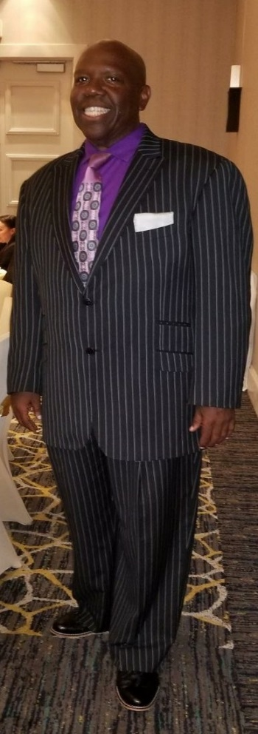
Professor Silvester Carl Henderson
Recently presented with the Albert Nelson 2019 Marquis “Who’s Who Lifetime Achievement Award”, Professor Silvester Carl Henderson is a nationally recognized Professor, educator, conference motivational speaker, business owner, respected real estate investor, community artistic organizer, musician/artist, internet radio blog personality, and conductor of the Gospel Song. Professor Henderson was recently Re-Elected to the “Executive Committee” for the Academic Senate for California Community Colleges (ASCCC). Comprised of 14 members, the ASCCC "Executive Committee" is the major governing board, who advises and advocates for changes and implementation regarding new educational laws and policies. This body supports academic and professional matters for 72,000 California Professors and two million, two hundred thousand students. As the Current Chair of the “Equity Diversity & Action Committee”, for the ASCCC, Professor Henderson, advocates, for Faculty Diversity, Foster Youth, Inmate Education and academic access for African American Males. Inducted into the “2017 Pittsburg Entertainment and Arts Hall of Fame”, Professor Henderson earned his Bachelor of Music and his Master of Arts Degrees from San Francisco State University. He taught there from 1984 to 1994 as a Professor/Lecturer of Piano and Music Theory. During the Fall of 2016, The Gospel Academy Awards, Inc. presented Professor Henderson with a “Gospel Music Academy Award” for his efforts in promoting “Higher Education”, through the usage of African American Gospel Music. Presently, he serves as the Full-Time Tenure Professor of Choral/Vocal Activities and Emeritus Chair of the Music Department at the Los Medanos College in Pittsburg, California. Professor Henderson directs the College Chorus, Chamber Chorale, and the Gospel Choir. In addition to those responsibilities, he also teaches voice classes, applied vocal lessons, music theory, class piano, musicianship, classical piano, and gospel piano. During the Fall of 2000, Professor Henderson developed a “Gospel Piano Curriculum”, which was the only collegiate academic course of its type in the State of California. Mr. Henderson is an Emeritus Professor/Lecturer of African American Studies and Music from the University of California, Berkeley, where he served as the original director of the internationally acclaimed Young Inspiration Gospel Choir (YIGC) from 1985 – 2005. In April of 1992, YIGC recorded their first live album entitled, “The Gospel Experience”. The album is placed in the permanent collection of the Smithsonian Institute’s Gospel Music Division, and accordingly, they named YIGC as the "finest" university gospel choir in the nation. The choir sold over one hundred thousand copies of this historic recording. In November of 1998, The “Second Gospel Experience” was released, which has been shared by over forty-five thousand purchasers. The Professor’s achievements can be found in “Gospel Digest” World News and World News. During January 2015, Professor Henderson was appointed as Professor/Lecturer of Choral/Vocal Activities for the College of Alameda’s Department of Music. From this appointment, the “Gospel Explosion Community Concert Series” was created. Professor Henderson has organized community concerts and performed with celebrity classical opera artist, gospel, jazz, broadway stars, rhythm and blues artist and musical greats such as Richard Smallwood, Reverend Daryl Coley, the late Walter Hawkins and the Love Center Choir, Kurt Carr, Quincey Fielding, Ron Kenoly Sr., V. Michael McKay, the late Helen Stephens and the Lighthouse Singers of Marin, Ca, Micah Stampley, Jon Gibson (the artist who paired with Stevie Wonder for the remake of “Have a Talk with God”), Billy Porter (New York Broadway Star and Soundtrack Artist for Bette Midler’s “First Wives Club”), James Iglehart (New York Broadway Star from Aladdin), Vesta, Howard Hewett, Kenny Lattimore, Gerald Albright, LaToya London, Chris Walker, Kathy Taylor Brown, Kevin LeVar, Anita Wilson, and most recently Keisha Renee, the vocal artist from the TV show entitled “The Voice”. Mr. Henderson has served as musician and Minister of Music for over thirty-eight years at the Bay Area’s prominent Palma Ceia Baptist Church, located in Hayward, CA. During the Professor’s early administrative leadership, one of Silvester’s most endeared accomplishments was to manage, organize and lead the entire department to record their “First Album/CD” entitled, “One Body In Christ”. Over ten thousand copies of this highly successful musical creation were sold and have been shared with listeners as far as Japan and Africa. Over the course of close to forty years, Professor Henderson has been the recipient of many prestigious educational, religious, and community awards. He won the National Piano Competition from the Gospel Music Workshop of America, Inc., which was founded by the late gospel legend Reverend James Cleveland. He was also nominated by the Bay Area’s Gospel Academy Awards as the Outstanding Pianist of the Year from 1992-1996. Professor Henderson was named as the “Most Influential African American Educator” by the Intel Corporation and the City Flight News magazine, 2001. The Delta Sigma Theta Sorority Inc. awarded him the "Outstanding Community Leader Award. Professor Henderson was honored with two City Proclamations by the California cities of Pittsburg and Martinez. These honors were awarded for his continuing efforts in using Gospel Music as a tool to support the value of “Higher Education”. Both cities named the first Saturday in May, “Gospel Celebration Day”. The Offices of Emeritus Congressman Pete Starks, Congressman Eric Swalwell, along with Emeritus Mayor Michael Sweeney, have bestowed upon Professor Henderson “Congressional Honors” and “Certificates of Commendation”, for bringing academic recognition of the artistic value of the gospel song through unifying African American and Latino American communities. California Assembly Members Johan Kleh, Jim Frazier, Susan Bonilla, and Senators Liz Figueroa, Ellen Corbett and Mark DeSaulnier, have presented Professor Henderson with many California Legislature Resolutions and Political Documents of Recognition for his extraordinary musical achievements and his work as an educator and artist to the people of Contra Costa. “Mr. Gospel/Jazz Production (Professor Henderson’s Performing Company) has arrange entertainment for personalities such as Reverend Jesse Jackson – “Operation Push” (Silicon Valley Branch, Honorable Emeritus Assemblyman Willie Brown, La Casa de las Madre, Contra Costa County Board of Supervisors and many noted political and county organizations. The professor was also awarded the 2004 “NAACP Educational Integrity Award”. On April 25, 2005, the University of California at Berkeley, College of Letters and Science, presented Professor Henderson with an “Educational Commendation” for his twenty years of highly valued service to the university and campus community. Registered in the “International Star Registry” was an honor bestowed upon Professor Henderson on May 7, 2005. Professor Henderson is included in the “Who's Who Among America's Teachers”, “Cambridge Who’s Who Registry” of Executive and Professionals. Additionally, he is part of the Remington’s Registry of Professionals, which only recognizes one thousand of the most noted “Successful Executives and Professionals” in the United States, once a decade, as part of the Library of Congress. “Professor Henderson was honored on April 29, 2006 by the 35th Academy of Gospel Music Awards” in the area of “Sacred Choral Music”. On July 28, 2011, AOL’s “Patch Online” Newspaper featured a story that “Celebrated” his many achievements. On January 12, 2012, he was presented with the “Dr. Martin Luther King Jr. “Community Award” from Dow Chemical located in Pittsburg, CA. This award was given to him because of his highly successful efforts in promoting higher education and diversity through the usage of Gospel Music. Moreover, the Professor was the winner of the “Professor of the Year” award for the 2012-2013 academic years, sponsored by the Los Medanos College Academic Senate. Professor Henderson has been the owner of “Mr. Gospel Properties and Investments” for close to three decades. Because of his business acumen, the San Francisco Chronicle honored the Professor with a featured story on August 7, 2012, entitled, “Mr. Gospel lifted by Music, Investments and Houses”. This article is an international publication of his success, business acumen and unstoppable perseverance. Professor Henderson was named "Quarterfinalist" for the International Grammy Association's Music Educator Award, 2014. During the Fall of 2013, he was appointed “Academic Senate President” for Los Medanos College. On April 26, 2014, Professor Henderson was awarded the 2014 “Community Service Award” from the East County Branch of the NAACP. On October 21, 2014, Professor Henderson was presented with the 2014 “Art Recognition Award” from the Contra Costa County Arts and Culture Commission. On July 1, 2016, Professor was voted/appointed as “President” of the “Faculty Senate Coordinating Council” for the Contra Costa Community College District. This position required the Professor to serve as a communication link between the Senates of the participating campuses and the District Chancellor and/or his/her representatives. Professor Silvester Carl Henderson’s educational objective is to ensure a permanent academic home for African American Music within Higher Education. Professor Henderson married Cecile Henderson during his early twenties. The Professor resides in Pleasanton, California and is the father of three daughters named Carlena, Celisse and Charde.

