February 6, 2024

Dear Mr. Giambattista and members of the Los Medanos College Academic Senate:

RE: CCCCD Nominee for Contra Costa County Office of Education Teacher of the Year

Kindly consider this self-nomination as Los Medanos College’s “Teacher of the Year.” I am a life-time adjunct instructor with experience teaching at Los Medanos College, Pittsburg; Los Medanos College Brentwood Center; Diablo Valley College, Pleasant Hill; and Diablo Valley College, San Ramon. My decades-long classroom experience has ranged from business, accounting, real estate, to work-study.

My qualifications include the following.
- Masters of Business Administration, University of California at Los Angeles
- Familiarly and experience with the Los Medanos College Work-Study program and its objectives
- Faculty Member of the Los Medanos College Business Department instructing Business Law
- California Real Estate Educator of the Year – 2015 as conferred by the California Real Estate Educators’ Association
- Experienced and committed to instruction to diverse student populations in both the traditional classroom and virtual classrooms
- Knowledge of the Pittsburg/East Contra Costa County Demographics as I am a 50-year resident of Brentwood
- Educated and experienced in small business and entrepreneurship education
- Committed to East County education and community development
- Active in local community organizations including the Oakley Chamber of Commerce and county historical societies
- Representative of Contra Costa County on State citizen committees including the Sacramento-San Joaquin Delta Heritage Area Management Committee.
- Consultant to the City of Oakley through LMC Contract Education providing entrepreneurship education on a monthly basis to start-up organizations in Oakley.
- Lecturer for LMC Community Education/Active Learning Program on local history topics (East Contra Costa County)
- Experienced in curriculum development (real estate and business)
- Past director of the California Community College Real Estate Education Center (responsible for ensuring all community college real estate curriculum are in compliance with the California Department of Real Estate educational requirements)
- Fulbright Scholar to Denmark – 2015
- Fulbright Specialist in Real Estate to Denmark - 2022

Thank you for your consideration. Kindly contact me at email: cjensen@losmedanos.edu or cell phone: 415 517 9585 should you have any questions or to schedule an interview. It will be an honor to represent Los Medanos College and the Contra Costa County Community College District in this capacity.
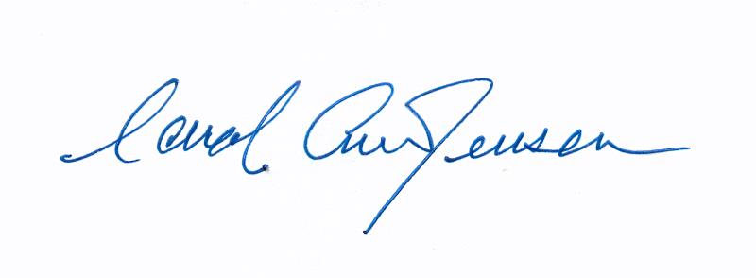
Yours truly,

Carol A. Jensen
Adjunct Instructor
Business Department and CWEE/CTE

Enclosure: Academic curriculum vitae

