1. Pick up an order form from the LMC Bookstore
2. Make your selection(s) and then make your payment at the Cashier Window at Student Services Center at the Pittsburg Campus.
Pay By Check: MAKE CHECK PAYABLE TO LOS MEDANOS COLLEGE
3. Pick up your order at the entrance of the Football Field on Graduation Day.

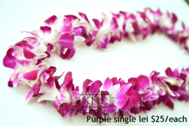
Fancy Bouquet $20.00 Single Orchid Lei $25.00
PURPLE
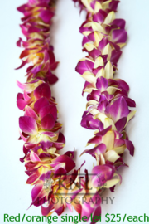
Single Orchid Lei $25.00 Single Orchid Lei $25.00

BLUE/WHITE
RED/YELLOW

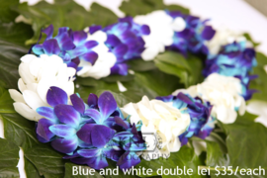
Double Orchid Lei $40.00 Double Orchid Lei $40.00
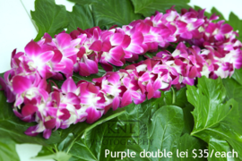
PURPLE BLUE/WHITE
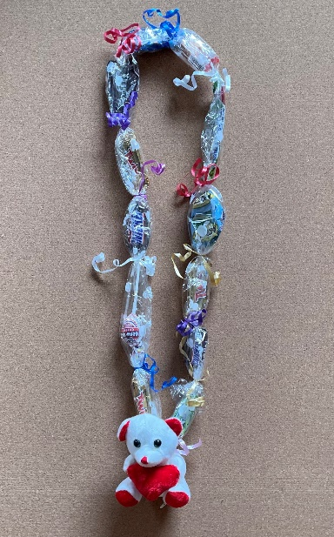
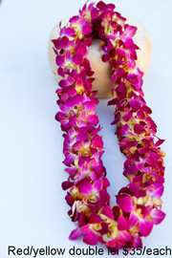
Double Orchid Lei Ribbon Lei (School Colors) Candy Lei w/ Bear
RED/YELLOW RED/GOLD $15.00
$40.00 $20.00

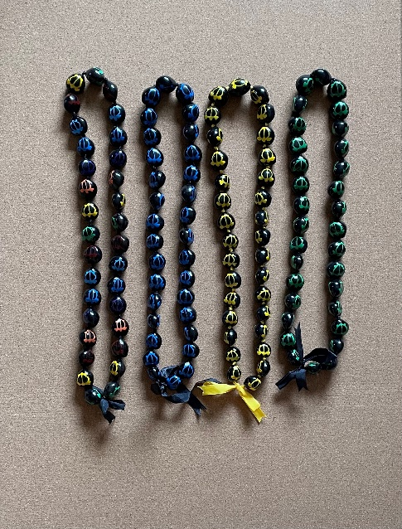
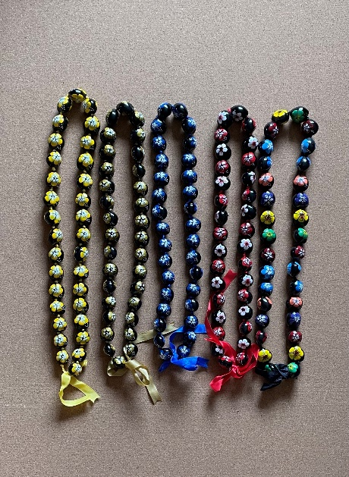
Flower OR Turtle
Nut Leis
$20.00

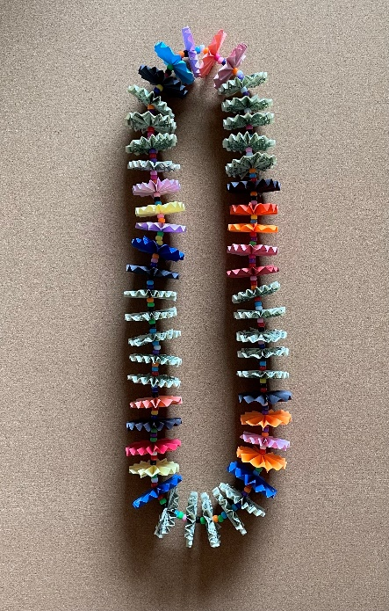
Money Lei (School Colors) $55.00 --
*$25.00 of $1.00 bills

NOTE:
Other Options will be available for purchase on graduation day
_______________________________ (_____)_____________________________
PRINT NAME CLEARLY PHONE _________________________________
EMAIL ADDRESS
Additional items will be available on graduation day for purchase.
ITEM | COST per ITEM | QUANTITY | TOTAL
Fancy Bouquet | $20.00
Single Orchid Lei | $25.00
Double Orchid Lei | $40.00
Ribbon Lei | $20.00
Candy Lei w/ Bear | $15.00
Flower Nut Lei | $20.00
Turtle Nut Lei | $20.00
Money Lei  $25.00 of $1.00 | $55.00
MAKE PAYMENTS
You will make pre-order payments at the Cashier’s Window located in the Student Services Center at the Pittsburg Campus.
Paying by Check? Make checks payable to Los Medanos College

