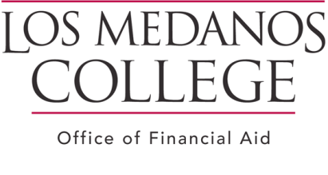
STUDENT SATISFACTORY ACADEMIC PROGRESS ON-LINE WORKSHOP AND QUIZ POLICY AND PROCEDURES

Office of Financial Aid
Los Medanos College (LMC)

Effective FALL 2012 SUSPENSION students will complete an on-line workshop and quiz.

Steps to complete the Satisfactory Academic Progress On-line Workshop and Quiz:

Step 1:
Logon to the Los Medanos College website www.losmedanos.edu; Click on ‘Current Students’, ‘Financial Aid’, Select and view the ‘Satisfactory Academic Progress Online Workshop’
Step 2:
After viewing the Satisfactory Academic Progress Video, Type in the link provided on the last slide of video. Complete the online Quiz and Click SUBMIT. Students are considered to have met the requirements of passing the quiz with a 100%. If a student cannot pass the quiz with 100%, the student will be notified via E-mail to retake the quiz and video.
Step 3:
Submit Appeal, Educational Plan and supporting documents to the Office of Financial Aid. (If you have a current Educational Plan on file ( WebAdvisor). Print and submit with your Appeal)

PLEASE NOTE:
The Office of Financial Aid will automatically deny any appeals submitted with no documentation.

