Setting up OneDrive for Business
Use this guide to learn how to set up the OneDrive for Business sync client on your PC to easily access your OneDrive library files offline.
- Find the URL for your District-supplied OneDrive for Business account
  - Open the browser of your choice
  - Enter onedrive.com in the address bar and hit the Enter key
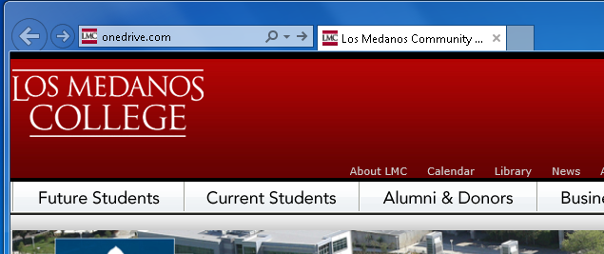
  - Click on the Sign in link
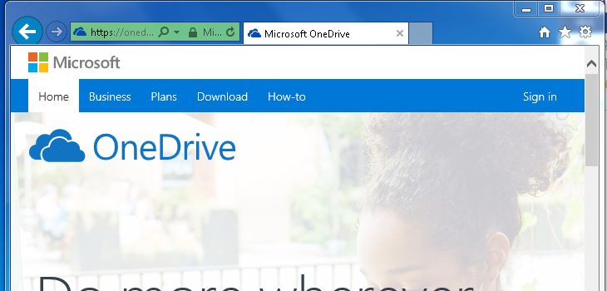

  - Sign in using your e-mail.4cd.edu address and password (e.g., jsmith123@email.4cd.edu) and click the Next button
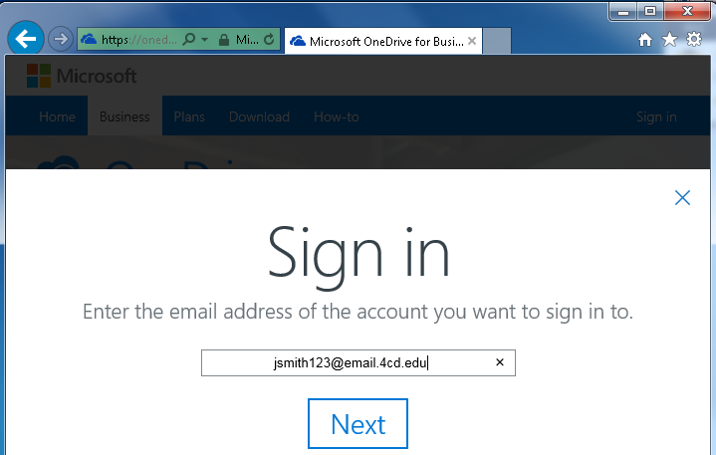
  - If a choice is given, select OneDrive for Business
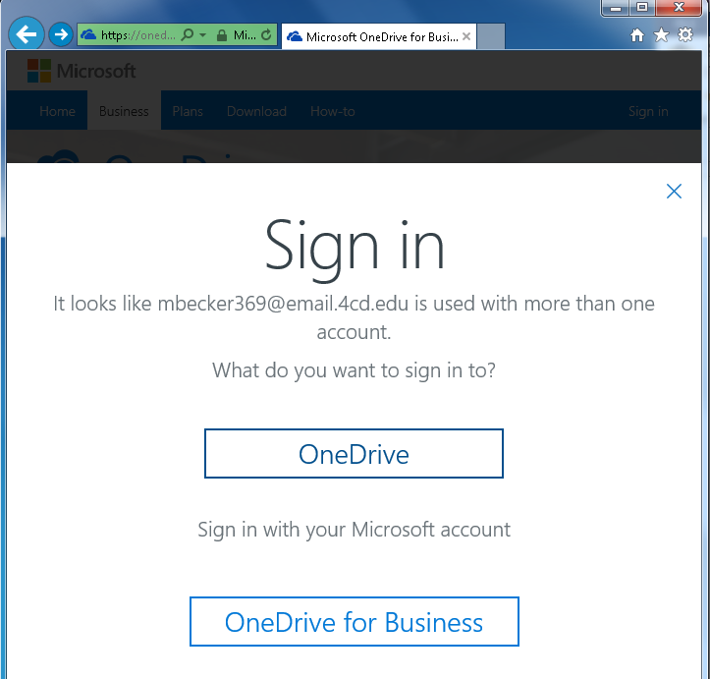

  - Enter your e-mail (AC.Portal/InSite) password when prompted and left-click on the Sign in button.
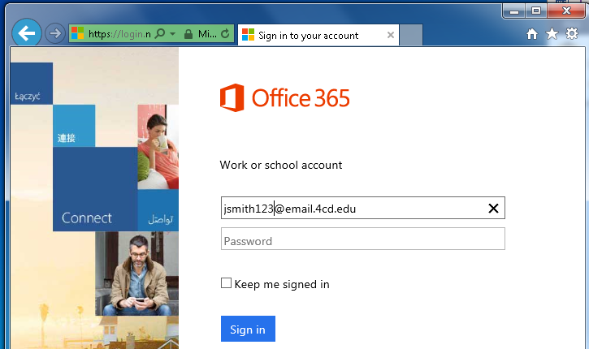
  - After the browser opens into your OneDrive for Business account, right-click on the address bar and select Copy from the drop down menu.
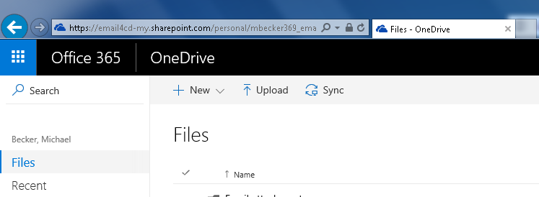

- Launch and configure OneDrive for Business
  - Left-click the Start button
  - Left-click All Programs
  - Left-click Microsoft Office 2013
  - Left-click OneDrive for Business
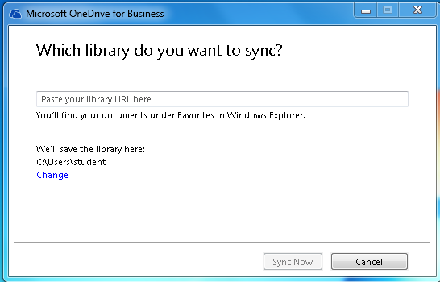
  - If there is a box that says Paste your library URL here, then right-click in the box and select Paste.
  - The box should say something like https://email4cd-my.sharepoint.com/personal/jsmith123_email_4cd_edu/Documents
  - Use the default library (C:\Users\youruser###) for the location to save the library and left-click on Sync Now
  - The sync process may take some time

- You will now have a folder in Windows Explorer Favorites area that is called OneDrive for Business. You can move files to and from this folder just like any other folder on your computer or the network.
