# OneDrive for Business Sync Client – Quick Guide

## Sync OneDrive for Business to your Windows computer

To sync changes made to your OneDrive for Business library to your computer, sign in to **onedrive.com** and select **Sync**.

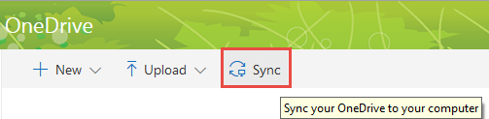

Click **Sync Now** to start syncing your OneDrive.

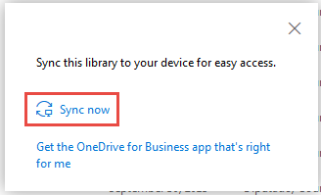

## Sync files on your Windows computer to OneDrive for Business

You can sync your OneDrive for Business library to your computer, and then work with the files on your computer by using Windows Explorer. Changes to your OneDrive for Business folder (including adding, deleting, or updating files) sync to your OneDrive library in the cloud automatically as long as your computer is online.

## **Limits on syncing content in OneDrive for Business**

|  |  |
| --- | --- |
| File size limit for syncing | You can sync files of up to 10 GB |
| Number of items that can be synced | No limit |
| Invalid characters | The following characters in file or folder names aren't supported when you sync:  \, /, :, *, ?, ", <, >, |, #, %  Additionally, a file or folder name that begins with a tilde (~) isn't supported. |

For a complete list of sync limits, review the [Restrictions and Limitations When You Sync Files and Folders Using the New OneDrive for Business Sync Client article from Microsoft Support](https://support.microsoft.com/en-us/kb/3125202).

## **Checking the status of your synced files**

Windows Explorer icons show you the sync status of your offline folders and files.

* It’s in sync with online version.
* It’s getting in sync.
*  The version on your PC is out of sync. To find out why, right-click on the file name in Windows Explorer and choose **OneDrive for Business** followed by “View sync problems”.

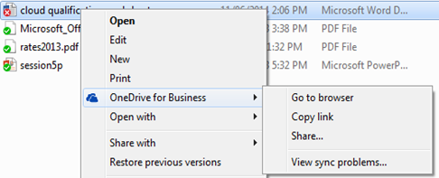

## Troubleshooting

If you experience problems syncing your files with OneDrive, review the following Microsoft Support tutorial: [Fix OneDrive sync problems](https://support.office.com/en-us/article/Fix-OneDrive-sync-problems-83ab0d8a-8400-45b0-8dcf-dc8aa8a6bcf8)

If you need to stop syncing a library, use the following Microsoft Support tutorial: [Stop syncing a library with OneDrive for Business app](https://support.office.com/en-us/article/Stop-syncing-a-library-with-the-OneDrive-for-Business-app-a7e41f1f-3a98-4ca7-9443-f10250688330).