LMC Online Counseling Cranium Café Evaluation & Implementation Plan

Name: Dr. Sophia Ramirez
Date: 11/13/19
Mission and Vision as it Pertains to D.E. at Los Medanos College
College Mission
Los Medanos College is a public community college that provides quality educational opportunities for those within the changing and diverse communities it serves. By focusing on student learning and success as our first priorities, we aim to help students build their abilities and competencies as life-long learners. We create educational excellence through continually assessing our students’ learning and our performance as an institution. To that end, we commit our resources and design our policies and procedures to support this mission.
Distance Education at LMC
Los Medanos College is dedicated to providing learning opportunities in both traditional and non-traditional environments to a diverse community of learners. To promote innovation and increased access, the college will develop and revise programs and services based on student need, workforce demand, institutional strength, and the ability to operate effectively and efficiently.
Vision
College Vision
Los Medanos College provides the premier educational opportunity for East County residents, where learning matters most.
Distance Education Vision
Online learning is an integral part of Los Medanos College’s educational services that promotes learner success through innovative, interactive teaching, learning and technology. Los Medanos College strives to provide access to quality online programs that meet the needs of a diverse population and address curriculum and student services, as well as faculty and student training, in a consistent and effective way. Students will receive advanced education that is seamless in delivery and access to instructional components as well as student services, regardless of delivery mode (face-to-face, online, or hybrid).
Per the Distance Education Guidelines, 2019 per the State Academic Senate, students must have access to equitable student support services:
‘The ASCCC has indicated that a DE Course Outline of Record Addendum might include additional exemplary elements such as statements on: (1) how a student’s identity will be confirmed; (2) how a student’s online readiness is assessed; (3) how students will access equitable student support services; (4) how instructors will work with their student support service areas, instructional designers, online administrators and others to ensure familiarity with information regarding ways to bridge all equity gaps in courses offered online; and, (5) whether instructors have assessed the use of high-quality open educational resources (OER) to help bridge the digital divide for students in the course.’

Identification of Standards for addressing Distance Education:
Standard 1: The Counseling Department will address the need for distance counseling services for our distance learners as well as the general student population.
- Identify number of distance education learners
- Identify counselors that are wanting to implement online counseling in their schedule
- Identify student learning outcomes for online counseling services
- Identify adequate student services for distance education students
Standard 2: The Counseling Department will encourage all counselors to be trained to use Cranium Café and learn how to incorporate the e-tools successfully to assist students in the online counseling session
- LMC Counselor Lead (Sophia Ramirez) will take on the role of ConexED Administrator: serving as a liaison between general counselors and ConexED
- LMC Counselor Lead (Sophia Ramirez) will design a process for 8 LMC counselors ( M. Pon, D. Reyes, T. Welter, E. Padilla, C. Santana, N. Westbrook, M. Mack, F. Watkins, and R.Rose) to partake in Online Counselor training (OEI professional development course) with the successful completion they will receive 800.00 dollar stipend.
- The 8 counselors will participate in the @one CVC-OEI online counseling course in Spring 2020. The 6-week online course will have two sessions on the following dates: 4/6-5/17 and 5/4-6/14.
- All counselors that want to conduct online counseling will have to successfully complete the online college counseling training conducted by @one OEI-CVC Online Counseling Network
- Once cranium café is purchased, the LMC Counselor Lead will schedule a ConexED Implementation team virtual meeting
Standard 3: Determine the number of scheduled hours and specific programs to offer (i.e., categorical, learning communities and student retention) online counseling services (i.e., chat feature, video conferencing, online counseling workshops, and group counseling).
- Identify online services hours that meet the needs of students
- Counseling department will review and update policies and procedures for online counseling scheduling
- Evaluating if all programs (i.e., learning communities and categorical funded programs) can implement online counseling services
Standard 4: Assessing for effectiveness and equitable access.
- Evaluating and identifying qualitative and quantitative data to assess online counseling services
- Identifying counselors to have admin privileges to run reports for online services
- Evaluating counseling services to be equally effective as in-person counseling appointments
Standard 5: All counselors that are conducting online counseling will have to participate in on-going professional development.
- Attending conferences or online workshops to assist in their online counseling practice and to stay current with recent initiatives for online counseling services and counseling skills
Reflection of Standards:
The five standards described are key areas needed for implementation for distance counseling services as Los Medanos College. In order to have our efforts supported and to strive for integration with cranium café, as our sole platform, we need to understand our student’s demographics and needs for implementation (standard 1). Understanding the need for our growing distance education students for online counseling can assist our department to become fully trained through the college online distance counseling training provided by OEI Online Counseling Network (standard 2). Researching and identifying the length and times of the online counseling will be determined by reaching out to our distance and face-to-face learners to see when the best times to make the services available. Thus, operational hours may change and be adapted to meet the unique needs of the students (standard 3). In order to make sure we are meeting the student learning outcomes for both face to face and online students' leaners we must assess through both qualitative and quantitative methods (standard 4). As technology changes as well as the skills needed to maintain a high standard of college counseling professional development is key (standard 5).

Stakeholders and Evaluative Tools for Assessment of Counseling Platform:
- The counselors who will participate in the beta cohort are: Michelle Mack, Eva Padilla, Melissa Pon, David Reyes, Rudolf Rose, Faith Watkins, Nicole Westbrook, and Camille Santana. Cranium Café was developed and customized specifically with student services in higher education setting. It possesses all the required compliance applications necessary to maintain the integrity of the counseling profession when it comes to offering students the following: educational, career, personal and mental health counseling in the online environment. Furthermore, Conex ED (cranium café) was adopted by the California Community Colleges statewide.
- Identify key questions about online counseling that you hope you answer by your evaluation plan. We will use the first two months of Cranium Café implementation as groundwork for an evaluation component used at the end of each student session to assess how the students engaged with counselors, their main questions, needs and the outcomes of the session. Also students will be evaluated if they would consider using the tool in the future. Students will also be evaluated on the times slots that serve them best, if they need bilingual support or any support that may not be offered during the beta cohort.
- Describe the type of evaluation tools you will use (surveys, focus groups, or other types of evaluation tools). An online survey will be given to each student at the end of the online counseling session. Please see the attachment for the survey sample that will be used.

Those that will be stakeholders in the online evaluation committee would be:
- Jeffrey Benford: Dean of Counseling (Oversees counseling services, strategies, & involved in funding)
- Tanisha Maxwell: V.P. of Student Services (Oversees student services on campus & involved in funding)
- Sophia Ramirez: General Counselor and Distance Education Co-chair (Strong interest in new online programs and background in research)
- Sarah Boland and Cheryl Carter: Counselors at DVC and CCC that will help with our district counseling efforts for collaboration in implementing online counseling
- Office Assistant (Strong understanding of department needs & how to effectively allocate resources)
- I.T. Department (They will be assisting with any updates to software or address hardware issues.)
- Distance Education Committee Coordinator and Committee members (to make sure we are receiving OEI benefits and reporting)
- SARS representative (E-SARS will be programs to make 45-minute online counseling appointments for counselors)

Implementation of LMC’s Cranium Café Online Counseling Program:
- Online Counseling Documents, Languages & Policies
- Informed Consent Form (Sample attached)
- Counseling Staff Intake Form
- Student Survey or Evaluation of Online Counseling Session
- Counseling Website, Scheduling & Policy
- A plan that specifies hours and scope of online counseling services (chat, virtual drop-ins, classrooms)
- A plan for communicating with students the minimum hardware and software requirements needed to participate in online counseling sessions including recommended browser. Onboarding letters to each student you make an email appointment with outlining the process
- A plan for connecting our distance education students with access to Cranium Café students to online counseling services (website, LMS, student portal or menu bar in CANVAS).

Vision & Goals Los Medanos Vision and Goals of Online Counseling Services
Los Medanos Counseling Department strives to provide quality counseling services to all students and understands the importance of addressing the same access and quality to our distance educational learners. E-counseling services are also available for general students because we understand students have various barriers that can hinder their involvement or access to counseling services. To assist students, we have implemented asynchronous E-advising for quick counseling questions and synchronous modes of communicating (online counseling) with our students for educational planning, career exploration and personal counseling.
Implementation for Fall 2020
The Counseling department online counseling faculty leads will be closely involved with the other counseling faculty leads at Contra Costa Community and Diablo Valley college to review policies, assessment methods and procedures that would be streamlined in our district. After completing this step, the counseling department co-chairs will present the implementation proposal to the Online Assessment Committee. Once this is complete the Co-Chairs of counseling will present the online services to academic senate, distance education committee and share out with student services meeting. All online counseling appointments will be scheduled for 45 minutes and will be sending via email through SARS the instructions for the appointment. Department will also address FAQ’s and information for online counseling readiness. There will be a single sign on by using our Insite portal and District will have a cranium café tile on the dashboard for easy access. A training will be held for student ambassadors and front staff for policies and procedures for online counseling service. Below is a chart to describe the various phases of the implementation plan for online services to be provided by Fall 2020 to LMC students.

History of E-Advising at LMC
Currently, LMC is offering the following E-services:
E-Advising (email correspondence)
https://www.losmedanos.edu/studentservices/counseling/online.aspx
The counseling department has offered e-advising to our students to answer the following types of student questions:
- Information regarding LMC classes, programs, and services
- Transferability and articulation agreements for LMC courses
- General academic advisement
- Pre-requisites co-requisites, and course content information
- Certificate, degree and transfer requirements
- General education options
- Referrals to campus and community resources
- College procedures and academic policies
- Admission and registration information

Numbers Served through E-advising:
For Fall 2018 semester we have served # 356 students.

Previous Distance Counseling via BlueJeans
The counseling department has implemented additional online counseling via BlueJeans a video conferencing platform. Webcams were installed in each counseling office. Utilizing video conferencing gave us the ability to validate the student’s credentials, screen share as we review their educational plans and show them the various tools needed for the counseling session. These sessions are also recorded for future information. Fall 2018 semester the department implemented a pilot program to solely serve our fully 100% distance education learners to receive online counseling services via BlueJeans. This service was available 4 evenings a week from 6pm to 9pm.

During Spring 2019, the Counseling department is implementing a second-level Online Counseling Initiative (pilot) to build upon information learned during the initial Fall 2018 pilot. This new pilot will similarly target courses that are being offered 100% online, previously totaling 61 sections across 19 disciplines, taught by 38 Instructors. 9-12 hours of Online Counseling appointments will be offered per week, in a variety of time blocks throughout the day, 2-3 days per week (i.e., Tuesdays 9-12pm and 3-6pm; Thursdays 12-3pm and 6-9pm; Fridays 11-2pm) for a 12-week period. In this pilot Counselors will also be embedded into the course via Canvas, to provide both instructor and student support, as needed. But also, to allow for direct student contact and to encourage student engagement in online Counseling services.

Phone Appointments: 30-minute appointment and can be made by phone only
Phone appointments are also made available for students that prefer not to use video conferencing. These appointments are limited and are not advertised on our website.

Educational Planning Tutorials:
The counseling department created student planning videos in order to assist students with accessing our InSite portal, student planning, 3sp steps, and progress page. Currently, the videos are being updated since our LMC webpage and dashboard changed.

Online Group Counseling and Workshops:
No online counseling workshops or group counseling are offered now, however that will be a goal for the department once we use cranium café.

Sample Informed Consent Statement

California Community College, Chancellor approved

Sample Informed Consent Statements California Community College, Chancellor approved (COLLEGE NAME HERE) is committed to protecting your privacy and personal information. By signing this form, you agree to this privacy policy and consent to the data practices described in this policy. Information collected: For this event, (COLLEGE NAME HERE) will collect personal information, including but not limited to: name, address, birth date, gender, e-mail address, phone number, social security number, employment information and if applicable student ID, high school attended, and other information unique to a particular event. You are not required to submit your social security number to participate in the event. This information is only used to track and match data in the Cal-PASS Plus system, which stores information on academic progress and success within the California K-12 and higher education systems. No personally identifiable data is ever shared, except with the institution to which you provide your information for the event.
Use of data: The institution and Cal-PASS Plus collects and uses the information you submit in order to provide statistical data about event attendance to individual community colleges and the California Community College Chancellor’s Office (CCCCO). Data collected will enable CCCCO and community colleges to analyze outcomes of the events in order to improve services. CCCCO is authorized to collect information for this purpose by California Education Code Section 70901(b)(7). Any information acquired by CCCCO, is subject to the limitations set forth in the Information Practices Act of 1977 (Title 1.8 (commencing with Section 1798) of Part 4 of Division 3 of the Civil Code).
How we protect your data: When you submit your personal information, it is stored securely at [institution name] and then transmitted to the Cal-PASS Plus web server over a secure connection. The data held by [institution name] is then destroyed. Without storing it in a file, Cal-PASS Plus encrypts the personally identifiable elements and then transmits them to a database for storage. Individual student information is not accessible by anyone, except by the institution to which you provided the information in order to edit or correct data. Only the aggregated data (total participation numbers, average graduation rates, etc.) is available for viewing by Cal-PASS Plus member institutions and authorized CCCCO users.
For more information: If you would like more information about the data being collected or how it is stored and used, please contact (COLLEGE NAME HERE) at (COLLEGE EMAIL ADDRESS HERE) or (COLLEGE PHONE NUMBER HERE) Copyright © 2016 (COLLEGE NAME HERE)

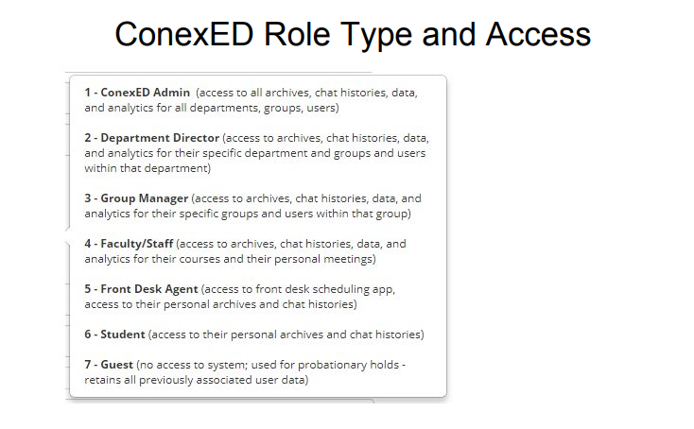
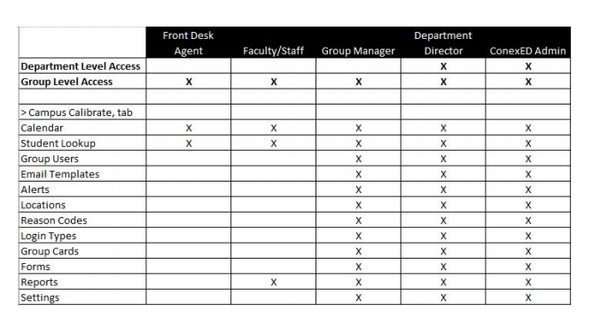

Survey and Forms
Counseling department will work with ConexEd to create an online survey, appointment intake form, student ed of the meeting survey, staff review form, and offline message form.
We have a few forms that can be customized for each group;
- Appointment Intake Form, allows you to gather information from the student prior to meeting. This information is provided in the meeting email confirmation received by the counselor, can be found in the Appointment Details, reporting is also available for this form.
- Student End of Meeting Survey, allows you to gather information from the student post meeting. You determine which meeting types/locations receive the end of meeting survey; for Cafe meetings the survey appears on the screen when the student hits “exit meeting”, the student receives the survey via a link in an email for on-campus and telephone meetings. Reporting is also available for this form.
- Staff Review Form, allows the counselor/advisor to enter additional notes which can be saved internally and/or emailed to the student as a post meeting following up. This can be accessed in the Appointment Details and it tied to that specific meeting in the student’s meeting history. Reporting is also available for this form.
- Offline Message Form, customize template when “send offline message” is enabled on the counselor/advisor’s ConexED card.
Resources and videos for Student Services Groups: Speed Training and Customization, https://blog.conexed.com/student-services-high-overview-training/

